Book title

|  |
| --- |
|  |

Teacher's name

Grade level(s)

School name

Book title

|  |  |
| --- | --- |
| Ernesto Mazza  Lesa Wallace  Lynette Yang  Author name  Author name | Author name  Author name  Author name  Author name  Author name |

Date

School name

Copyright © 2019

by Copyright holder name

ISBN: 123-45678-9

Printed in Country name

Table of Contents

[**Understanding Logistic Regression step by step** 4](#_Toc33186238)

[Authors 9](#_Toc33186239)

# **Understanding Logistic Regression step by step**

|  |  |
| --- | --- |
| https://miro.medium.com/max/1150/1*sR6PgnEB5HmuRuz62DfWzQ.png | https://miro.medium.com/max/1148/1*ArM2nhi7ZQNgdegWAWgG4Q.png |

Logistic Regression is a popular statistical model used for binary classification, that is for predictions of the type this or that, yes or no, A or B, etc. Logistic regression can, however, be used for multiclass classification, but here we will focus on its simplest application.

As an example, consider the task of **predicting someone’s gender** (Male/Female) based on their **Weight** and **Height**.

For this, we will train a machine learning model from a data set of 10,000 samples of people’s weight and height. The data set is taken from the [Conway & Myles Machine Learning for Hackers book, Chapter 2](https://amzn.to/2Xjkuqa), and can it can be directly downloaded [here](https://raw.githubusercontent.com/johnmyleswhite/ML_for_Hackers/master/02-Exploration/data/01_heights_weights_genders.csv).

Each sample contains three columns: Height, Weight, and Male.

* Height in inches
* Weight in pounds
* Male: 1 means that the measurement corresponds to a male person, and 0 means that the measurement corresponds to a female person.

There are 5,000 samples from males, and 5,000 samples for females, thus the data set is balanced and we can proceed to training.

The Python’s scikit-learn code to train a logistic regression classifier and make a prediction is very straightforward:

The general workflow is:

1. get a dataset
2. train a classifier
3. make a prediction using such classifier

**Logistic regression hypothesis**

The logistic regression classifier can be derived by analogy to the **linear regression hypothesis** which is:



Linear regression hypothesis.

However, the logistic regression hypothesis *generalizes* from the linear regression hypothesis in that it uses the **logistic function**:

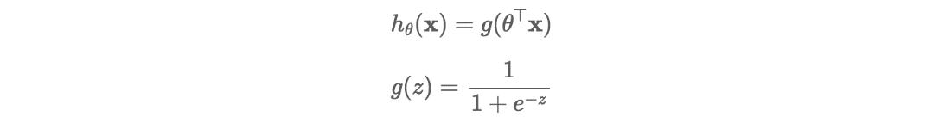

The result is the logistic regression hypothesis:



Logistic regression hypothesis.

The function **g(z)** is the **logistic function**, also known as the sigmoid function.

The logistic function has asymptotes at 0 and 1, and it crosses the y-axis at 0.5.

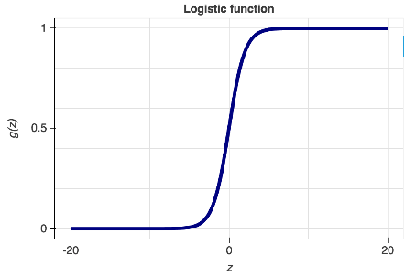

Logistic function.

**Logistic regression decision boundary**

Since our data set has two features: height and weight, the logistic regression hypothesis is the following:



The logistic regression classifier will predict “Male” if:



This is because the logistic regression “threshold” is set at g(z)=0.5, see the plot of the logistic regression function above for verification.

For our data set the values of θ are:

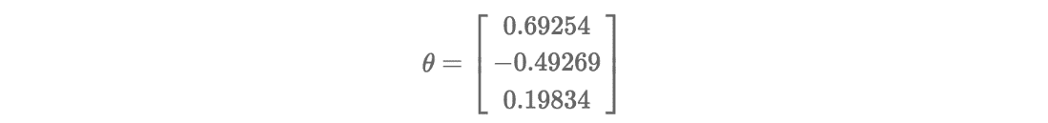

To get access to the θ parameters computed by scikit-learn one can do:

**# For theta\_0:**print( fitted\_model.intercept\_ )

**# For theta\_1 and theta\_2:**print( fitted\_model.coef\_ )

With the coefficients at hand, a manual prediction (that is, without using the function **clf.predict()**) would simply require to compute the vector product



and to check if the resulting scalar is bigger than or equal to zero (to predict Male), or otherwise (to predict Female).

**As an example**, say we want to predict the gender of someone with **Height=70 inches** and **Weight = 180 pounds**, like at line 14 at the script LogisticRegression.py above, one can simply do:

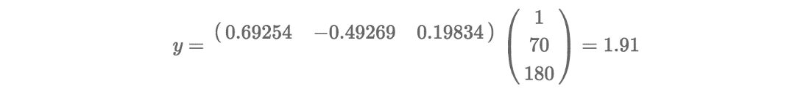

Making a prediction using the Logistic Regression parameter θ.

Since the result of the product is bigger than zero, the classifier will predict Male.

A visualization of the **decision boundary** and the complete data set can be seen here:

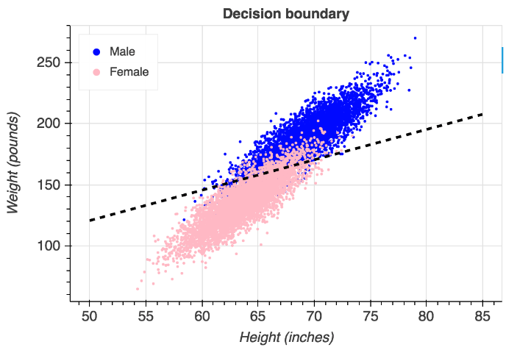

As you can see, above the decision boundary lie most of the **blue points that correspond to the Male class**, and below it all the **pink points that correspond to the Female class**.

Also, from just looking at the data you can tell that the predictions won’t be perfect. This can be improved by including more features (beyond weight and height), and by potentially using a different decision boundary.

Logistic regression decision boundaries can also be non-linear functions, such as higher degree polynomials.

**Computing the logistic regression parameter**

The scikit-learn library does a great job of abstracting the computation of the logistic regression parameter θ, and the way it is done is by solving an optimization problem.

Let’s start by defining the logistic regression cost function for the two points of interest: y=1, and y=0, that is, when the hypothesis function predicts Male or Female.

$$Cost\left(h_{θ}\left(x\right),y\right)=\left\{\begin{aligned}-\log\left(h_{θ}\left(x\right)\right) if y=1 \\ -\log\left(1- h_{θ}\left(x\right)\right) if y=0\end{aligned}\right.$$

Then, we take a convex combination in **y** of these two terms to come up with the logistic regression cost function:

$$J\left(θ\right)=-[y\log\left(h_{θ}\left(x\right)\right)+(1-y)\log\left(h_{θ}\left(x\right)\right)]$$

The logistic regression cost function is convex. Thus, in order to compute θ, one needs to solve the following (unconstrained) optimization problem:

$$\min_{θ}{J(θ)}$$

There is a variety of methods that can be used to solve this unconstrained optimization problem, such as the 1st order method **gradient descent** that requires the gradient of the logistic regression cost function, or a 2nd order method such as **Newton’s method** that requires the gradient and the Hessian of the logistic regression cost function — this was the method prescribed in the scikit-learn script above.

For the case of gradient descent, the search direction is the negative partial derivative of the logistic regression cost function with respect to the parameter θ:

$$\frac{∂J(θ)}{∂θ}=\frac{1}{m}(h_{θ}\left(x\right)-y)x$$

In its most basic form, gradient descent will iterate along the negative gradient direction of θ (known as a minimizing sequence) until reaching convergence.

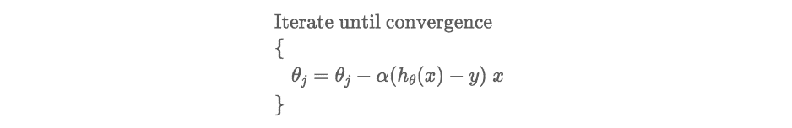

**Prototype of gradient descent**.

Notice that the constant α is usually called the learning rate or the search step and that it has to be carefully tuned to reach convergence. Algorithms such as [backtracking line search](https://en.wikipedia.org/wiki/Backtracking_line_search) aid in the determination of α.

In summary, these are the three fundamental concepts that you should remember next time you are using, or implementing, a logistic regression classifier:

1. *Logistic regression hypothesis*
2. *Logistic regression decision boundary*
3. *Logistic regression cost function*

For a discussion of the Logistic regression classifier applied to a data set with more features (using Python too) I recommend this [Medium post](https://towardsdatascience.com/building-a-logistic-regression-in-python-step-by-step-becd4d56c9c8) of [Susan Li](https://medium.com/u/731d8566944a?source=post_page-----704a78be7e0a----------------------).

**Logistic Regression [**[Susan Li](https://medium.com/u/731d8566944a?source=post_page-----704a78be7e0a----------------------)**]**

**Logistic Regression** is a Machine Learning classification algorithm that is used to predict the probability of a categorical dependent variable. In logistic regression, the dependent variable is a binary variable that contains data coded as 1 (yes, success, etc.) or 0 (no, failure, etc.). In other words, the logistic regression model predicts P(Y=1) as a function of X.

**Logistic Regression Assumptions**

* Binary logistic regression requires the dependent variable to be binary.
* For a binary regression, the factor level 1 of the dependent variable should represent the desired outcome.
* Only the meaningful variables should be included.
* The independent variables should be independent of each other. That is, the model should have little or no multicollinearity.
* The independent variables are linearly related to the log odds.
* Logistic regression requires quite large sample sizes.

**Over-sampling using SMOTE**

At a high level, SMOTE:

1. Works by creating synthetic samples from the minor class (no-subscription) instead of creating copies.
2. Randomly choosing one of the k-nearest-neighbors and using it to create a similar, but randomly tweaked, new observations.

**Recursive Feature Elimination**

[Recursive Feature Elimination (RFE)](http://scikit-learn.org/stable/modules/generated/sklearn.feature_selection.RFE.html) is based on the idea to repeatedly construct a model and choose either the best or worst performing feature, setting the feature aside and then repeating the process with the rest of the features. This process is applied until all features in the dataset are exhausted. The goal of RFE is to select features by recursively considering smaller and smaller sets of features.

**Compute precision, recall, F-measure and support**

The precision is the ratio tp / (tp + fp) where tp is the number of true positives and fp the number of false positives. The precision is intuitively the ability of the classifier to not label a sample as positive if it is negative.

The recall is the ratio tp / (tp + fn) where tp is the number of true positives and fn the number of false negatives. The recall is intuitively the ability of the classifier to find all the positive samples.

The F-beta score can be interpreted as a weighted harmonic mean of the precision and recall, where an F-beta score reaches its best value at 1 and worst score at 0. The F-beta score weights the recall more than the precision by a factor of beta. beta = 1.0 means recall and precision are equally important.

The support is the number of occurrences of each class in y\_test.

**ROC Curve**

[The receiver operating characteristic (ROC)](https://en.wikipedia.org/wiki/Receiver_operating_characteristic) curve is another common tool used with binary classifiers.

The Jupyter notebook used to make this post is available [here](https://github.com/susanli2016/Machine-Learning-with-Python/blob/master/Logistic%20Regression%20balanced.ipynb). I would be pleased to receive feedback or questions on any of the above.

Reference: [Learning Predictive Analytics with Python book](https://books.google.com/books/about/Learning_Predictive_Analytics_with_Pytho.html?id=Ia5KDAAAQBAJ&printsec=frontcover&source=kp_read_button#v=onepage&q&f=false)

**Logistic regression**

Logistic regression is another technique borrowed by machine learning from the field of statistics. It is the go-to method for binary classification problems (problems with two class values).

After reading this post you will know:

* The many names and terms used when describing logistic regression (like log odds and logit).
* The representation used for a logistic regression model.
* Techniques used to learn the coefficients of a logistic regression model from data.
* How to actually make predictions using a learned logistic regression model.
* Where to go for more information if you want to dig a little deeper.

## **Logistic Function**

Logistic regression is named for the function used at the core of the method, the logistic function. The logistic function, also called the sigmoid function was developed by statisticians to describe properties of population growth in ecology, rising quickly and maxing out at the carrying capacity of the environment. It’s an S-shaped curve that can take any real-valued number and map it into a value between 0 and 1, but never exactly at those limits.

$$f\left(val\right)=\frac{1}{1+e^{-val}}$$

Where,

e is the base of the natural logarithms

val is the actual numerical value that you want to transform.

Below is a plot of the numbers between -5 and 5 transformed into the range 0 and 1 using the logistic function.

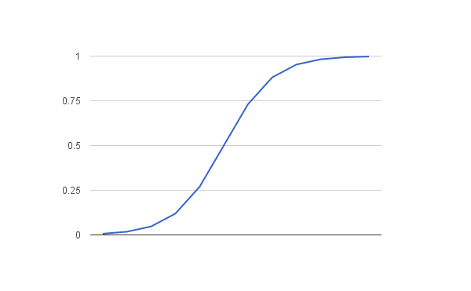

Now that we know what the logistic function is, let’s see how it is used in logistic regression.

## **Representation Used for Logistic Regression**

Input values (x) are combined linearly using weights or coefficient values (referred to as the Greek capital letter Beta) to predict an output value (y). A key difference from linear regression is that the output value being modeled is a binary values (0 or 1) rather than a numeric value.

Below is an example logistic regression equation:

$$y=\frac{e^{(β_{0}+β_{1}*x)}}{1+e^{(β_{0}+β_{1}*x)}}$$

Where,

y is the predicted output,

$β_{0}$ is the bias or intercept term.

$β_{1}$ is the coefficient for the single input value (x).

Each column in your input data has an associated $β$ coefficient (a constant real value) that must be learned from your training data. The actual representation of the model that you would store in memory or in a file are the coefficients in the equation.

## **Logistic Regression Predicts Probabilities (Technical Interlude)**

Logistic regression models the probability of the default class (e.g. the first class).

For example, if we are modeling people’s sex as male or female from their height, then the first class could be male and the logistic regression model could be written as the probability of male given a person’s height, or more formally:

$$P(sex=male|height)$$

Written another way, we are modeling the probability that an input (X) belongs to the default class (Y=1), we can write this formally as:

$$P(X) = P(Y=1|X)$$

We’re predicting probabilities? I thought logistic regression was a classification algorithm?

Note that the probability prediction must be transformed into a binary values (0 or 1) in order to actually make a probability prediction. More on this later when we talk about making predictions.

Logistic regression is a linear method, but the predictions are transformed using the logistic function. The impact of this is that we can no longer understand the predictions as a linear combination of the inputs as we can with linear regression, for example, continuing on from above, the model can be stated as:

$$p(x)=\frac{e^{(β_{0}+β_{1}*x)}}{1+e^{(β_{0}+β_{1}*x)}}$$

above equation as follows (remember we can remove the e from one side by adding a natural logarithm (ln) to the other):

$$ln(\frac{p(X) }{ 1 – p(X)}) = β_{0}+β_{1}*x$$

This is useful because we can see that the calculation of the output on the right is linear again (just like linear regression), and the input on the left is a log of the probability of the default class.

This ratio on the left is called the odds of the default class (it’s historical that we use odds, for example, odds are used in horse racing rather than probabilities). Odds are calculated as a ratio of the probability of the event divided by the probability of not the event, e.g. 0.8/(1-0.8) which has the odds of 4. So we could instead write:

$$\ln\left(odds\right)=β_{0}+β_{1}*x$$

Because the odds are log transformed, we call this left hand side the log-odds or the probit. It is possible to use other types of functions for the transform (which is out of scope\_, but as such it is common to refer to the transform that relates the linear regression equation to the probabilities as the link function, e.g. the probit link function.

We can move the exponent back to the right and write it as:

$$odds=e^{β_{0}+β_{1}*x}$$

All of this helps us understand that indeed the model is still a linear combination of the inputs, but that this linear combination relates to the log-odds of the default class.

## **Learning the Logistic Regression Model**

The coefficients (Beta values b) of the logistic regression algorithm must be estimated from your training data. This is done using maximum-likelihood estimation.

[**Maximum-likelihood estimation**](https://en.wikipedia.org/wiki/Maximum_likelihood) is a common learning algorithm used by a variety of machine learning algorithms, although it does make assumptions about the distribution of your data (more on this when we talk about preparing your data).

The best coefficients would result in a model that would predict a value very close to 1 (e.g. male) for the default class and a value very close to 0 (e.g. female) for the other class. The intuition for maximum-likelihood for logistic regression is that a search procedure seeks values for the coefficients (Beta values) that minimize the error in the probabilities predicted by the model to those in the data (e.g. probability of 1 if the data is the primary class).

We are not going to go into the math of maximum likelihood. It is enough to say that a minimization algorithm is used to optimize the best values for the coefficients for your training data. This is often implemented in practice using efficient numerical optimization algorithm (like the [Quasi-newton method](https://en.wikipedia.org/wiki/Quasi-Newton_method)).

When you are learning logistic, you can implement it yourself from scratch using the much simpler gradient descent algorithm.

## **Making Predictions with Logistic Regression**

Making predictions with a logistic regression model is as simple as plugging in numbers into the logistic regression equation and calculating a result.

Let’s make this concrete with a specific example.

Let’s say we have a model that can predict whether a person is male or female based on their height (completely fictitious). Given a height of 150cm is the person male or female.

We have learned the coefficients of b0 = -100 and b1 = 0.6. Using the equation above we can calculate the probability of male given a height of 150cm or more formally P(male|height=150). We will use EXP() for e, because that is what you can use if you type this example into your spreadsheet:

y = e^(b0 + b1\*X) / (1 + e^(b0 + b1\*X))

y = exp(-100 + 0.6\*150) / (1 + EXP(-100 + 0.6\*X))

y = 0.0000453978687

Or a probability of near zero that the person is a male.

In practice we can use the probabilities directly. Because this is classification and we want a crisp answer, we can snap the probabilities to a binary class value, for example:

0 if p(male) < 0.5

1 if p(male) >= 0.5

Now that we know how to make predictions using logistic regression, let’s look at how we can prepare our data to get the most from the technique.

## **Prepare Data for Logistic Regression**

The assumptions made by logistic regression about the distribution and relationships in your data are much the same as the assumptions made in linear regression.

Much study has gone into defining these assumptions and precise probabilistic and statistical language is used.

Ultimately in predictive modeling machine learning projects you are laser focused on making accurate predictions rather than interpreting the results. As such, you can break some assumptions as long as the model is robust and performs well.

* **Binary Output Variable**: This might be obvious as we have already mentioned it, but logistic regression is intended for binary (two-class) classification problems. It will predict the probability of an instance belonging to the default class, which can be snapped into a 0 or 1 classification.
* **Remove Noise**: Logistic regression assumes no error in the output variable (y), consider removing outliers and possibly misclassified instances from your training data.
* **Gaussian distribution**: Logistic regression is a linear algorithm (with a non-linear transform on output). It does assume a linear relationship between the input variables with the output. Data transforms of your input variables that better expose this linear relationship can result in a more accurate model. For example, you can use log, root, Box-Cox and other univariate transforms to better expose this relationship.
* **Remove Correlated Inputs**: Like linear regression, the model can overfit if you have multiple highly-correlated inputs. Consider calculating the pairwise correlations between all inputs and removing highly correlated inputs.
* **Fail to Converge**: It is possible for the expected likelihood estimation process that learns the coefficients to fail to converge. This can happen if there are many highly correlated inputs in your data or the data is very sparse (e.g. lots of zeros in your input data).

**Introduction to Logistic Regression**



Logistic regression is a classification algorithm used to assign observations to a discrete set of classes. Some of the examples of classification problems are Email spam or not spam, Online transactions Fraud or not Fraud, Tumor Malignant or Benign. Logistic regression transforms its output using the logistic sigmoid function to return a probability value.

**What are the types of logistic regression**

1. Binary (eg. Tumor Malignant or Benign)
2. Multi-linear functions failsClass (eg. Cats, dogs or Sheep's)

# Logistic Regression

Logistic Regression is a Machine Learning algorithm which is used for the classification problems, it is a predictive analysis algorithm and based on the concept of probability.

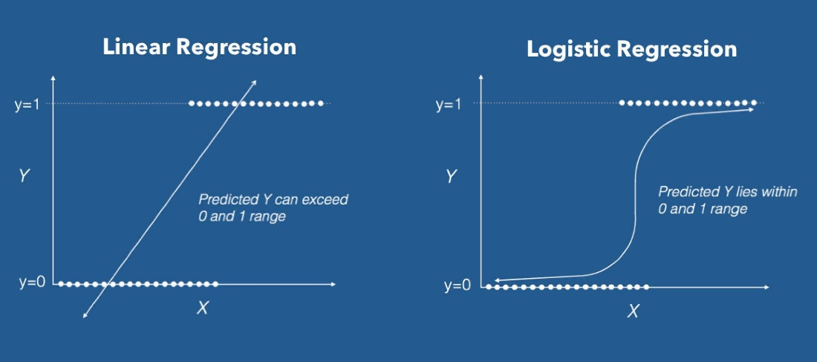

***Linear Regression VS Logistic Regression Graph***

We can call a Logistic Regression a Linear Regression model but the Logistic Regression uses a more complex cost function, this cost function can be defined as the ‘**Sigmoid function**’ or also known as the ‘logistic function’ instead of a linear function.

The hypothesis of logistic regression tends it to limit the cost function between 0 and 1. Therefore linear functions fail to represent it as it can have a value greater than 1 or less than 0 which is not possible as per the hypothesis of logistic regression.

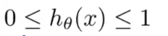

Logistic regression hypothesis expectation

## What is the Sigmoid Function?

In order to map predicted values to probabilities, we use the Sigmoid function. The function maps any real value into another value between 0 and 1. In machine learning, we use sigmoid to map predictions to probabilities.



Sigmoid Function Graph

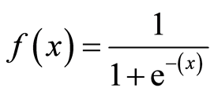

Formula of a sigmoid function | Image: Analytics India Magazine

# **Hypothesis Representation**

When using linear regression we used a formula of the hypothesis i.e.

*hΘ(x) = β₀ + β₁X*

For logistic regression we are going to modify it a little bit i.e.

*σ(Z) = σ(β₀ + β₁X)*

We have expected that our hypothesis will give values between 0 and 1.

Z = β₀ + β₁X

hΘ(x) = sigmoid(Z)

i.e. hΘ(x) = 1/(1 + e^-(β₀ + β₁X)

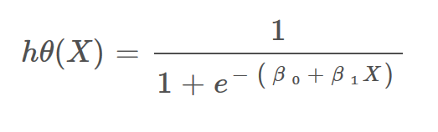

The Hypothesis of logistic regression

## Decision Boundary

We expect our classifier to give us a set of outputs or classes based on probability when we pass the inputs through a prediction function and returns a probability score between 0 and 1.

For Example, We have 2 classes, let’s take them like cats and dogs(1 — dog , 0 — cats). We basically decide with a threshold value above which we classify values into Class 1 and of the value goes below the threshold then we classify it in Class 2.

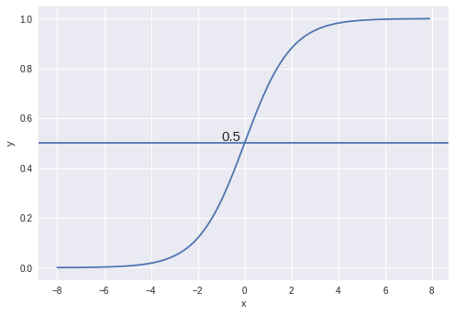

Example

As shown in the above graph we have chosen the threshold as 0.5, if the prediction function returned a value of 0.7 then we would classify this observation as Class 1(DOG). If our prediction returned a value of 0.2 then we would classify the observation as Class 2(CAT).

# Cost Function

We learnt about the cost function J(θ) in the [Linear regression](https://towardsdatascience.com/introduction-to-linear-regression-and-polynomial-regression-f8adc96f31cb), the cost function represents optimization objective i.e. we create a cost function and minimize it so that we can develop an accurate model with minimum error.

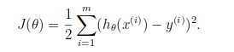

The Cost function of Linear regression

If we try to use the cost function of the linear regression in ‘Logistic Regression’ then it would be of no use as it would end up being a **non-convex** function with many local minimums, in which it would be very **difficult** to **minimize the cost value** and find the global minimum.

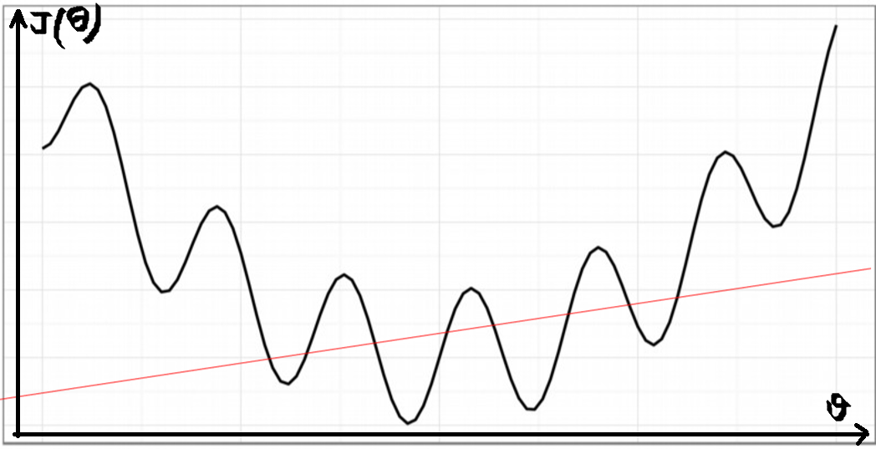

Non-convex function

For logistic regression, the Cost function is defined as:

*−log(*hθ*(*x*)) if y = 1*

*−log(1−*hθ*(*x*)) if y = 0*

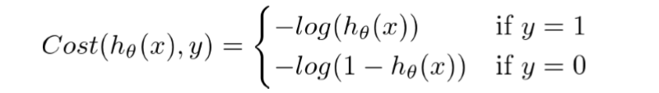

Cost function of Logistic Regression

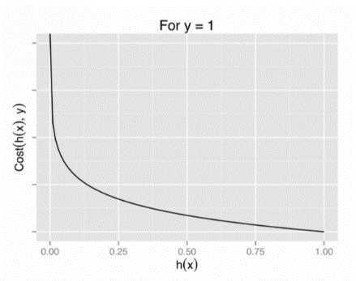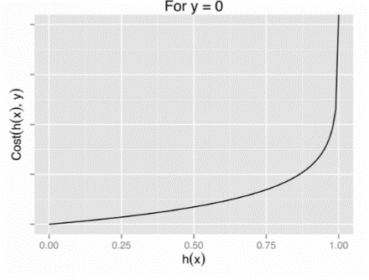

Graph of logistic regression

The above two functions can be compressed into a single function i.e.

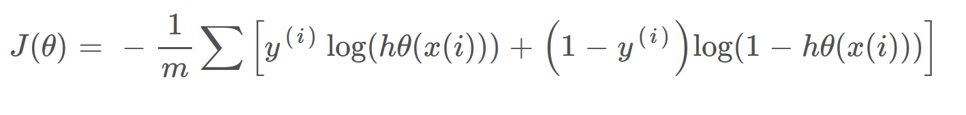

Above functions compressed into one cost function

# Gradient Descent

Now the question arises, how do we reduce the cost value. Well, this can be done by using **Gradient Descent.** The main goal of Gradient descent is to **minimize the cost value.** i.e. min J(**θ**).

Now to minimize our cost function we need to run the gradient descent function on each parameter i.e.

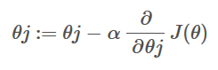

Objective: To minimize the cost function we have to run the gradient descent function on each parameter

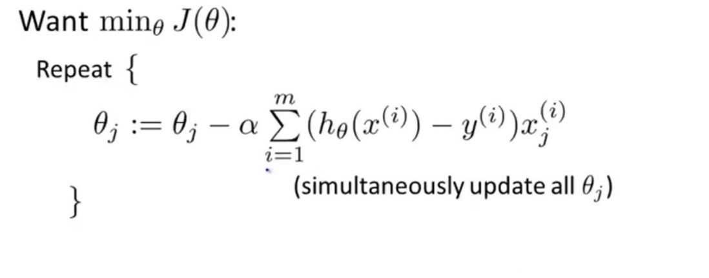

Gradient Descent Simplified

Gradient descent has an analogy in which we have to imagine ourselves at the top of a mountain valley and left stranded and blindfolded, our objective is to reach the bottom of the hill. Feeling the slope of the terrain around you is what everyone would do. Well, this action is analogous to calculating the gradient descent, and taking a step is analogous to one iteration of the update to the parameters.

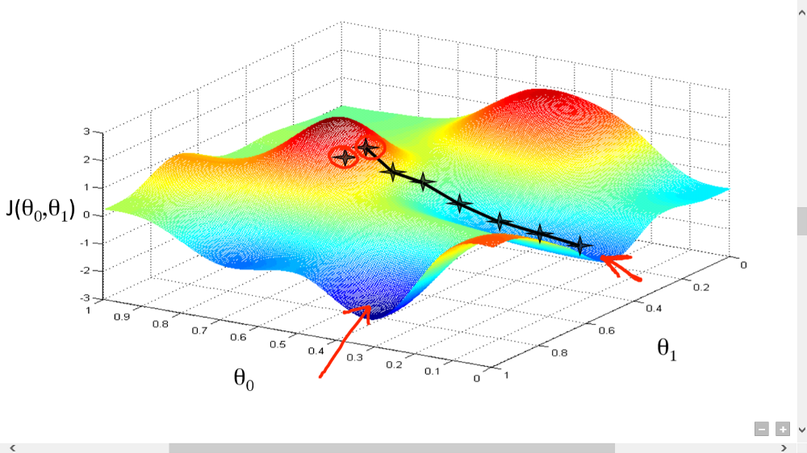

Gradient Descent analogy

# Conclusion

In this blog, I have presented you with the basic concept of Logistic Regression. I hope this blog was helpful and would have motivated you enough to get interested in the topic.

# **An Introduction to Logistic Regression**

**What is Logistic Regression?**

Logistic regression is a traditional and classic statistical model, which has been widely used in the academy and industry. Unlike linear regression, which is used to make a prediction on the numeric response, logistic regression is used to solve a classification problem. For example, when a person applies a loan from a bank, bank is interested in whether this applicant will default in the future? (default or not default)

One solution is to make a prediction on the applicant future status directly, such as Perceptron, which is foundation to SVM and Neural Network. Please read my blog on Perceptron.

The other solution, such as logistic regression, is to make a prediction on the probability that applicant will default. Due to the nature of probability, the prediction will fall in [0, 1]. By the rule of thumb, if the predicted probability is greater or equal to 0.5, then we can label this applicant as ‘default’; if the predicted probability is smaller to 0.5, then we can label this applicant as ‘not default’. However, the range of linear regression is from negative infinite to positive infinite, not in [0, 1]. Then sigmoid function is introduced to solve this problem. The expression of sigmoid function is:

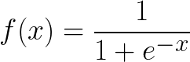

The sigmoid function gives an S-shaped curve and saturates when its argument is very positive or very negative. Take a moment to note down the formula. We will apply it later in the maximum likely estimation.

The figure of sigmoid function:

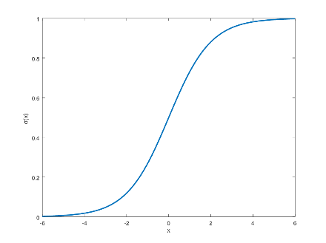

Sigmoid function has many properties, including:

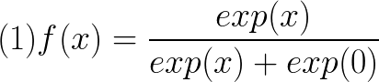

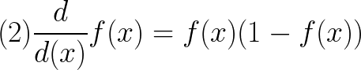

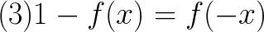

In logistic regression, we can write:

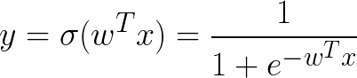

The derivative of function is shown below, which will be used to calculate gradient of cost function.

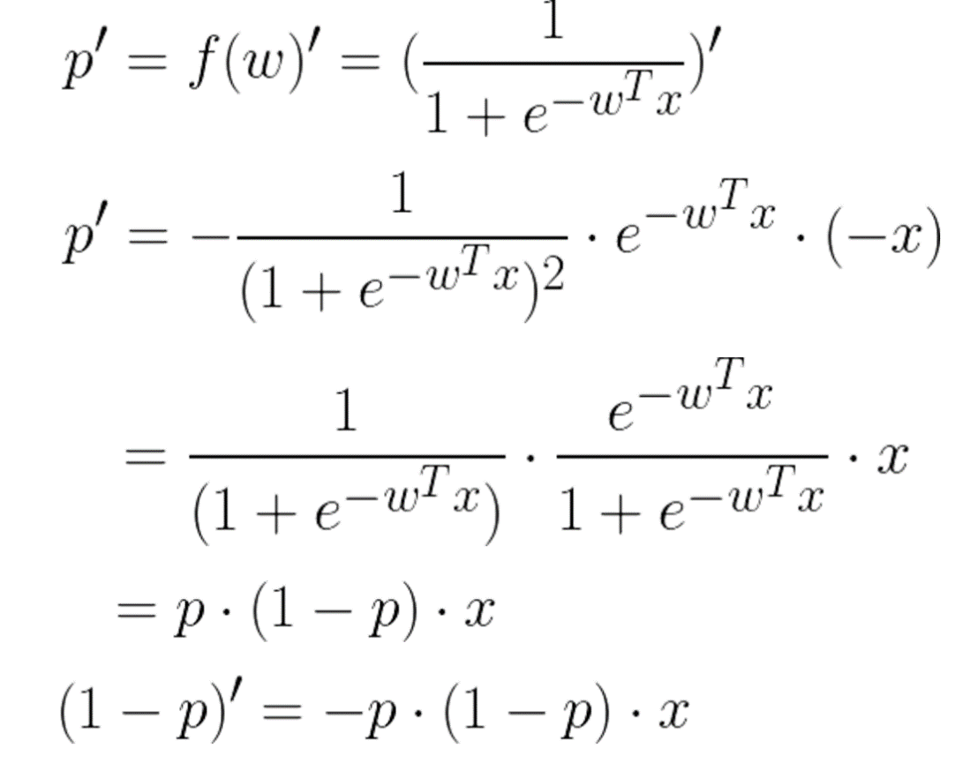

**2. Why not use Linear Regression?**

An Introduction to Statistical Learning gives a straightforward explanation why logistic regression is used for classification problem, instead of linear regression. First of all, the range of linear regression is negative infinite to positive infinite, which is out of the boundary of [0, 1]. If both linear regression and logistic regression make a prediction on the probability, linear model can even generate negative prediction, while logistic regression does not have such problem. See the figure below.

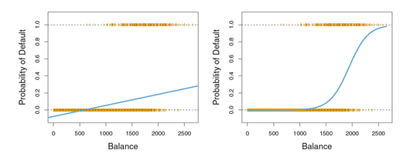

Figures Source: Gareth James, Daniela Witten, Trevor Hastie, Robert Tibshirani, 2017, An Introduction to Statistical Learning

Another problem for linear regression is that the prediction of linear model is always cardinal rather than nominal. Even though in some cases the value of response did take on a natural ordering, such as bad, neutral and good. It seems that the gap between bad and neutral is same as that between neutral and good, so it is reasonable to code bad, neutral and good into 1, 2 and 3 correspondingly. However, there is no natural or direct way to convert a nominal response into a numeric response.

**3. Maximum Likely Estimation (MLE)**

Take one sample from whole population. This record follows a Bernoulli distribution.

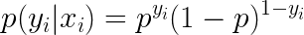

In this formula, y is an indicator either 1 or 0 and p is the probability that event happens.

What if there are N records in total and what is the probability? In brief, assuming each record is independent and identically distributed (I.I.D) we can time N records’ probability together.



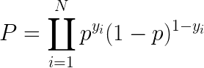

Then take a log on both sides and we can get log likelihood.

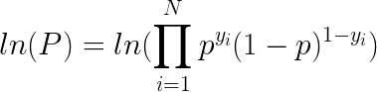

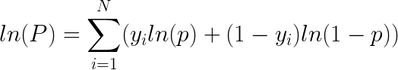

Note that in the formula, p is the parameter (probability) needs to be estimated, which equals:

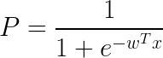

In statistics, maximum likelihood estimation (MLE) is widely used to obtain the parameter for a distribution. In this paradigm, to maximize log likelihood is equal to minimize the cost function J. It is a dual problem in Convex Optimization. The cost function J is provided below:

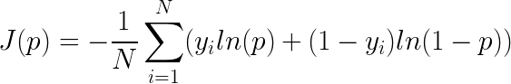

This section shows the relation between MLE and cost function and how sigmoid function is embedded in the MLE. The next question is how to calculate p and further to calculate w to minimize the cost function.

**4. Gradient Decent for Logistic Regression**

Unlike linear regression, which has a closed-form solution, gradient decent is applied in logistic regression. The general idea of gradient descent is to tweak parameters w and b iteratively to minimize a cost function. There are three typical gradient decent, including Batch Gradient Decent, Mini-batch Gradient Decent and Stochastic Gradient Decent. In this blog, Batch Gradient Decent is used.

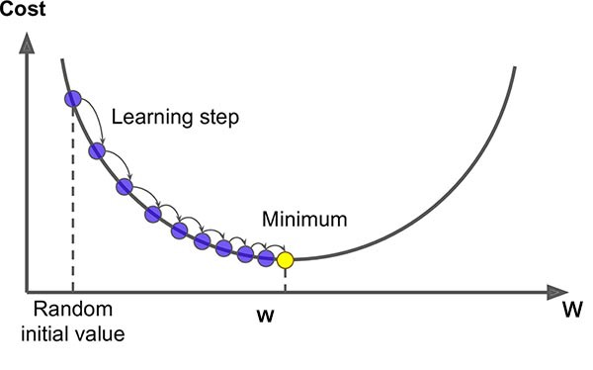

Figure Source: <https://saugatbhattarai.com.np/what-is-gradient-descent-in-machine-learning/>

The gradient of cost function **J** is:

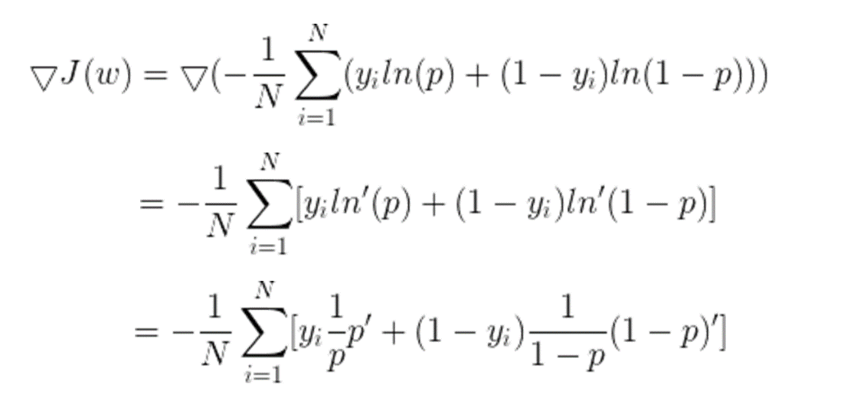

Apply derivative of sigmoid function in the first section, then we can get:

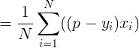

An initial value is assigned to w; then iteratively update w by Learning Rate \* Gradient of cost function. The algorithm will not stop until it converges.



**5. Implement Logistic Regression in Python**

In this part, I will use well known data iris to show how gradient decent works and how logistic regression handle a classification problem.

First, import the package

from sklearn import datasets  
import numpy as np  
import pandas as pd  
import matplotlib.pyplot as plt  
import matplotlib.lines as mlines

Next, load data. For simplicity, I only choose 2 kinds of iris.

# Load data  
iris = datasets.load\_iris()  
X=iris.data[0:99,:2]  
y=iris.target[0:99]# Plot the training points  
x\_min, x\_max = X[:, 0].min() - .5, X[:, 0].max() + .5  
y\_min, y\_max = X[:, 1].min() - .5, X[:, 1].max() + .5  
plt.figure(2, figsize=(8, 6))

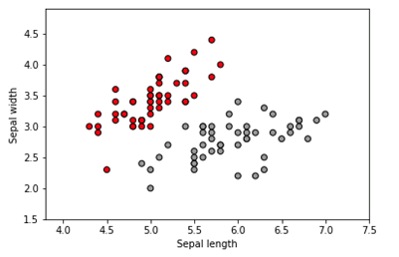

Pseudocode for gradient decent

1. Initialize the parameters  
Repeat {  
 2. Make a prediction on y  
 3. Calculate cost function  
 4. Get gradient for cost function  
 5. Update parameters  
 }

Code for gradient decent

#Step 1: Initial Model Parameter  
Learning\_Rate=0.01  
num\_iterations=100000  
N=len(X)  
w=np.zeros((2,1))  
b=0  
costs=[]for i in range(num\_iterations):  
 #Step 2: Apply sigmoid Function and get y prediction  
 Z=np.dot(w.T,X.T)+b  
 y\_pred=1/(1+1/np.exp(Z)) #Step 3: Calculate Cost Function  
 cost=-(1/N)\*np.sum(y\*np.log(y\_pred)+(1-y)\*np.log(1-y\_pred)) #Step 4: Calculate Gradient  
 dw=1/N\*np.dot(X.T,(y\_pred-y).T)  
 db=1/N\*np.sum(y\_pred-y) #Step 5: Update w & b  
 w = w - Learning\_Rate\*dw  
 b = b - Learning\_Rate\*db  
 #Records cost  
 if i%100==0:  
 costs.append(cost)  
 print(cost)

Visualize cost function over time

# Plot cost function  
Epoch=pd.DataFrame(list(range(100,100001,100)))  
Cost=pd.DataFrame(costs)  
Cost\_data=pd.concat([Epoch, Cost], axis=1)  
Cost\_data.columns=['Epoch','Cost']  
plt.scatter(Cost\_data['Epoch'], Cost\_data['Cost'])  
plt.xlabel('Epoch')  
plt.ylabel('Cost')

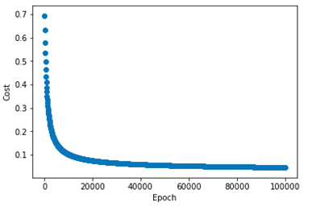

From figure above, we can see that at first the cost decreases dramatically; after 40,000 rounds of iteration, it becomes stable.

Visualize linear classification

# Plot linear classification  
fig, ax = plt.subplots()  
ax.scatter(X[:, 0], X[:, 1], c=y, cmap=plt.cm.Set1,edgecolor='k')  
line=mlines.Line2D([3.701,7],[2,4.1034],color='red')  
ax.add\_line(line)  
ax.set\_xlabel('Sepal length')  
ax.set\_ylabel('Sepal width')  
plt.show()

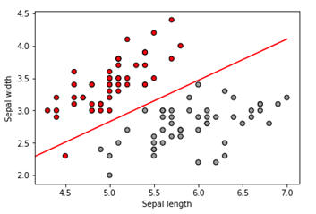

The red line in the figure above is the decision boundary of logistic regression. Because the iris data only contains 2 dimensions, so the decision boundary is a line. In some cases when there are 3 or more dimensions, the decision boundary will be a hyperplane.

**Summary**

In this blog, I explain logistic regression from theory to practice. Hope you have a better understanding of logistic regression after reading this blog. If you have interest in other blogs, please click on the following link:

## [A Tour of Machine Learning and Deep Learning](https://medium.com/@songyangdetang_41589/table-of-contents-689c8af0c731" \t "_blank)

### **[This series of blogs will have an introduction on the deep learning from both theory and implementation aspect.](https://medium.com/@songyangdetang_41589/table-of-contents-689c8af0c731" \t "_blank)**

#### **[medium.com](https://medium.com/@songyangdetang_41589/table-of-contents-689c8af0c731" \t "_blank)**

**Reference**

[1] Ian Goodfellow, Yoshua Bengio, Aaron Courville, (2017) Deep Learning

[2] Gareth James, Daniela Witten, Trevor Hastie, Robert Tibshirani, (2017) An Introduction to Statistical Learning

[3] <https://en.wikipedia.org/wiki/Gradient_descent>

# **Real world implementation of Logistic Regression**

Classification techniques are an essential part of machine learning and data mining applications. Approximately 70% of problems in Data Science are classification problems. A popular classification technique to predict binomial outcomes (y = 0 or 1) is called Logistic Regression. Logistic regression predicts categorical outcomes (binomial/multinomial values of y), whereas linear Regression is good for predicting continuous-valued outcomes (such as the weight of a person in kg, the amount of rainfall in cm).

I have divided this article into 3 parts. In the first part we’ll take a look at some of the important concepts of Logistic Regression, In the second part we’ll build a Binary classifier and in the third part, we’ll build a Multiclass classifier.

**Table of Content:**

* Logistic Regression
* Maximum Likelihood Estimation Vs. Ordinary Least Square Method
* Sigmoid Function
* Logistic Regression assumptions
* Binary Logistic Regression model building in Scikit-learn
* Model Evaluation using Confusion Matrix
* Multiclass Logistic Regression model building in Scikit-learn
* Model Evaluation using Confusion Matrix
* Advantages and Disadvantages of Logistic Regression

# Logistic Regression

Logistic regression is a statistical method for predicting binary classes. The outcome or target variable is binary in nature. For example, it can be used for cancer detection problems. It computes the probability of an event occurrence.

It is a special case of linear regression where the target variable is categorical in nature. It uses a log of odds as the dependent variable. Logistic Regression predicts the probability of occurrence of a binary event utilizing a logit function.

Linear Regression Equation:

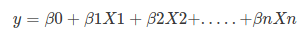

Where, y is dependent variable and x1, x2 … and Xn are explanatory variables.

Sigmoid Function:

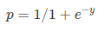

Apply Sigmoid function on linear regression:

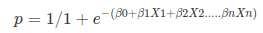

Properties of Logistic Regression:

* The dependent variable in logistic regression follows Bernoulli Distribution.
* Estimation is done through maximum likelihood.
* No R Square, Model fitness is calculated through Concordance, KS-Statistics.

# Maximum Likelihood Estimation

The MLE is a “likelihood” maximization method, while OLS is a distance-minimizing approximation method. Maximizing the likelihood function determines the parameters that are most likely to produce the observed data. From a statistical point of view, MLE sets the mean and variance as parameters in determining the specific parametric values for a given model. This set of parameters can be used for predicting the data needed in a normal distribution.

# Sigmoid Function

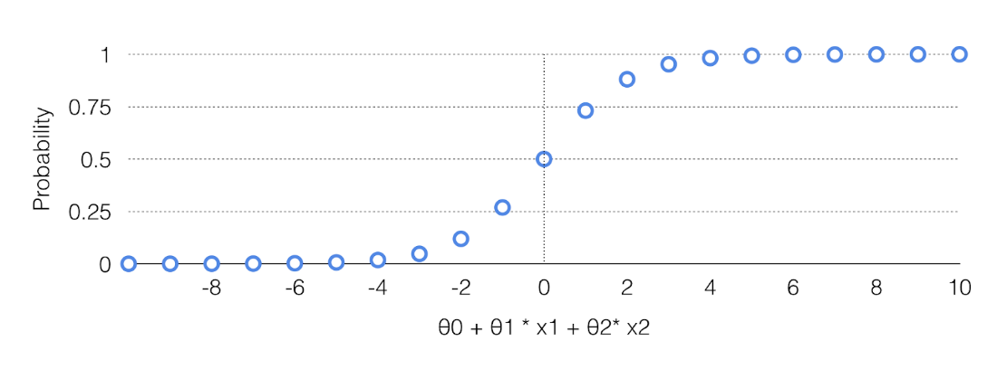

[Sigmoid curve](https://blog.clearbrain.com/posts/how-to-predict-yesno-outcomes-using-logistic-regression)

The sigmoid function also called the logistic function gives an ‘S’ shaped curve that can take any real-valued number and map it into a value between 0 and 1. If the curve goes to positive infinity, y predicted will become 1, and if the curve goes to negative infinity, y predicted will become 0. If the output of the sigmoid function is more than 0.5, we can classify the outcome as 1 or YES, and if it is less than 0.5, we can classify it like 0 or NO. If the output is 0.75, we can say in terms of probability as: There is a 75 percent chance that patient will suffer from cancer.

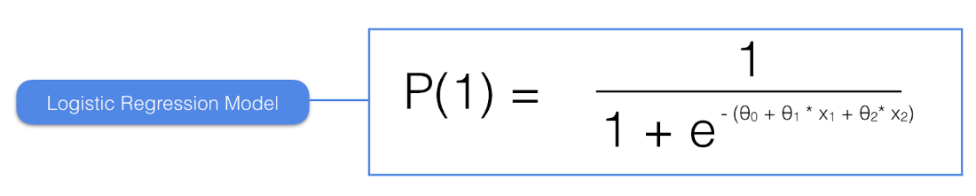

[Sigmoid function](https://blog.clearbrain.com/posts/how-to-predict-yesno-outcomes-using-logistic-regression)

The sigmoid curve has a finite limit of:

‘0’ as x approaches −∞

‘1’ as x approaches +∞

The output of sigmoid function when x=0 is 0.5

Thus, if the output is more tan 0.5, we can classify the outcome as 1 (or YES) and if it is less than 0.5, we can classify it as 0(or NO).

For example: If the output is 0.65, we can say in terms of probability as:

“There is a 65 percent chance that your favorite cricket team is going to win today ”.

# Logistic Regression Assumptions

* Binary logistic regression requires the dependent variable to be binary.
* For a binary regression, the factor level 1 of the dependent variable should represent the desired outcome.
* Only meaningful variables should be included.
* The independent variables should be independent of each other. That is, the model should have little or no multicollinearity.
* The independent variables are linearly related to the log odds.
* Logistic regression requires quite large sample sizes.

# Binary Logistic Regression model building in Scikit learn

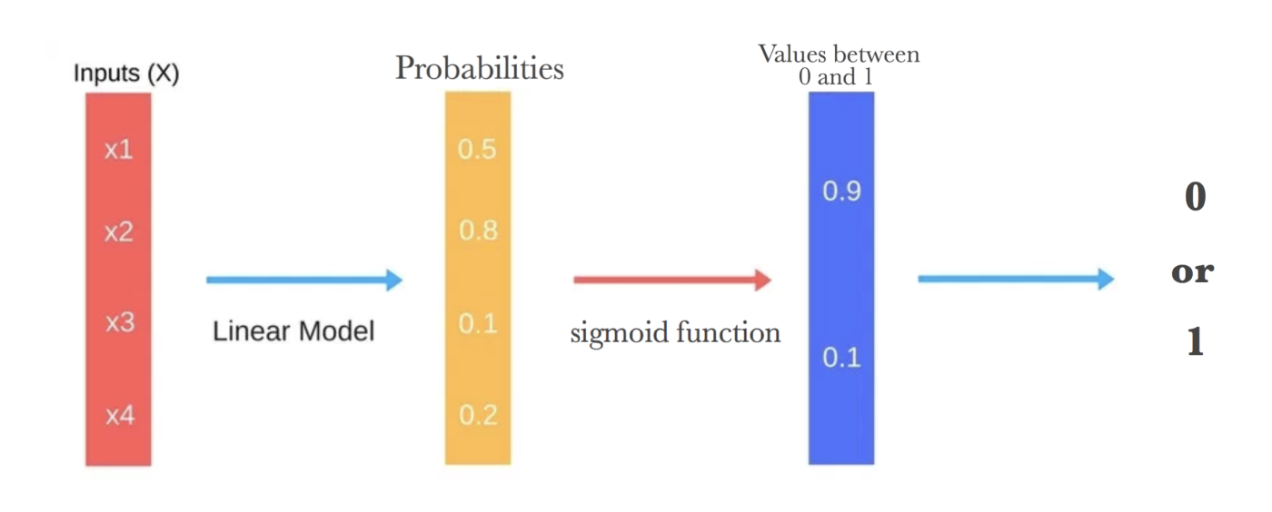

[Binary Classification](https://machinelearning-blog.com/2018/04/23/logistic-regression-101/)

A **Binary** **logistic regression** (often referred to simply as **logistic regression**), predicts the probability that an observation falls into one of two categories of a dichotomous dependent variable based on one or more independent variables that can be either continuous or categorical.

In this example, a magazine reseller is trying to decide what magazines to market to customers. In the “old days,” this might have involved trying to decide which customers to send advertisements to via regular mail. In the context of today and the “web,” this might involved deciding what recommendations to make to a customer viewing a web page about other items that the customer might be interested in and therefore want to buy. The two problems are essentially the same.

You can download the dataset from [here](https://drive.google.com/open?id=1otpWibylJ3QVMoaQW9_kunHQ9NGU1dvr).

Here are the variables that magazine reseller has on each customer from third-party sources:

* Household Income (Income; rounded to the nearest $1,000.00)
* Gender (IsFemale = 1 if the person is female, 0 otherwise)
* Marital Status (IsMarried = 1 if married, 0 otherwise)
* College Educated (HasCollege = 1 if has one or more years of college education, 0 otherwise)
* Employed in a Profession (IsProfessional = 1 if employed in a profession, 0 otherwise)
* Retired (IsRetired = 1 if retired, 0 otherwise)
* Not employed (Unemployed = 1 if not employed, 0 otherwise)
* Length of Residency in Current City (ResLength; in years)
* Dual Income if Married (Dual = 1 if dual income, 0 otherwise)
* Children (Minors = 1 if children under 18 are in the household, 0 otherwise)
* Home ownership (Own = 1 if own residence, 0 otherwise)
* Resident type (House = 1 if the residence is a single-family house, 0 otherwise)
* Race (White = 1 if the race is white, 0 otherwise)
* Language (English = 1 is the primary language in the household is English, 0 otherwise)

With this dataset, we will be building a binary classification model which will take above inputs as features and predict if the customer will buy the magazine or not. At last, we’ll evaluate our model using the [confusion matrix](https://en.wikipedia.org/wiki/Confusion_matrix).

step 1. Import all the required libraries

import numpy as np  
import pandas as pd  
import matplotlib.pyplot as plt  
import seaborn as sns  
from sklearn.model\_selection import train\_test\_split   
from sklearn.linear\_model import LogisticRegression  
from sklearn import metrics  
%matplotlib inline  
import warnings  
warnings.filterwarnings('ignore')

step 2. Load the dataset and check

kidDataset = pd.read\_csv("/Users/nageshsinghchauhan/Documents/projects/ML/logisticRegression/Kid.csv")  
kidDataset.head()

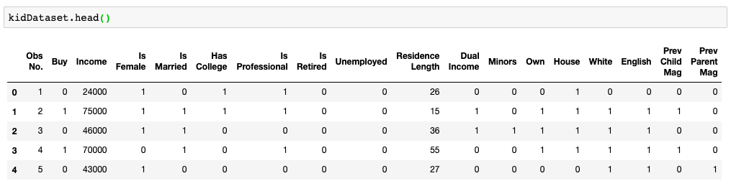

original dataset

If we run kidDataset.shape and we will get the number of rows and columns. For this case, there are 673 rows and 18 columns.

step 3. Remove first column “Obs No.” as it doesn’t have any relevance.

kidDataset.drop(columns=['Obs No.'])

step 4. Check for null values anywhere in our dataset. If you have zero values for all the columns then it meant we don’t have any null value in any of the columns.

kidDataset.isnull().sum()

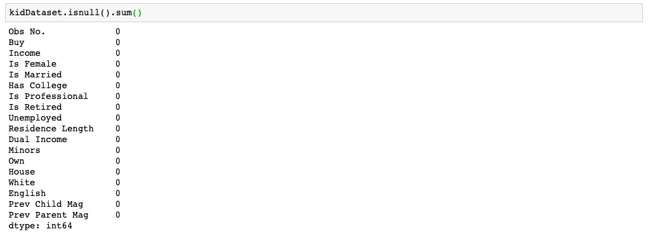

To check for null values

step 4. Let us explore our target variable and visualize it.

kidDataset.Buy.value\_counts()  
sns.countplot(x = 'Buy', data = kidDataset, palette = 'hls')  
plt.show()

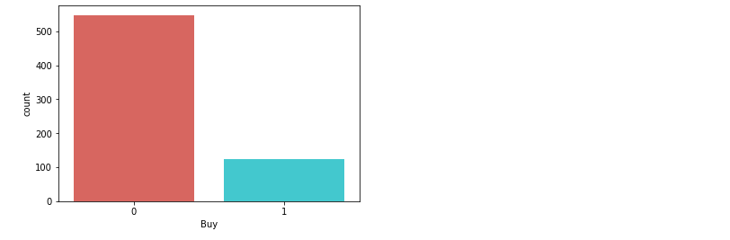

Pictorial representation of target variable

step 5. Here we need to divide the given data into two types of variables dependent(or target variable) and independent variable(or feature variables).

X = kidDataset[['Income', 'Is Female', 'Is Married', 'Has College', 'Is Professional', 'Is Retired', 'Unemployed', 'Residence Length', 'Dual Income','Minors','Own', 'House','White',  
'English', 'Prev Child Mag', 'Prev Parent Mag']]  
y = kidDataset['Buy']

step 6. Next, we split 80% of the data into training set while 20% of the data to test set using below code.  
The **test\_size** variable is where we actually specify the proportion of the test set.

X\_train,X\_test,y\_train,y\_test=train\_test\_split(X,y,test\_size=0.20,random\_state=0)

step 7. Instantiate the Logistic Regression model using default and use fit() function to train your model.

logreg = LogisticRegression()logreg.fit(X\_train,y\_train)

step 8. Now that we have trained our algorithm, it’s time to make some predictions. To do so, we will use our test data and see how accurately our algorithm predicts the percentage score. To make predictions on the test data, execute the following script:

y\_pred=logreg.predict(X\_test)

**Model Evaluation using Confusion Matrix**

Let’s talk about the confusion matrix little bit. A confusion matrix is a table that is often used to **describe the performance of a classification model** on a set of test data for which the true values are known.

Few terms to remember in the context of confusion matrix, refer the table below:

* **true positives (TP):** These are cases in which we predicted yes and are actually yes.
* **true negatives (TN):** We predicted no, and no in actual.
* **false positives (FP):** We predicted yes, but actual is no. (Type I error)
* **false negatives (FN):** We predicted no, yes in actual. (Type II error)

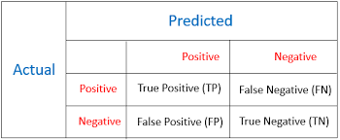

[Confusion matrix](https://www.analyticsvidhya.com/blog/2016/03/practical-guide-deal-imbalanced-classification-problems/cost1/)

There is also a list of rates that are often computed from a confusion matrix for a binary classifier:

* **Accuracy:** Overall, how often is the classifier correct?

*Accuracy = (TP+TN)/total*

* **Misclassification Rate(Error Rate):** Overall, how often is it wrong?

*Misclassification Rate =**(FP+FN)/total*

* **True Positive Rate(Sensitivity or Recall):** When it’s actually yes, how often does it predict yes?

*True Positive Rate =**TP/actual yes*

* **False Positive Rate:** When it’s actually no, how often does it predict yes?

*False Positive Rate=FP/actual no*

* **True Negative Rate(Specificity):** When it’s actually no, how often does it predict no?

*True Negative Rate=TN/actual no*

* **Precision:** When it predicts yes, how often is it correct?

*Precision=TP/predicted yes*

* **Prevalence:** How often does the yes condition actually occur in our sample?

*Prevalence=actual yes/total*

Now let's get back to our original problem.

So let us compute the confusion matrix taking parameters test data of target variable and predicted target data.

cnf\_matrix = metrics.confusion\_matrix(y\_test, y\_pred)  
cnf\_matrix

Output :

array([[106, 8],  
 [ 3, 18]])

Here, you can see the confusion matrix in the form of the array object. The dimension of this matrix is 2\*2 because this model is a binary classification. You have two classes 0 and 1. Diagonal values represent accurate predictions, while non-diagonal elements are inaccurate predictions. In the output, 106 and 18 are actual predictions, and 8 and 3 are incorrect predictions.

## Visualizing Confusion Matrix using Heatmap

Let’s visualize the results of the model in the form of a confusion matrix using matplotlib and seaborn.

Here, you will visualize the confusion matrix using Heatmap.

fig, ax = plt.subplots()  
tick\_marks = np.arange(len(class\_names))  
plt.xticks(tick\_marks, class\_names)  
plt.yticks(tick\_marks, class\_names)  
sns.heatmap(pd.DataFrame(cnf\_matrix), annot=True, cmap="viridis" ,fmt='g')  
ax.xaxis.set\_label\_position("top")  
plt.tight\_layout()  
plt.title('Confusion matrix', y=1.1)  
plt.ylabel('Actual label')  
plt.xlabel('Predicted label')

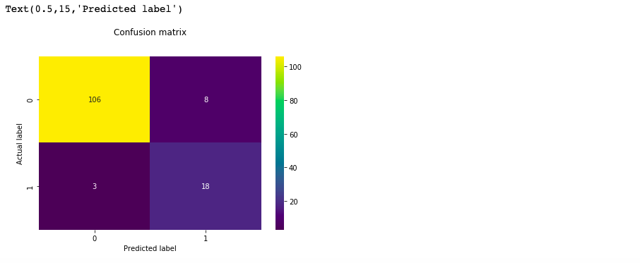

Confusion matrix

## Confusion Matrix Evaluation Metrics

Let’s evaluate the model using model evaluation metrics such as accuracy, precision, and recall.

print("Accuracy:",metrics.accuracy\_score(y\_test, y\_pred))  
print("Precision:",metrics.precision\_score(y\_test, y\_pred))  
print("Recall:",metrics.recall\_score(y\_test, y\_pred))

It should give output as :

('Accuracy:', 0.9185185185185185)  
('Precision:', 0.6923076923076923)  
('Recall:', 0.8571428571428571)

Well, our binary classification model predicted the outcome with 91% accuracy which is considered as good.

**Precision**: Precision is about being precise, i.e., how accurate your model is. In other words, you can say, when a model makes a prediction, how often it is correct. In your prediction case, when your Logistic Regression model predicted customers will buy the magazine 69% of the time.

**Recall or Sensitivity**: If there are customers that bought the magazine in test data and your Logistic Regression model can identify it 85% of the time.

## ROC Curve

Receiver Operating Characteristic(ROC) curve is a plot of the true positive rate(Recall) against the false positive rate. It shows the tradeoff between sensitivity and specificity.

y\_pred\_proba = logreg.predict\_proba(X\_test)[::,1]  
fpr, tpr, \_ = metrics.roc\_curve(y\_test, y\_pred\_proba)  
auc = metrics.roc\_auc\_score(y\_test, y\_pred\_proba)  
plt.plot(fpr,tpr,label="data 1, auc="+str(auc))  
plt.legend(loc=4)  
plt.show()

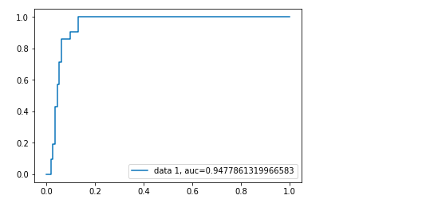

ROC Curve

AUC(Area Under Curve) score for the case is 0.94. AUC score 1 represents perfect classifier, and 0.5 represents a worthless classifier.

# Multiclass Logistic Regression model building in scikit-learn

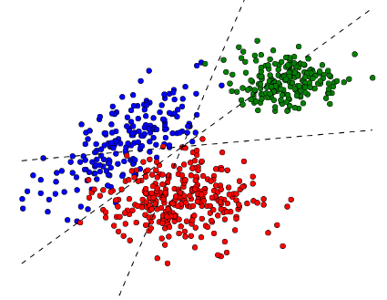

[Multiclass classification](http://dalab.github.io/dissolve-struct/examples/multiclass-classification/)

**A Multiclass logistic regression** is a classification method that generalizes logistic regression to multiclass problems, i.e. with more than two possible discrete outcomes.

Let's implement multiclass logistic regression on data produced by Cardiotocograph. After taking into consideration all the parameters our classifier will predict the fetal state class code(NSP). NSP has 3 classes namely N=normal; S=suspect; P=pathologic

***Cardiotocography*** *(****CTG****) is a technical means of recording the* [*fetal heartbeat*](https://en.wikipedia.org/wiki/Fetal_heartbeat) *and the* [*uterine contractions*](https://en.wikipedia.org/wiki/Uterine_contractions) *during* [*pregnancy*](https://en.wikipedia.org/wiki/Pregnancy)*. The machine used to perform the monitoring is called a cardiotocograph, more commonly known as an electronic fetal monitor (EFM).*

— Wikipedia

[cardiotocograph](https://en.wikipedia.org/wiki/Cardiotocography#/media/File:Cardiotocography_diagram.jpg)

You can download the dataset from [UCI machine learning repository](https://archive.ics.uci.edu/ml/datasets/cardiotocography).

Following are the attributes from the dataset.

LB — FHR baseline (beats per minute)  
AC — # of accelerations per second  
FM — # of fetal movements per second  
UC — # of uterine contractions per second  
DL — # of light decelerations per second  
DS — # of severe decelerations per second  
DP — # of prolongued decelerations per second  
ASTV — percentage of time with abnormal short term variability  
MSTV — mean value of short term variability  
ALTV — percentage of time with abnormal long term variability  
MLTV — mean value of long term variability  
Width — width of FHR histogram  
Min — minimum of FHR histogram  
Max — Maximum of FHR histogram  
Nmax — # of histogram peaks  
Nzeros — # of histogram zeros  
Mode — histogram mode  
Mean — histogram mean  
Median — histogram median  
Variance — histogram variance  
Tendency — histogram tendency  
CLASS — FHR pattern class code (1 to 10)  
NSP — fetal state class code (N=normal; S=suspect; P=pathologic)

Let's start coding…

step 1. Import all the required libraries.

import numpy as np  
import pandas as pd  
import matplotlib.pyplot as plt  
import seaborn as sns  
sns.set(style="ticks", color\_codes=True)  
from sklearn.model\_selection import train\_test\_split   
from sklearn.linear\_model import LogisticRegression  
from sklearn.metrics import roc\_auc\_score  
from sklearn.preprocessing import LabelBinarizer  
from sklearn import metrics  
%matplotlib inline  
import warnings  
warnings.filterwarnings('ignore')

step 2. Load the dataset

data = pd.read\_excel("/Users/nageshsinghchauhan/Documents/projects/ML/logisticRegression/CTG.xls", sheetname='Raw Data')

If we run dataset.shape and we will get the number of rows and columns. For this case, there are 2130 rows and 40 columns.

step 3. Now let's drop irrelevant columns

dataset\_rmvCol = data.drop(columns=['FileName', 'SegFile', 'Date'])

step 4. Remove all the Null values from the dataset

finaldata = dataset\_rmvCol.dropna()

step 5. Explore the target data and visualize it.

sns.countplot(x = 'NSP', data = finaldata, palette = 'hls')  
plt.show()



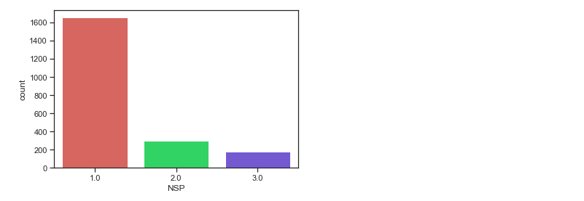

pictorial representation of target data

step 6. Now divide the given data into two types of variables dependent(or target variable) and independent variable(or feature variables).

X = finaldata[['b', 'e', 'LBE', 'LB', 'AC', 'FM', 'UC', 'ASTV', 'MSTV', 'ALTV', 'MLTV','DL', 'DS', 'DP', 'DR', 'Width', 'Min', 'Max', 'Nmax','Nzeros', 'Mode', 'Mean', 'Median', 'Variance', 'Tendency', 'A', 'B', 'C', 'D', 'E', 'AD', 'DE', 'LD', 'FS', 'SUSP', 'CLASS']]  
y = finaldata['NSP']

step 7. Next, we split 75% of the data to training set while 25% of the data to test set using below code.

X\_train,X\_test,y\_train,y\_test=train\_test\_split(X,y,test\_size=0.25,random\_state=0)

step 8. Instantiate the Logistic Regression model using default and use fit() function to train your model.

logreg = LogisticRegression()logreg.fit(X\_train,y\_train)

step 9. Now that we have trained our algorithm, it’s time to make some predictions.

y\_pred=logreg.predict(X\_test)

## **Model Evaluation using Confusion Matrix**

cnf\_matrix = metrics.confusion\_matrix(y\_test, y\_pred)  
cnf\_matrixoutput :  
array([[404, 2, 4],  
 [ 24, 48, 0],  
 [ 2, 10, 38]])

Here, you can see the confusion matrix in the form of the array object. The dimension of this matrix is 3\*3 as this is a multiclass classifier. You have three classes 1,2 and 3. Diagonal values represent accurate predictions, while non-diagonal elements are inaccurate predictions. In the output, 404, 48 and 38 are actual predictions, while rest all are incorrect predictions.

## Visualizing Confusion Matrix using Heatmap

Let’s visualize the results of the model in the form of a confusion matrix using matplotlib and seaborn.

Here, you will visualize the confusion matrix using Heatmap.

class\_names=[1,2,3]  
fig, ax = plt.subplots()  
tick\_marks = np.arange(len(class\_names))  
plt.xticks(tick\_marks, class\_names)  
plt.yticks(tick\_marks, class\_names)  
sns.heatmap(pd.DataFrame(cnf\_matrix), annot=True, cmap="coolwarm" ,fmt='g')  
ax.xaxis.set\_label\_position("top")  
plt.tight\_layout()  
plt.title('Confusion matrix', y=1.1)  
plt.ylabel('Actual label')  
plt.xlabel('Predicted label')



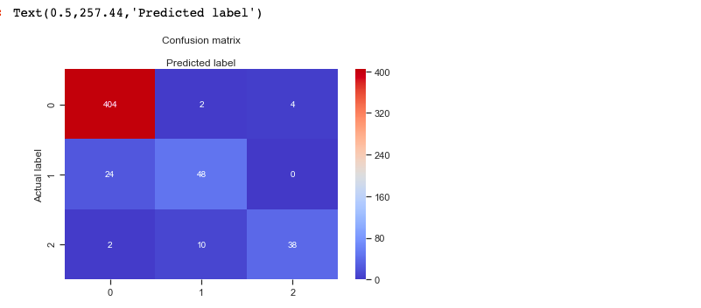

Confusion matrix of a multiclass classifier

Also let's check the accuracy of the model.

print("Accuracy:",metrics.accuracy\_score(y\_test, y\_pred))output :   
('Accuracy:', 0.9210526315789473)

Well, our Multiclass classification model predicted the outcome with 92% accuracy which is considered quite good.

Let's check how much area is under the ROC curve

def multiclass\_roc\_auc\_score(y\_test, y\_pred, average="macro"):  
 lb = LabelBinarizer()  
 lb.fit(y\_test)  
 y\_test = lb.transform(y\_test)  
 y\_pred = lb.transform(y\_pred)  
 return roc\_auc\_score(y\_test, y\_pred, average=average)auc = multiclass\_roc\_auc\_score(y\_test, y\_pred, average="macro")  
print("Area under curve : ", auc)

It should give output as :

('Area under curve : ', 0.8607553424197302)

AUC(Area Under Curve) score for the case is 0.86. AUC score 1 represents perfect classifier, and 0.5 represents a worthless classifier.

# Advantages and Disadvantages of Logistic Regression

## **Advantages :**

It is a widely used technique because it is very efficient, does not require too many computational resources, it’s highly interpretable, it doesn’t require input features to be scaled, it doesn’t require any tuning, it’s easy to regularize, and it outputs well-calibrated predicted probabilities.

Logistic regression does work better when you remove attributes that are unrelated to the output variable as well as attributes that are very similar (correlated) to each other. Therefore Feature Engineering plays an important role in regards to the performance of Logistic and also Linear Regression.

Because of its simplicity and the fact that it can be implemented relatively easy and quick, Logistic Regression is also a good baseline that you can use to measure the performance of other more complex Algorithms.

## Disadvantages :

Logistic Regression is also not one of the most powerful algorithms out there and can be easily outperformed by more complex ones.

Also, we can’t solve non-linear problems with logistic regression since it’s decision surface is linear.

Logistic regression will not perform well with independent variables that are not correlated to the target variable and are very similar or correlated to each other.

# Conclusion

In this tutorial, we covered a lot of details about Logistic Regression. we have learned what the logistic regression is, how to build both binary and multiclass classifiers, how to visualize results and some of the theoretical background information. Also, we covered some basic concepts such as the sigmoid function, maximum likelihood, confusion matrix, ROC curve, AUC.

# 06: Logistic Regression

[Previous](http://www.holehouse.org/mlclass/05_Octave.html) [Next](http://www.holehouse.org/mlclass/07_Regularization.html) [Index](http://www.holehouse.org/mlclass/index.html)

**Classification**

* Where y is a discrete value
  + Develop the logistic regression algorithm to determine what class a new input should fall into
* Classification problems
  + Email -> spam/not spam?
  + Online transactions -> fraudulent?
  + Tumor -> Malignant/benign
* Variable in these problems is Y
  + Y is either 0 or 1
    - 0 = negative class (absence of something)
    - 1 = positive class (presence of something)
* Start with **binary class problems**
  + Later look at multiclass classification problem, although this is just an extension of binary classification
* How do we develop a classification algorithm?
  + Tumour size vs malignancy (0 or 1)
  + We *could* use linear regression
    - Then threshold the classifier output (i.e. anything over some value is yes, else no)
    - In our example below linear regression with thresholding seems to work

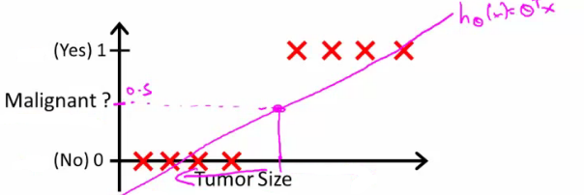

* We can see above this does a reasonable job of stratifying the data points into one of two classes
  + But what if we had a single Yes with a very small tumour
  + This would lead to classifying all the existing yeses as nos
* Another issues with linear regression
  + We know Y is 0 or 1
  + Hypothesis can give values large than 1 or less than 0
* So, logistic regression generates a value where is always either 0 or 1
  + Logistic regression is a **classification algorithm** - don't be confused

**Hypothesis representation**

* What function is used to represent our hypothesis in classification
* We want our classifier to output values between 0 and 1
  + When using linear regression we did hθ(x) = (θ*T* x)
  + For classification hypothesis representation we do hθ(x) = g((θ*T* x))
    - Where we define g(z)
      * z is a real number
    - g(z) = 1/(1 + e*-z*)
      * This is the **sigmoid function**, or the **logistic function**
    - If we combine these equations we can write out the hypothesis as  
      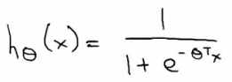
* What does the sigmoid function look like
* Crosses 0.5 at the origin, then flattens out]
  + Asymptotes at 0 and 1

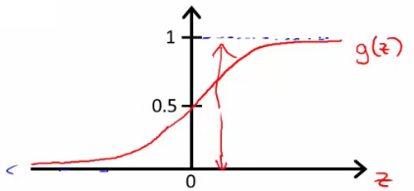

* Given this we need to fit θ to our data

**Interpreting hypothesis output**

* When our hypothesis (hθ(x)) outputs a number, we treat that value as the estimated probability that y=1 on input x
  + Example
    - If X is a feature vector with x0 = 1 (as always) and x1 = tumourSize
    - hθ(x) = 0.7
      * Tells a patient they have a 70% chance of a tumor being malignant
  + We can write this using the following notation
    - hθ(x) = P(y=1|x ; θ)
  + What does this mean?
    - Probability that y=1, given x, parameterized by θ
* Since this is a binary classification task we know y = 0 or 1
  + So the following must be true
    - P(y=1|x ; θ) + P(y=0|x ; θ) = 1
    - P(y=0|x ; θ) = 1 - P(y=1|x ; θ)

**Decision boundary**

* Gives a better sense of what the hypothesis function is computing
* Better understand of what the hypothesis function looks like
  + One way of using the sigmoid function is;
    - When the probability of y being 1 is greater than 0.5 then we can predict y = 1
    - Else we predict y = 0
  + When is it exactly that hθ(x) is greater than 0.5?
    - Look at sigmoid function
      * g(z) is greater than or equal to 0.5 when z is greater than or equal to 0  
        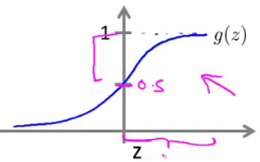
    - So if z is positive, g(z) is greater than 0.5
      * z = (θ*T* x)
    - So when
      * θ*T* x >= 0
    - Then hθ >= 0.5
* So what we've shown is that the hypothesis predicts y = 1 when θ*T* x >= 0
  + The corollary of that when θ*T* x <= 0 then the hypothesis predicts y = 0
  + Let's use this to better understand how the hypothesis makes its predictions

**Decision boundary**

* hθ(x) = g(θ0 + θ1x1 + θ2x2)

**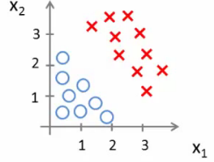**

* So, for example
  + θ0 = -3
  + θ1 = 1
  + θ2 = 1
* So our parameter vector is a column vector with the above values
  + So, θ*T* is a row vector = [-3,1,1]
* What does this mean?
  + The z here becomes θ*T* x
  + We predict "y = 1" if
    - -3x0 + 1x1 + 1x2 >= 0
    - -3 + x1 + x2 >= 0
* We can also re-write this as
  + If (x1 + x2 >= 3) then we predict y = 1
  + If we plot
    - x1 + x2 = 3 we graphically plot our **decision boundary**

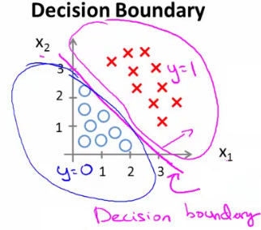

* Means we have these two regions on the graph
  + Blue = false
  + Magenta = true
  + Line = decision boundary
    - Concretely, the straight line is the set of points where hθ(x) = 0.5 exactly
  + The decision boundary is a property of the hypothesis
    - Means we can create the boundary with the hypothesis and parameters without any data
      * Later, we use the data to determine the parameter values
    - i.e. y = 1 if
      * 5 - x1 > 0
      * 5 > x1

**Non-linear decision boundaries**

* Get logistic regression to fit a complex non-linear data set
  + Like polynomial regress add higher order terms
  + So say we have
    - hθ(x) = g(θ0 + θ1x1+ θ3x12 + θ4x22)
    - We take the transpose of the θ vector times the input vector
      * Say θT was [-1,0,0,1,1] then we say;
      * Predict that "y = 1" *if*
        + -1 + x12 + x22 >= 0  
          or
        + x12 + x22 >= 1
      * If we plot x12 + x22 = 1
        + This gives us a circle with a radius of 1 around 0

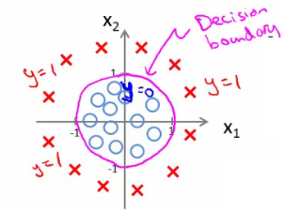

* Mean we can build more complex decision boundaries by fitting complex parameters to this (relatively) simple hypothesis
* More complex decision boundaries?
  + By using higher order polynomial terms, we can get even more complex decision boundaries

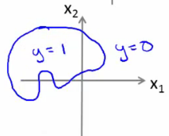

**Cost function for logistic regression**

* Fit θ parameters
* Define the optimization object for the cost function we use the fit the parameters
  + Training set of *m* training examples
    - Each example has is n+1 length column vector

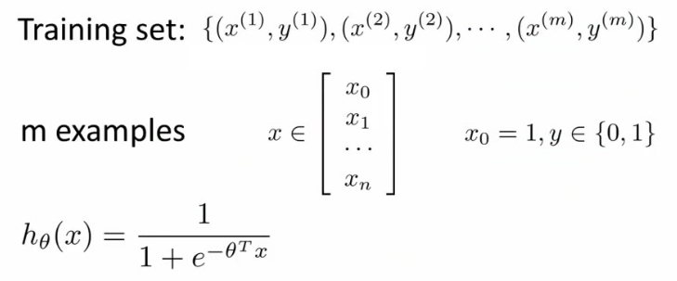

* This is the situation
  + Set of m training examples
  + Each example is a feature vector which is n+1 dimensional
  + x0 = 1
  + y ∈ {0,1}
  + Hypothesis is based on parameters (θ)
    - Given the training set how to we chose/fit θ?
* Linear regression uses the following function to determine θ

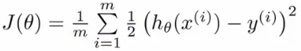

* Instead of writing the squared error term, we can write
  + If we define "cost()" as;
    - cost(hθ(xi), y) = 1/2(hθ(xi) - yi)2
    - Which evaluates to the cost for an individual example using the same measure as used in linear regression
  + We can **redefine J(θ) as**  
    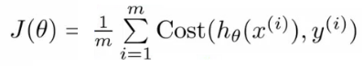
    - Which, appropriately, is the sum of all the individual costs over the training data (i.e. the same as linear regression)
* To further simplify it we can get rid of the superscripts
  + So  
    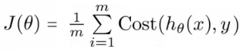
* What does this actually mean?
  + This is the cost you want the learning algorithm to pay if the outcome is hθ(x) and the actual outcome is y
  + If we use this function for logistic regression this is a **non-convex function** for parameter optimization
    - Could work....
* What do we mean by non convex?
  + We have some function - J(θ) - for determining the parameters
  + Our hypothesis function has a non-linearity (sigmoid function of hθ(x) )
    - This is a complicated non-linear function
  + If you take hθ(x) and plug it into the Cost() function, and them plug the Cost() function into J(θ) and plot J(θ) we find many local optimum -> *non convex function*
  + Why is this a problem
    - Lots of local minima mean gradient descent may not find the global optimum - may get stuck in a global minimum
  + We would like a convex function so if you run gradient descent you converge to a global minimum

**A convex logistic regression cost function**

* To get around this we need a different, convex Cost() function which means we can apply gradient descent

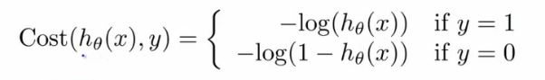

* **This is our logistic regression cost function**
  + This is the penalty the algorithm pays
  + Plot the function
* Plot y = 1
  + So hθ(x) evaluates as -log(hθ(x))

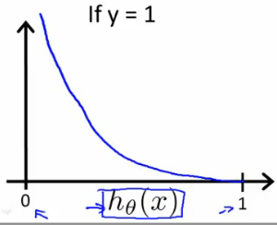

* So when we're right, cost function is 0
  + Else it slowly increases cost function as we become "more" wrong
  + X axis is what we predict
  + Y axis is the cost associated with that prediction
* This cost functions has some interesting properties
  + If y = 1 and hθ(x) = 1
    - If hypothesis predicts exactly 1 and thats exactly correct then that corresponds to 0 (exactly, not nearly 0)
  + As hθ(x) goes to 0
    - Cost goes to infinity
    - This captures the intuition that if hθ(x) = 0 (predict *P* (y=1|x; θ) = 0) but y = 1 this will penalize the learning algorithm with a massive cost
* What about if y = 0
* then cost is evaluated as -log(1- hθ( x ))
  + Just get inverse of the other function

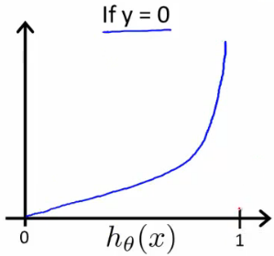

* Now it goes to plus infinity as hθ(x) goes to 1
* With our particular cost functions J(θ) is going to be convex and avoid local minimum

**Simplified cost function and gradient descent**

* Define a simpler way to write the cost function and apply gradient descent to the logistic regression
  + By the end should be able to implement a fully functional logistic regression function
* Logistic regression cost function is as follows

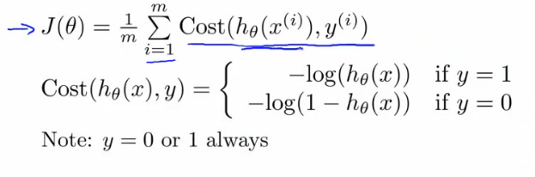

* This is the cost for a single example
  + For binary classification problems y is always 0 or 1
    - Because of this, we can have a simpler way to write the cost function
      * Rather than writing cost function on two lines/two cases
      * Can compress them into one equation - more efficient
  + Can write cost function is
    - **cost(hθ, (x),y) = -ylog( hθ(x) ) - (1-y)log( 1- hθ(x) )** 
      * This equation is a more compact of the two cases above
  + We know that there are only two possible cases
    - y = 1
      * Then our equation simplifies to
        + -log(hθ(x)) - (0)log(1 - hθ(x))

-log(hθ(x))

Which is what we had before when y = 1

* + - y = 0
      * Then our equation simplifies to  
        + -(0)log(hθ(x)) - (1)log(1 - hθ(x))
        + = -log(1- hθ(x))
        + Which is what we had before when y = 0
    - Clever!
* So, in summary, our cost function for the θ parameters can be defined as



* Why do we chose this function when other cost functions exist?
  + This cost function can be derived from statistics using the principle of **maximum likelihood estimation**
    - Note this does mean there's an underlying Gaussian assumption relating to the distribution of features
  + Also has the nice property that it's convex
* To fit parameters θ:
  + Find parameters θ which minimize J(θ)
  + This means we have a set of parameters to use in our model for future predictions
* Then, if we're given some new example with set of features x, we can take the θ which we generated, and output our prediction using  
   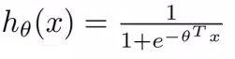
  + This result is
    - p(y=1 | x ; θ)
      * Probability y = 1, given x, parameterized by θ

**How to minimize the logistic regression cost function**

* Now we need to figure out how to minimize J(θ)
  + Use gradient descent as before
  + Repeatedly update each parameter using a learning rate

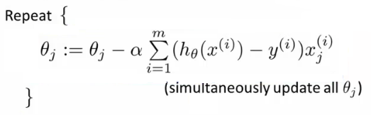

* If you had *n* features, you would have an n+1 column vector for θ
* This equation is the same as the linear regression rule
  + The only difference is that our definition for the hypothesis has changed
* Previously, we spoke about how to monitor gradient descent to check it's working
  + Can do the same thing here for logistic regression
* When implementing logistic regression with gradient descent, we have to update all the θ values (θ0 to θn) simultaneously
  + Could use a for loop
  + Better would be a vectorized implementation
* Feature scaling for gradient descent for logistic regression also applies here

**Advanced optimization**

* Previously we looked at gradient descent for minimizing the cost function
* Here look at advanced concepts for minimizing the cost function for logistic regression
  + Good for large machine learning problems (e.g. huge feature set)
* *What is gradient descent actually doing?*
  + We have some cost function J(θ), and we want to minimize it
  + We need to write code which can take θ as input and compute the following
    - J(θ)
    - Partial derivative if J(θ) with respect to j (where j=0 to j = n)

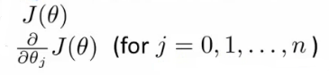

* Given code that can do these two things
  + Gradient descent repeatedly does the following update

**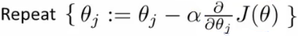**

* So update each j in θ sequentially
* So, we must;
  + Supply code to compute J(θ) and the derivatives
  + Then plug these values into gradient descent
* Alternatively, instead of gradient descent to minimize the cost function we could use
  + **Conjugate gradient**
  + **BFGS** (Broyden-Fletcher-Goldfarb-Shanno)
  + **L-BFGS** (Limited memory - BFGS)
* These are more optimized algorithms which take that same input and minimize the cost function
* These are *very* complicated algorithms
* Some properties
  + **Advantages**
    - No need to manually pick alpha (learning rate)
      * Have a clever inner loop (line search algorithm) which tries a bunch of alpha values and picks a good one
    - Often faster than gradient descent
      * Do more than just pick a good learning rate
    - Can be used successfully without understanding their complexity
  + **Disadvantages**
    - Could make debugging more difficult
    - Should not be implemented themselves
    - Different libraries may use different implementations - may hit performance

**Using advanced cost minimization algorithms**

* How to use algorithms
  + Say we have the following example

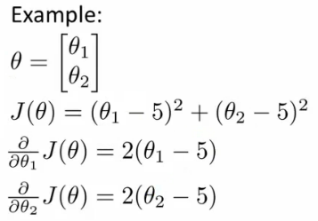

* Example above
  + θ1 and θ2 (two parameters)
  + Cost function here is J(θ) = (θ1 - 5)2 + ( θ2 - 5)2
  + The derivatives of the J(θ) with respect to either θ1 and θ2 turns out to be the 2(θi - 5)
* First we need to define our cost function, which should have the following signature

**function [jval, gradent] = costFunction(THETA)**

* Input for the cost function is **THETA**, which is a vector of the θ parameters
* Two return values from **costFunction** are
  + **jval**
    - How we compute the cost function θ (the underived cost function)
      * In this case = (θ1 - 5)2 + (θ2 - 5)2
  + **gradient**
    - 2 by 1 vector
    - 2 elements are the two partial derivative terms
    - i.e. this is an n-dimensional vector
      * Each indexed value gives the partial derivatives for the partial derivative of J(θ) with respect to θi
      * Where i is the index position in the **gradient** vector
* With the cost function implemented, we can call the advanced algorithm using

**options**= optimset('GradObj', 'on', 'MaxIter', '100'); **% define the options data structure**

**initialTheta**= zeros(2,1); # set the initial dimensions for theta **% initialize the theta values**

**[optTheta, funtionVal, exitFlag]**= fminunc(@costFunction, initialTheta, options); **% run the algorithm**

* Here
  + **options** is a data structure giving options for the algorithm
  + **fminunc**
    - function minimize the cost function (**f**ind **min**imum of **unc**onstrained multivariable function)
  + **@costFunction** is a pointer to the costFunction function to be used
* For the octave implementation
  + **initialTheta** must be a matrix of at least two dimensions
* How do we apply this to logistic regression?
  + Here we have a vector

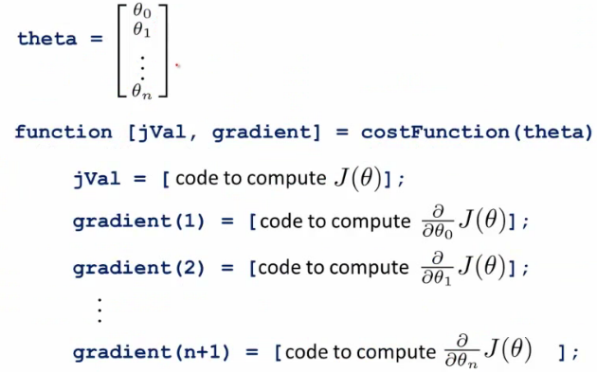

* Here
  + theta is a n+1 dimensional column vector
  + Octave indexes from 1, not 0
* Write a cost function which captures the cost function for logistic regression

**Multiclass classification problems**

* Getting logistic regression for multiclass classification using **one vs. all**
* Multiclass - more than yes or no (1 or 0)
  + Classification with multiple classes for assignment

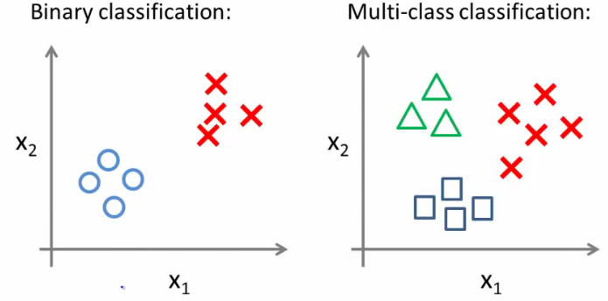

* Given a dataset with three classes, how do we get a learning algorithm to work?
  + Use one vs. all classification make binary classification work for multiclass classification
* **One vs. all classification**
  + Split the training set into three separate binary classification problems
    - i.e. create a new fake training set
      * Triangle (1) vs crosses and squares (0) hθ1(x)
        + P(y=1 | x1; θ)
      * Crosses (1) vs triangle and square (0) hθ2(x)
        + P(y=1 | x2; θ)
      * Square (1) vs crosses and square (0) hθ3(x)
        + P(y=1 | x3; θ)

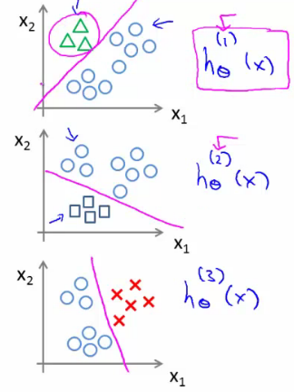

* **Overall**
  + Train a logistic regression classifier hθ(i)(x) for each class i to predict the probability that y = i
  + On a new input, *x* to make a prediction, pick the class *i* that maximizes the probability that hθ(i)(x) = 1

# 07: Regularization

[Previous](http://www.holehouse.org/mlclass/06_Logistic_Regression.html) [Next](http://www.holehouse.org/mlclass/08_Neural_Networks_Representation.html) [Index](http://www.holehouse.org/mlclass/index.html)

**The problem of overfitting**

* So far we've seen a few algorithms - work well for many applications, but can suffer from the problem of overfitting
* What is overfitting?
* What is regularization and how does it help

**Overfitting with linear regression**

* Using our house pricing example again
  + Fit a linear function to the data - not a great model
    - This is **underfitting** - also known as **high bias**
    - Bias is a historic/technical one - if we're fitting a straight line to the data we have a strong preconception that there should be a linear fit
      * In this case, this is not correct, but a straight line can't help being straight!
  + Fit a quadratic function
    - Works well
  + Fit a 4th order polynomial
    - Now curve fit's through all five examples
      * Seems to do a good job fitting the training set
      * But, despite fitting the data we've provided very well, this is actually not such a good model
    - This is **overfitting** - also known as **high variance**
  + Algorithm has high variance
    - High variance - if fitting high order polynomial then the hypothesis can basically fit any data
    - Space of hypothesis is too large

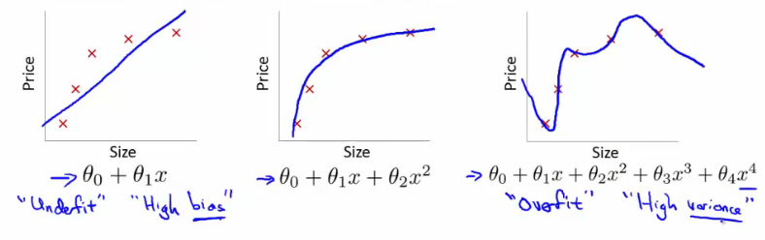

* To recap, if we have too many features then the learned hypothesis may give a cost function of exactly zero
  + But this tries too hard to fit the training set
  + Fails to provide a *general* solution - **unable to generalize** (apply to new examples)

**Overfitting with logistic regression**

* Same thing can happen to logistic regression
  + Sigmoidal function is an underfit
  + But a high order polynomial gives and overfitting (high variance hypothesis)

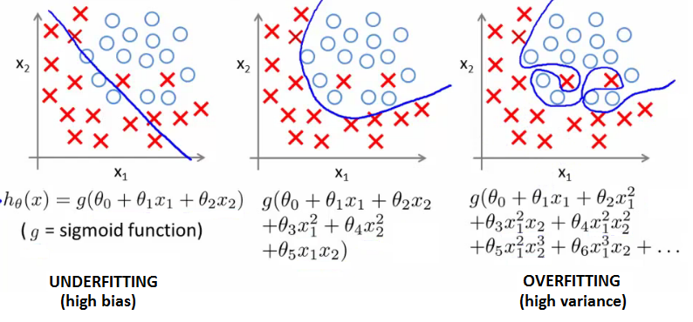

**Addressing overfitting**

* Later we'll look at identifying when overfitting and underfitting is occurring
* Earlier we just plotted a higher order function - saw that it looks "too curvy"
  + Plotting hypothesis is one way to decide, but doesn't always work
  + Often have lots of a features - here it's not just a case of selecting a degree polynomial, but also harder to plot the data and visualize to decide what features to keep and which to drop
  + If you have lots of features and little data - overfitting can be a problem
* How do we deal with this?
  + 1) **Reduce number of features**
    - Manually select which features to keep
    - Model selection algorithms are discussed later (good for reducing number of features)
    - But, in reducing the number of features we lose some information
      * Ideally select those features which minimize data loss, but even so, some info is lost
  + 2) **Regularization**
    - Keep all features, but reduce magnitude of parameters θ
    - Works well when we have a lot of features, each of which contributes a bit to predicting y

**Cost function optimization for regularization**

* Penalize and make some of the θ parameters really small
  + e.g. here θ3 and θ4

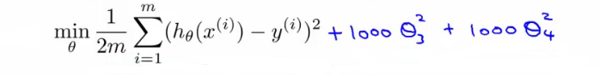

* The addition in blue is a modification of our cost function to help penalize θ3 and θ4
  + So here we end up with θ3 and θ4 being close to zero (because the constants are massive)
  + So we're basically left with a quadratic function

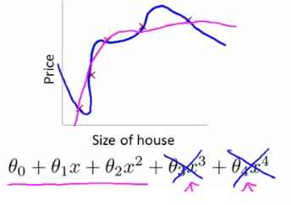

* In this example, we penalized two of the parameter values
  + More generally, regularization is as follows
* Regularization
  + Small values for parameters corresponds to a simpler hypothesis (you effectively get rid of some of the terms)
  + A simpler hypothesis is less prone to overfitting
* Another example
  + Have 100 features x1, x2, ..., x100
  + Unlike the polynomial example, we don't know what are the high order terms
    - How do we pick the ones to pick to shrink?
  + With regularization, take cost function and modify it to shrink all the parameters
    - Add a term at the end
      * This regularization term shrinks every parameter
      * By convention you don't penalize θ0 - minimization is from θ1 onwards

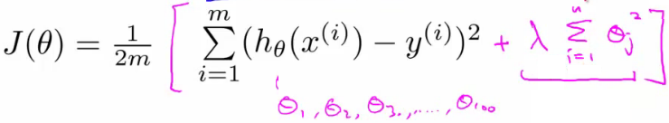

* In practice, if you include θ0 has little impact
* **λ** is the **regularization parameter**
  + Controls a trade off between our two goals
    - 1) Want to fit the training set well
    - 2) Want to keep parameters small
* With our example, using the **regularized objective** (i.e. the cost function with the regularization term) you get a much smoother curve which fits the data and gives a much better hypothesis
  + If **λ** is very large we end up penalizing ALL the parameters (θ1, θ2 etc.) so all the parameters end up being close to zero
    - If this happens, it's like we got rid of all the terms in the hypothesis
      * This results here is then underfitting
    - So this hypothesis is too biased because of the absence of any parameters (effectively)
* So, **λ** should be chosen carefully - not too big...
  + We look at some automatic ways to select **λ** later in the course

**Regularized linear regression**

* Previously, we looked at two algorithms for linear regression
  + Gradient descent
  + Normal equation
* Our linear regression with regularization is shown below

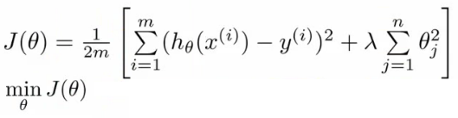

* Previously, gradient descent would repeatedly update the parameters θj, where j = 0,1,2...n simultaneously
  + Shown below

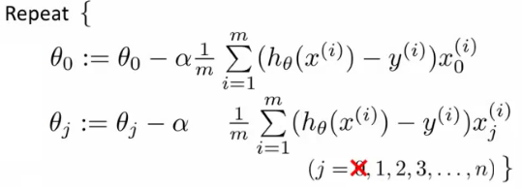

* We've got the θ0 update here shown explicitly
  + This is because for regularization we don't penalize θ0 so treat it slightly differently
* How do we regularize these two rules?
  + Take the term and add λ/m \* θj
    - Sum for every θ (i.e. j = 0 to n)
  + This gives regularization for gradient descent
* We can show using calculus that the equation given below is the partial derivative of the regularized J(θ)

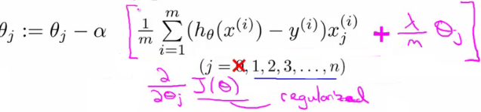

* The update for θj 
  + θj gets updated to
    - θj - α \* [a big term which also depends on θj]
* So if you group the θj terms together

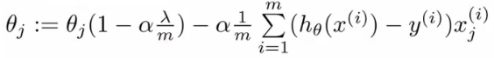

* The term   
   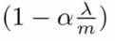
  + Is going to be a number less than 1 usually
  + Usually learning rate is small and m is large
    - So this typically evaluates to (1 - a small number)
    - So the term is often around 0.99 to 0.95
* This in effect means θj gets multiplied by 0.99
  + Means the squared norm of θj a little smaller
  + The second term is exactly the same as the original gradient descent

**Regularization with the normal equation**

* Normal equation is the other linear regression model
  + Minimize the J(θ) using the normal equation
  + To use regularization we add a term (+ λ [n+1 x n+1]) to the equation
    - [n+1 x n+1] is the n+1 identity matrix

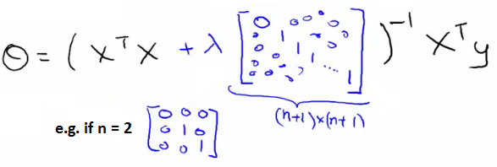

**Regularization for logistic regression**

* We saw earlier that logistic regression can be prone to overfitting with lots of features
* Logistic regression cost function is as follows;

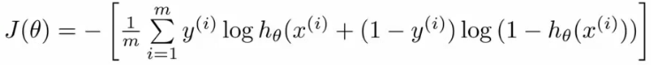

* To modify it we have to add an extra term  
  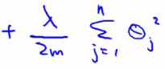
* This has the effect of penalizing the parameters θ1, θ2 up to θn 
  + Means, like with linear regression, we can get what appears to be a better fitting lower order hypothesis
* How do we implement this?
  + Original logistic regression with gradient descent function was as follows  
    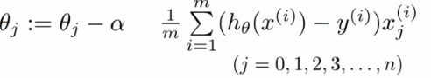
* Again, to modify the algorithm we simply need to modify the update rule for θ1, onwards
  + Looks cosmetically the same as linear regression, except obviously the hypothesis is very different  
    

**Advanced optimization of regularized linear regression**

* As before, define a costFunction which takes a θ parameter and gives jVal and gradient back

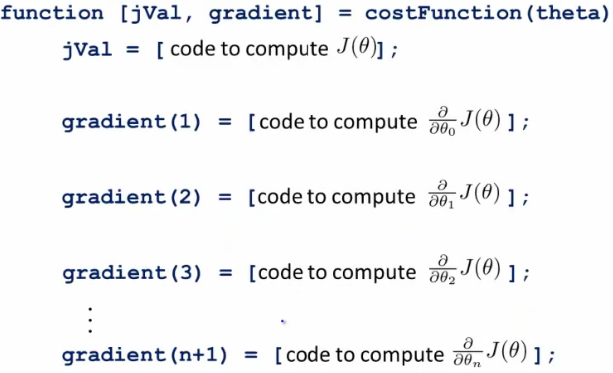

* use **fminunc**
  + Pass it an **@costfunction** argument
  + Minimizes in an optimized manner using the cost function
* **jVal**
  + Need code to compute J(θ)
    - Need to include regularization term
* Gradient
  + Needs to be the partial derivative of J(θ) with respect to θi
  + Adding the appropriate term here is also necessary

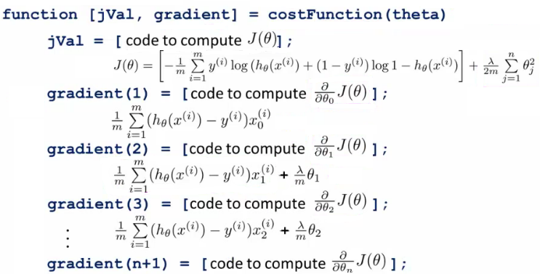

* Ensure summation doesn't extend to to the lambda term!
  + It doesn't, but, you know, don't be daft!

<https://towardsdatascience.com/introduction-to-na%C3%AFve-bayes-classifier-fa59e3e24aaf>

# The Gradient Boosters I: The Good Old Gradient Boosting

In 2001, Jerome H. Friedman wrote up a seminal paper – Greedy function approximation: A gradient boosting machine. Little did he know that was going to evolve into a class of methods which threatens Wolpert’s [No Free Lunch theorem](https://chemicalstatistician.wordpress.com/2014/01/24/machine-learning-lesson-of-the-day-the-no-free-lunch-theorem/) in the tabular world. Gradient Boosting and its cousins(XGBoost and LightGBM) have conquered the world by giving excellent performances in classification as well as regression problems in the realm of tabular data.

Not Really!

Today, I am starting a new blog series on the Gradient Boosting Machines and all its cousins. The outline for the blog series are as follows: (This will be updated with links as and when each of them gets published)

1. Part I – [Gradient Boosting Algorithm](https://deep-and-shallow.com/2020/02/02/the-gradient-boosters-i-the-math-heavy-primer-to-gradient-boosting-algorithm/)
2. Part II – Regularized Greedy Forest
3. Part III – XGBoost
4. Part IV – LightGBM
5. Part V – CatBoost
6. Part VI – NGBoost
7. Part VII – The Battle of the Boosters

In the first part, let’s understand the classic Gradient Boosting methodology put forth by Friedman. Even though this is math heavy, it’s not that difficult. And wherever possible, I have tried to provide intuition to what’s happening.

## Problem Setup

Let there be a dataset D with n samples. Each sample has m set of features in a vector x, and a real valued target, y. Formally, it is written as



Now, Gradient Boosting algorithms are an ensemble method which takes an additive form. The intuition is that a complex function, which we are trying to estimate, can be made up of smaller and simpler functions, added together.

Suppose the function we are trying to approximate is



We can break this function as :





This is the assumption we are taking when we choose an additive ensemble model and the Tree ensemble that we usually talk about when talking about Gradient Boosting can be written as below:



where M is the number of base learners and F is the space of regression trees.

## Loss Function



where l is the differentiable convex loss function

Since we are looking at an additive functional form for , we can replace  with



So, the loss function will become:



## Algorithm

1. Initialize the model with a constant value by minimizing the loss function
   * 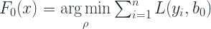
   *  is the prediction of the model which minimizes the loss function at 0th iteration
   * For the Squared Error loss, it works out to be the average over all training samples
   * For the Least Absolute Deviation loss, it works out to be the median over all training samples
2. for m=1 to M:
   * Compute 
     +  is nothing but the derivative of the Loss Function(between true and the output from the last iteration) w.r.t. F(x) from the last iteration
     + For the Squared Error loss, this works out to be the residual(Observed – Predicted)
     + It is also called the pseudo residual because it acts like the residual and it is the residual for the Squared Error loss function
     + We calculate the  for all the n samples
   * Fit a Regression Tree to the  values using Gini Impurity or Entropy (the usual way)
     + Each leaf of the tree is denoted by  for , where  is the number of leaves in the tree created in iteration m
   * For  compute 
     +  is the basis function or the least squared coefficients. This conveniently works out to be the average over all the samples in any leaf for the Squared Error loss and median for the Least Absolute Deviation loss
     +  is the scaling factor or leaf weights.
     + The inner summation over  can be ignored because of the disjoint nature of the Regression Trees. One particular sample will only be in one of those leaves. So the equation simplifies to:
     + 
     + So, for each of the leaves, , we calculate the optimum value , when added to the prediction of the last iteration minimizes the loss for the samples that reside in the leaf
     + For known loss functions like the Squared Error loss and Least Absolute Deviation loss, the scaling factor is 1. And because of that, the standard GBM implementation ignores the scaling factor.
     + For some losses like the Huber loss,  is estimated using a line search to find the minimum loss.
   * Update 
     + Now we add the latest, optimized tree to the result from previous iteration.
     +  is the shrinkage or learning rate
     + The summation in the equation is only useful in the off chance that a particular sample ends up in multiple nodes. Otherwise, it’s just the optimized regression tree score 

## Regularization

In the standard implementation (Sci-kit Learn), the regularization term in the objective function is not implemented. The only regularization that is implemented there are the following:

* **Regularization by Shrinkage** – In the additive formulation, each new weak learner is “shrunk” by a factor, . This shrinkage is also called learning rate in some implementation because it resembles the learning rate in neural networks.
* **Row Subsampling** – Each of the candidate trees in the ensemble uses a subset of samples. This has a regularizing effect.
* **Column Subsampling** – Each of the candidate trees in the ensemble uses a subset of features. This also has a regularizing effect and is usually more effective. This also helps in parallelization.

## Gradient Boosting & Gradient Descent

### The Similarity

We know that Gradient Boosting is an additive model and can be shows as below:



where F is the ensemble model, f is the weak learner, η is the learning rate and X is the input vector.

Substituting F with , we get the familiar equation,



Now since  is obtained at each iteration by minimizing the loss function which is a function of the first and second order gradients (derivatives), we can intuitively think about that as a directional vector pointing towards the steepest descent. Let’s call this directional vector as . The subscript is m-1 because the vector has been trained on stage m-1 of the iteration. Or, intuitively the residual . So the equation now becomes:



Flipping the signs, we get:



Now let’s look at the standard Gradient Descent equation:



We can clearly see the similarity. And this result is what enables us to use any differentiable loss function.

### The Difference

When we train a neural network using Gradient Descent, it tries to find the optimum parameters(weights and biases), ***w***, that minimizes the loss function. And this is done using the gradients of the loss with respect to the parameters.

But in Gradient Boosting, the gradient only adjusts the way the ensemble is created and not the parameters of the underlying base learner.

While in neural network, the gradient directly gives us the direction vector of the loss function, in Boosting, we only get the approximation of that direction vector from the weak learner. Consequently, the loss of a GBM is only likely to reduce monotonically. It is entirely possible that the loss jumps around a bit as the iterations proceed.

## Implementation

[GradientBoostingClassifier](https://scikit-learn.org/stable/modules/generated/sklearn.ensemble.GradientBoostingClassifier.html#sklearn.ensemble.GradientBoostingClassifier) and [GradientBoostingRegressor](https://scikit-learn.org/stable/modules/generated/sklearn.ensemble.GradientBoostingRegressor.html#sklearn.ensemble.GradientBoostingRegressor) in Sci-kit Learn are one of the earliest implementations in the python ecosystem. It is a straight forward implementation, faithful to the original paper. I follows pretty much the discussion we had till now. And it has implemented for a variety of loss functions for which the Greedy function approximation: A gradient boosting machine[1] by Friedman had derived algorithms.

* Regression Losses
  + ‘ls’ → Least Squares
  + ‘lad’ → Least Absolute Deviation
  + ‘huber’ → Huber Loss
  + ‘quantile’ → Quantile Loss
* Classification Losses
  + ‘deviance’ → Logistic Regression loss
  + ‘exponential’ → Exponential Loss

In the next part of the series, let’s take a look at one of the lesser known cousin of Gradient Boosting – **Regularized Greedy Forest**

* Part I – [Gradient boosting Algorithm](https://deep-and-shallow.com/2020/02/02/the-gradient-boosters-i-the-math-heavy-primer-to-gradient-boosting-algorithm/)
* Part II – [Regularized Greedy Forest](https://deep-and-shallow.com/2020/02/09/the-gradient-boosters-ii-regularized-greedy-forest/)
* Part III – [XGBoost](https://deep-and-shallow.com/2020/02/12/the-gradient-boosters-iii-xgboost/)
* Part IV – [LightGBM](https://deep-and-shallow.com/2020/02/21/the-gradient-boosters-iii-lightgbm/)
* Part V – [CatBoost](https://deep-and-shallow.com/2020/02/29/the-gradient-boosters-v-catboost/)
* Part VI – NGBoost
* Part VII – The Battle of the Boosters

Stay tuned!

## References

1. Friedman, Jerome H. Greedy function approximation: A gradient boosting machine. Ann. Statist. 29 (2001), no. 5, 1189–1232.

# The Gradient Boosters II: Regularized Greedy Forest

In 2011, Rie Johnson and Tong Zhang, proposed a modification to the Gradient Boosting model. they called it [Regularized Greedy Forest](https://github.com/RGF-team/rgf). When they came up with the modification, GBDTs were already, sort of, ruling the tabular world. They tested the new modification of a wide variety of datasets, both synthetic and real world, and found that their modification achieves a better performance than standard GBDTs. They also entered a few Kaggle type competitions ([Bond Price challenge](https://www.kaggle.com/c/benchmark-bond-trade-price-challenge), [Biological Response Prediction](https://www.kaggle.com/c/bioresponse), and Heritage Provider Network Health Prize) and won them beating out other GBDT models in the running.

The implementation(both the original and a faster multi-core version) is on the Github Page : <https://github.com/RGF-team/rgf>

The key modifications to the core GBDT algorithm they suggested are as follows:

## Fully Corrective Greedy Update

According to Friedman[1], one of the disadvantages of the standard Gradient Boosting is that the shrinkage/learning rate, needs to be small to achieve convergence. In fact, he argued for infinitesimal step size. They suggested a modification which made the shrinkage parameter unnecessary.

In standard Gradient Boosting, the algorithm does a partial corrective step in each iteration. The algorithm only optimizes the base learner in the current iteration and ignores all the previous ones. It creates the best regression tree for the current timestep and adds it to the ensemble. But they proposed that at every iteration, we update the whole forest(m base learners for iteration m) and readjust the scaling factor at each iteration.

## Structured Sparsity Regularization

While the fully corrective greedy update means that the algorithm will converge faster, it also means that it overfitted faster. Therefore Structured Sparsity Regularization was adopted to combat this problem. The general idea of structured sparsity is that in a situation where a sparse solution is assumed, one can take advantage of the sparsity structure underlying the task. In this specific setting, it was implemented as a sparse search of decision rules in the forest structure.

## Explicit Regularization

In addition to the Structured Sparsity Regularization, they also included an explicit Regularization term to the loss function.



where l is the differentiable convex loss function and Ω is the regularisation term penalising the complexity of the tree structure, and  is the Forest structure.

The paper introduces three types of Regularization options:

### L2 Regularization on Leaves

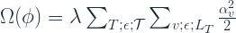

where  is the forest structure,  is the constant for controlling the strength of regularization,  are the weights of the node v (which is restricted to leaf nodes),  is the leaves of the tree T, and  is the set of all Trees in the forest.

hyperparameter in implementation: l2

### Minimum-penalty Regularization

The minimum penalty regularization penalises the depth of the trees. This is a regularization that acts on all nodes and not just the leaves of the trees. This uses the principle that any leaf node can be written in terms of its ancestor nodes. The intuition behind the regularization is that it penalises depth, which is conceptually a complex decision rule.

The exact formula is beyond our scope, but the key hyperparameters in there are l2 which governs the overall strength of regularization, and reg\_depth which controls how severely you penalise the depth of a tree. Suggested values for l2 are 1, 0.1, 0.01 and reg\_depth should be a value greater than 1

### Minimum-penalty Regularization with Sum-to-Zero Siblings

This is very similar to Minimum-penalty regularization, but with an added condition that the weights of sibling nodes should sum to zero. The intuition behind the sum-to-zero constraint is that less redundant models are preferable and that the models are least redundant when branches at internal nodes lead to completely opposite actions, like adding ‘x’ to versus subtracting ‘x’ from the output value. So this penalises two things- depth of the tree and redundancy of the tree. There are no additional hyperparameters here.

**Note:** An interesting tidbit to note here is that all the bechmarks in the paper and the competitions only used simple L2 regularization.

## Algorithm

The general concept is still similar to Gradient Boosting, but the key differences are in the tree updates in each iteration. And also the easy and convenient derivations or gradients to be mean or median does not work anymore because of the regularization term in the objective function.

Let’s look at the new algorithm, albeit at a high level.

1. repeat
   1.  is the optimum forest that minimizes  among all the forests that can be obtained by applying one step of structure-changing operation to the current forest 
   2. Optimize the leaf weights in  to minimize the loss 
2. until some exit criteria is met
3. Optimize the leaf weights in  to minimize the loss 
4. return 

### Tree building Strategy

There is one key difference in the way the trees are built in the forest in Regularized Greedy Forest. In classical Gradient Boosting, at each stage a new tree is built, with a specific criteria of stopping, like depth or number of leaves. Once you pass a stage, you do not touch that tree or the weights associated with it. On the contrary, in RGF, at any m iteration, the option to update any of the previously created m-1 trees or starting a new tree is open. The exact update to the forest is determined by the action which minimizes the loss function.

Let’s look at an example to understand the fundamental difference in Tree Building between Gradient Boosting and Regularized Greedy Forest

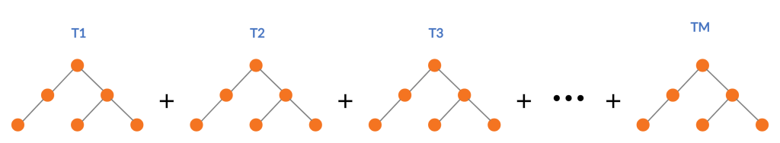Tree Building Process of Gradient Boosting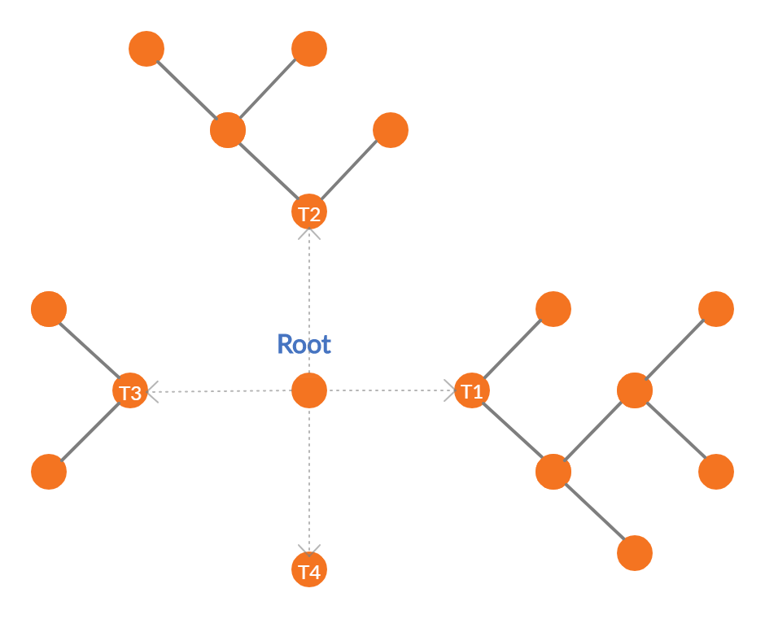Tree Building Process of Regularized Greedy Forest

Standard Gradient Boosting builds successive trees and sum those up into an additive function which approximates the desired function.

RGF takes a slightly different route. For each step change in the structure of the tree, it evaluates the possibility of growing a new leaf in an existing tree vs starting a new tree with the help of the loss function, and then takes the greedy approach of taking the route with least loss. So in the diagram above, we can choose to grow leaves in T1, T2, or T3, or we can start a new tree T4 depending on which one gives you the most reduction in loss.

But practically, it is computationally challenging to do this as the possible splits to evaluate grows exponentially as we move deeper and deeper into the forest. So, there is a hyperparameter, n\_tree\_search, in the implementation which restricts the retrospective update of trees to those many latest trees only. The default value is set as 1 so that the update always looks at one previously created tree. In our example, this reduces the possibilities to growing leaves in T3 or growing a new tree T4.

Conceptually, this becomes an additive function over leaves of the forest than an additive function of trees in a forest, and consequently, there is not max\_depth parameter in RGF as the depth of the tree is automatically restrained by the incremental updates to the tree structure.

The next step is the weights of the new leaf that was selected to be the best structural change. This is an optimization problem and can be solved using any of the multiple methods like Gradient Descent, or Newton-Raphson’s method. Since the optimization that we are looking at is simpler, the paper uses a Newton’s step, which is much more accurate than Gradient Descent, to get an approximately optimal weight for the new leaf. Refer to Appendix A, if you are interested in how and why we need a Newton’s step to optimize such functions.

### Weight Optimization

With the base learner or the basis function fixed, we need to optimize the weights of all the leaves in the forest. This is again an optimization problem, and this is solved using Cordinate Descent, which iteratively go through each of the leaves and update the weights by a Newton Step with a small step size.

Since the initial weights that is already set are approximately optimal, we do not need to re-optimize the weights every iteration. It would be computationally expensive if we do that. This is another hyperparameter in the implementation called opt\_interval. Empirically, it was observed that unless opt\_interval is an extreme value, the choice of opt\_interval is not critical. For all the competitions they won, they had simply set the value as 100.

## Key Hyperparameters and Tuning

Below is a list of key Hyperparameters that the authors of the paper suggest. It is almost directly taken from their [Github Page](https://github.com/RGF-team/rgf/blob/master/RGF/rgf-guide.rst#432-parameters-to-control-training), but adopted to the Python Wrapper.

|  |
| --- |
| Parameters to control training |
| algorithm= | RGF | RGF\_Opt | RGF\_Sib (Default: RGF)RGF: RGF with regularization on leaf-only models.RGF\_Opt: RGF with min-penalty regularization.RGF\_Sib: RGF with min-penalty regularization with the sum-to-zero sibling constraints. |
| loss= | Loss function . LS | Expo | Log (Default: LS)LS: square loss .Expo: exponential loss .Log: logistic loss . |
| max\_leaf= | Training will be terminated when the number of leaf nodes in the forest reaches this value. It should be large enough so that a good model can be obtained at some point of training, whereas a smaller value makes training time shorter. Appropriate values are data-dependent and in [[2]](https://github.com/RGF-team/rgf/blob/master/RGF/rgf-guide.rst#references) varied from 1000 to 10000. (Default: 10000) |
| normalize | If turned on, training targets are normalized so that the average becomes zero. It was turned on in all the regression experiments in [[2]](https://github.com/RGF-team/rgf/blob/master/RGF/rgf-guide.rst#references). |
| l2= | . Used to control the degree of regularization. Crucial for good performance. Appropriate values are data-dependent. Either 1.0, 0.1, or 0.01 often produces good results though with exponential loss (loss=Expo) and logistic loss (loss=Log) some data requires smaller values such as 1e-10 or 1e-20. |
| sl2= | . Override regularization parameter for the process of growing the forest. That is, if specified, the weight correction process uses and the forest growing process uses . If omitted, no override takes place and is used throughout training. On some data, works well. |
| reg\_depth= | Must be no smaller than 1. Meant for being used with algorithm=RGF\_Opt|RGF\_Sib. A larger value penalizes deeper nodes more severely. (Default: 1) |
| test\_interval= | Test interval in terms of the number of leaf nodes. For example, if test\_interval=500, every time 500 leaf nodes are newly added to the forest, end of training is simulated and the model is tested or saved for later testing. For efficiency, it must be either multiple or divisor of the optimization interval (opt\_interval: default 100). If not, it may be changed by the system automatically. (Default: 500) |
| n\_tree\_search= | Number of trees to be searched for the nodes to split. The most recently-grown trees are searched first. (Default: 1) |

## Appendix A

### Taylor’s Approximation And Newton-Raphson Method of Optimization

Youtube Channel 3Blue1Brown(which I recommend strongly if you want fundamental intuitions about Math), has a yet another brilliant video for explaining the Taylor Expansions/Approximations. Be sure to check out at least the first 6 minutes of the video.

Taylor’s approximation lets us approximate a function close to a point by using the derivatives of that function.

…

Suppose we are taking a second order approximation and finding a local minima, we can do that by setting the derivative to zero

.

Setting it to zero, we get:

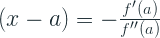

This (x-a) is the optimum step to minimize the function at that point. So, this minima is more like the **step direction** towards the minima than the actual minima.

To optimize the non-differentiable function, we need to take multiple steps in the step direction until we are relatively satisfied with the loss, or technically until the loss is below our tolerance. This is called the **Newton-Raphson method** of optimization.

In the next part of the series, let’s take a look at giant – **XGBoost**

* Part I – [Gradient boosting Algorithm](https://deep-and-shallow.com/2020/02/02/the-gradient-boosters-i-the-math-heavy-primer-to-gradient-boosting-algorithm/)
* Part II – [Regularized Greedy Forest](https://deep-and-shallow.com/2020/02/09/the-gradient-boosters-ii-regularized-greedy-forest/)
* Part III – [XGBoost](https://deep-and-shallow.com/2020/02/12/the-gradient-boosters-iii-xgboost/)
* Part IV – [LightGBM](https://deep-and-shallow.com/2020/02/21/the-gradient-boosters-iii-lightgbm/)
* Part V – [CatBoost](https://deep-and-shallow.com/2020/02/29/the-gradient-boosters-v-catboost/)
* Part VI – NGBoost
* Part VII – The Battle of the Boosters

Stay tuned!

## References

1. Friedman, Jerome H. Greedy function approximation: A gradient boosting machine. Ann. Statist. 29 (2001), no. 5, 1189–1232.
2. Johnson, Rie & Zhang, Tong, “Learning Nonlinear Functions Using Regularized Greedy Forest”, [*IEEE Transactions on Pattern Analysis and Machine Intelligence*](https://ieeexplore.ieee.org/xpl/RecentIssue.jsp?punumber=34) ( Volume: 36 , [*Issue: 5*](https://ieeexplore.ieee.org/xpl/tocresult.jsp?isnumber=6809246) , May 2014 ).

# The Gradient Boosters III: XGBoost

Now let’s get the elephant out of the way – XGBoost. This is the most popular cousin in the Gradient Boosting Family. XGBoost with its blazing fast implementation stormed into the scene and almost unanimously turned the tables in its favor. Soon enough, Gradient Boosting, via XGBoost, was the reigning king in Kaggle Competitions and pretty soon, it trickled down to the business world.

There were a few key innovations that made XGBoost so effective:

## Explicit Regularization

Similar to Regularized Greedy Forest, XGBoost also has an explicit regularization term in the objective function.







 is the regularization term which penalizes T, the number of leaves in the tree and  is the regularization term which penalizes w, the weights of different leaves.

This is a much simpler regularization term than some of the ways we saw in Regularized Greedy Forest.

## Objective Function Agnostic Implementation

One of the key ingredients of Gradient Boosting algorithms is the gradients or derivatives of the objective function. And all the implementations that we saw earlier used pre-calculated gradient formulae for specific loss functions, thereby, restricting the objectives which can be used in the algorithm to a set which is already implemented in the library.

XGBoost uses the Newton-Raphson method we discussed in a previous part of the series to approximate the loss function.



Now, the complex recursive function made up of tree structures can be approximated using Taylor’s approximation into a differentiable form. In the case of Gradient Boosting, we take the second order approximation, meaning we use two terms – first order derivative and second order derivative- to approximate the function.

Let,



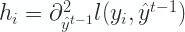

Approximated Loss function:

The first term, the loss, is constant at a tree building stage, t, and because of that it doesn’t add any value to the optimization objective. So removing it and simplifying we get,



Substituting the Ω with the regularization term, we get:

The f(x) we are talking about is essentially a tree with leaf weights, w. So if we define  as the instance set in leaf j, we can substitute the tree structure directly into the equation and simplify as:

Setting this equation to zero we can find the optimum value for  as :

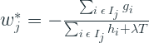

Putting this back into the loss function and simplifying we get:

What all of this enables us to do is to separate out the objective function from the core working of the algorithm. And by adopting this formulation, the only requirement from an objective function/loss function is that it needs to be differentiable. To be very specific, the loss function should return the first and second order derivatives.

See [here](https://xgboost.readthedocs.io/en/latest/parameter.html#learning-task-parameters) for a list of all the objective functions that are pre-built into XGBoost.

## Tree Building Strategy

The tree building strategy lies somewhat in between classical Gradient Boosting and regularized Greedy Forests. While the classical Gradient Boosting takes the tree at each stage as a black box, Regularized Greedy Forest operates at a leaf level by updating any part of the forest at each step. XGBoost takes a middle ground and considers a tree that is made in a previous iteration sacrosanct, but while making a tree for any iteration, it doesn’t use the standard impurity measures, but the gradient based Loss function we derived in the last section in the tree building process. While in classic Gradient Boosting the optimization of the loss function happens after the tree is built, XGBoost gets that optimization during the tree building process as well.

Normally its impossible to enumerate all possible tree structures. Therefore a greedy algorithm is implemented that starts from a single leaf and iteratively adds branches to the tree based on the simplified loss function

## Split-finding Algorithm

One of the key problems in tree learning is to find the best split. Usually, we will have to enumerate all the possible splits over all the features and then use the impurity criteria to choose the best split. This is called exact greedy algorithm. It is computationally demanding, especially for continuous and high cardinality categorical features. And it also not feasible when the data doesn’t fit into memory.

To overcome these inefficiencies, the paper proposes an Approximate Algorithm. It first proposes candidate splitting points according to the percentiles of the features. On a highlevel, the algorithm is:

1. Propose candidate splitting points for all the features using the percentiles of the features
2. Map the continuous features to buckets split by the candidate splitting points
3. Aggregate the gradient statistics for all the features based on the candidate splitting points
4. Finds the best solution among proposals based on aggregate statistics

### Weighted Quantile Sketch

One of the important steps in the algorithm discussed above is the proposal of candidate splits. usually percentiles of a feature are used to make candidates distribute evenly on the data. And a set of algorithms which does that in a distributed manner and with speed and efficiency are called Quantile sketching algorithms. But here, the problem is slightly complicated because the need is to have a weighted quantile sketching algorithm which weighs the instances based on the gradient(so that we can learn the most from instances with most error). So they proposed a new data structure which has provable theoretical guarantee.

## Sparsity-aware Split Finding

This is another key innovation in XGBoost and this came from the realization that real-world datasets are sparse. This sparsity can come form multiple causes,

1. Presence of missing values in the data
2. Frequent zero values
3. Artifacts of feaature engineering such as One-Hot Encoding

And for this reason, the authors decide to make the algorithm aware of the sparsity so that it can be dealt with intelligently. And the way they made that is deceivingly simple.

They gave a default direction in each tree node. i.e. if a value is missing or zero, that instance flows down a default direction in the branch. And the optimal default direction is learned from the data

This innovation has a two fold benefit –

1. it helps group the missing values learn an optimal way of handling them
2. it boosts the performance by making sure no computing power is wasted in trying to find gradient statistics for missing values.

## Performance Improvements

One of the main drawbacks of all the implementations of the Gradient Boosting algorithm were that they were quite slow. While the forest creation in a Random Forest was parallel out of the box, Gradient Boosting was a sequential process which builds new base learners on old ones. One of XGBoost’s claim to fame was how blazingly fast it was. It was at least 10 times faster than the existing implementations and it was able to work with large datasets because of the out-of-core learning capabilities. The key innovations in performance improvement were:

### Column Block for Parallel Learning

The most time consuming part of tree learning is to get the data sorted into order. The authors of the paper proposed to store the data in in-memory units, called blocks. Data in each block is sorted in the [Compressed column (CSC) format](http://netlib.org/linalg/html_templates/node92.html). This input data layout is computed once before training and reused thereafter. By handing the data in this sorted format, the tree split algorithm is reduced to a linear scan over the sorted columns

### Cache-aware Access

While the proposed block structure helps optimize the computation complexity of split finding, it requires indirect fetches of gradient statistics by row index. To get over the slow write and read operations in the process, the authors implemented an internal buffer for each thread and accumulate the gradient statistics in minibatches. This helps in reducing the runtime overhead when the rows are large.

### Blocks for Out-of-core Computation

One of the goals of the algorithm is to fully utilize the machine’s resources. While the CPUs are utilized by parallelization of the process, the available disk space is utilized by the out-of-core learning. These blocks that we saw earlier are stored on disk and a separate prefetch thread keeps fetching the data into memory just in time for the computation to continue. They use two techniques to make the I/O operations from disk faster –

* Block Compression, where each block is compressed before storage and uncompressed on the fly while reading.
* Block Sharding, where a block is broken down into multiple pieces and stored across multiple disks(if any). And the prefetcher reads the block by alternating between the two disks, thereby increasing throughput of the disk reading.

## HyperParameters

XGBoost has so many articles and blogs about it covering the hyperparameters and how to tune them that I’m not even going to attempt it.

The single source of truth for any hyperparameter is the [official documentation](https://xgboost.readthedocs.io/en/latest/parameter.html). It might be intimidating to look at the long list of hyperparameters there, but you won’t end up touching the majority of them in a normal use case.

The major ones are:

* **eta [default=0.3, alias: learning\_rate]**
  + Step size shrinkage used in update to prevents overfitting. After each boosting step, we can directly get the weights of new features, and eta shrinks the feature weights to make the boosting process more conservative.
  + range: [0,1]
* **gamma [default=0, alias: min\_split\_loss]**
  + Minimum loss reduction required to make a further partition on a leaf node of the tree. The larger gamma is, the more conservative the algorithm will be.
  + range: [0,∞]
* **max\_depth [default=6]**
  + Maximum depth of a tree. Increasing this value will make the model more complex and more likely to overfit. 0 is only accepted in lossguided growing policy when tree\_method is set as hist and it indicates no limit on depth. Beware that XGBoost aggressively consumes memory when training a deep tree.
  + range: [0,∞] (0 is only accepted in lossguided growing policy when tree\_method is set as hist)
* **min\_child\_weight [default=1]**
  + Minimum sum of instance weight (hessian) needed in a child. If the tree partition step results in a leaf node with the sum of instance weight less than min\_child\_weight, then the building process will give up further partitioning. In linear regression task, this simply corresponds to minimum number of instances needed to be in each node. The larger min\_child\_weight is, the more conservative the algorithm will be.
  + range: [0,∞]
* **subsample [default=1]**
  + Subsample ratio of the training instances. Setting it to 0.5 means that XGBoost would randomly sample half of the training data prior to growing trees. and this will prevent overfitting. Subsampling will occur once in every boosting iteration.
  + range: (0,1]
* **colsample\_bytree, colsample\_bylevel, colsample\_bynode [default=1]**
  + This is a family of parameters for subsampling of columns.
  + All colsample\_by\* parameters have a range of (0, 1], the default value of 1, and specify the fraction of columns to be subsampled.
  + colsample\_bytree is the subsample ratio of columns when constructing each tree. Subsampling occurs once for every tree constructed.
  + colsample\_bylevel is the subsample ratio of columns for each level. Subsampling occurs once for every new depth level reached in a tree. Columns are subsampled from the set of columns chosen for the current tree.
  + colsample\_bynode is the subsample ratio of columns for each node (split). Subsampling occurs once every time a new split is evaluated. Columns are subsampled from the set of columns chosen for the current level.
  + colsample\_by\* parameters work cumulatively. For instance, the combination {‘colsample\_bytree’:0.5, ‘colsample\_bylevel’:0.5, ‘colsample\_bynode’:0.5} with 64 features will leave 8 features to choose from at each split.
* **lambda [default=1, alias: reg\_lambda]**
  + L2 regularization term on weights. Increasing this value will make model more conservative.
* **alpha [default=0, alias: reg\_alpha]**
  + L1 regularization term on weights. Increasing this value will make model more conservative.

##### UPDATE – 13-02-2020

## Leaf-wise Tree Growth

After publishing this, I came to realize I haven’t talked about some of the later developments in XGBoost like leaf-wise tree growth and how tuning the parameters are slightly different for the new faster implementation.

LightGBM, about which we will be talking about in the next blog in the series, implemented leaf-wise tree growth and that led to a huge performance improvement. XGBoost also played catch-up and implemented the leaf-wise strategy in a histogram based tree splitting strategy.

Leaf-wise growth policy, while faster, also overfits faster if the data is small. Therefore it is quite important to use regularization or cap tree complexity through hyperparameters. But if we just keep tuning max\_depth as before to control complexity, it won’t work. num\_leaves (which controls the number of leaves in a tree) also need to be tuned together. This is because with the same depth, a leaf-wise tree growing algorithm can make a more complex tree.

You can enable leaf-wise tree building in XGBoost by setting tree\_method parameter to “hist” and the grow\_policy parameter to “lossguide”

In the next part of our series, let’s look at the one who challenged the king – **LightGBM**

* Part I – [Gradient boosting Algorithm](https://deep-and-shallow.com/2020/02/02/the-gradient-boosters-i-the-math-heavy-primer-to-gradient-boosting-algorithm/)
* Part II – [Regularized Greedy Forest](https://deep-and-shallow.com/2020/02/09/the-gradient-boosters-ii-regularized-greedy-forest/)
* Part III – [XGBoost](https://deep-and-shallow.com/2020/02/12/the-gradient-boosters-iii-xgboost/)
* Part IV – [LightGBM](https://deep-and-shallow.com/2020/02/21/the-gradient-boosters-iii-lightgbm/)
* Part V – [CatBoost](https://deep-and-shallow.com/2020/02/29/the-gradient-boosters-v-catboost/)
* Part VI – NGBoost
* Part VII – The Battle of the Boosters

## References

1. Friedman, Jerome H. Greedy function approximation: A gradient boosting machine. Ann. Statist. 29 (2001), no. 5, 1189–1232.
2. Chen, Tianqi & Guestrin, Carlos. (2016). XGBoost: A Scalable Tree Boosting System. 785-794. 10.1145/2939672.2939785.

### Share this:

# The Gradient Boosters IV: LightGBM

XGBoost reigned king for a while, both in accuracy and performance, until a contender rose to the challenge. LightGBM came out from Microsoft Research as a more efficient GBM which was the need of the hour as datasets kept growing in size. LightGBM was faster than XGBoost and in some cases gave higher accuracy as well. Although XGBoost made some changes and implemented the innovations LightGBM brought forward and caught up, LightGBM had already made it’s splash. It became a staple component in the winning ensembles in many Kaggle Competitions.

The starting point for the LightGBM was [XGBoost](https://deep-and-shallow.com/2020/02/12/the-gradient-boosters-iii-xgboost/). So essentially, they took XGBoost and optimized it, and therefore, it has all the innovations XGBoost had (more or less), and some additional ones. Let’s take a look at the incremental improvements that LightGBM made:

## Leaf-wise Tree Growth

One of the main changes from all the other GBMs, like XGBoost, is the way tree is constructed. In LightGBM, a leaf-wise tree growth strategy is adopted.

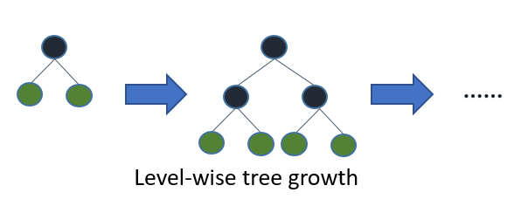[Source](https://github.com/Microsoft/LightGBM/blob/master/docs/Features.rst#references)

All the other popular GBM implementations follow somehting called a Level-wise tree growth, where you find the best possible node to split and you split that one level down. This strategy will result in symmetric trees, where every node in a level will have child nodes resulting in an additional layer of depth.

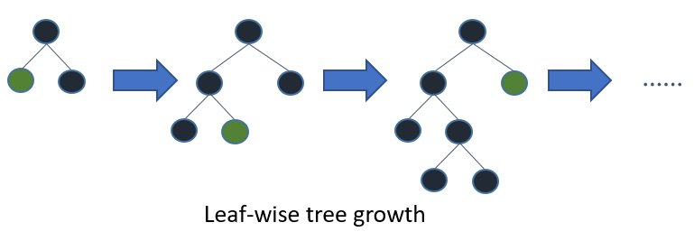[Source](https://github.com/Microsoft/LightGBM/blob/master/docs/Features.rst#references)

In LightGBM, the leaf-wise tree growth finds the leaves which will reduce the loss the maximum, and split only that leaf and not bother with the rest of the leaves in the same level. This results in an asymmetrical tree where subsequent splitting can very well happen only on one side of the tree.

Leaf-wise tree growth strategy tend to achieve lower loss as compared to the level-wise growth strategy, but it also tends to overfit, especially small datasets. So small datasets, the level-wise growth acts like a regularization to restrict the complexity of the tree, where as the leaf-wise growth tends to be greedy.

## Gradient-based One-Side Sampling (GOSS)

Subsampling or Downsampling is one of the ways with which we introduce variety and speed up the training process in an ensemble. It is also a form of regularization as it restricts from fitting to the complete training data. Usually, this subsampling is done by taking a random sample from the training dataset and building a tree on that subset. But what LightGBM introduced was an intelligent way of doing this downsampling.

The core of the idea is that the gradients of different samples is an indicator to how big of a role does it play in the tree building process. The instances with larger gradients (under-trained), contribute a lot more to the tree building process than instances with small gradients. So, when we downsample, we should strive to keep the instances with large gradients so that the tree building is the most efficient.

The most straightforward idea is to discard the instances with low gradients and build the tree on just the large gradient instances. But this would change the distribution of the data which in turn would hurt the accuracy of the model. And hence, the GOSS method.

The algorithm is pretty straightforward:

1. Keep all the instances with large gradients
2. Perform random sampling on instances with small gradients
3. Introduce a constant multiplier for the data instances with small gradients when computing the information gain in the tree building process.
   1. If we select a instances with large gradients and randomly samples b instances with small gradients, we amplify the sampled data by 

## Exclusive Feature Bundling (EFB)

The motivation behind EFB is a common theme between LightGBM and XGBoost. In many real world problems, although there are a lot of features, most of them are really sparse, like on-hot encoded categorical variables. The way LightGBM tackles this problem is slightly different.

The crux of the idea lies in the fact that many of these sparse features are exclusive, i.e. they do not take non-zero values simultaneously. And we can efficiently bundle these features and treat them as one. But finding the optimal feature bundles is an [NP-Hard](https://en.wikipedia.org/wiki/NP-hardness) problem.

To this end, the paper proposes a Greedy Approximation to the problem, which is the Exclusive Feature Bundling algorithm. The algorithm is also slightly fuzzy in nature, as it will allow bundling features which are not 100% mutually exclusive, but it tries to maintain the balance between accuracy and efficiency when selecting the bundles.

The algorithm, on a high level, is:

1. Construct a graph with all the features, weighted by the edges which represents the total conflicts between the features
2. Sort the features by their degrees in the graph in descending order
3. Check each feature and either assign it to an existing bundle with a small conflict or create a new bundle.

## Histogram-based Tree Splitting

The amount of time it takes to build a tree is proportional to the number of splits that have to be evaluated. And when you have continuous or categorical features with high cardinality, this time increases drastically. But most of the splits that can be made for a feature only offer miniscule changes in performance. And this concept is why a histogram based method is applied to tree building.

The core idea is to group features into set of bins and perform splits based on these bins. This reduces the time complexity from O(#data) to O(#bins).

## Sparse Inputs

In another innovation, similar to XGBoost, LightGBM ignores the zero feature values while creating the histograms. And this reduces the cost of building the histogram from O(#data) to O(#non-zero data).

## Categorical Features

In many real world datasets, Categorical features make a big presence and thereby it becomes essential to deal with them appropriately. The most common approach is to represent a categorical feature as it’s one-hot representation, but this is sub-optimal for tree learners. If you have high-cardinality categorical features, your tree needs to be very deep to achieve accuracy.

LightGBM takes in a list of categorical features as an input so that it can deal with it more optimally. It takes inspiration from “On Grouping for Maximum Homogeneity” by Fisher, Walter D. and uses the following methodology for finding the best split for categorical features.

1. Sort the histogram on accumulated gradient statistics
2. Find the best split on the sorted histogram

There are a few hyperparameters which help you tune the way the categorical features are dealt with[4]:

* cat\_l2 , default = 10.0, type = double, constraints: cat\_l2 >= 0.0
  + used for the categorical features
  + L2 regularization in categorical split
* cat\_smooth , default = 10.0, type = double, constraints: cat\_smooth >= 0.0
  + used for the categorical features
  + this can reduce the effect of noises in categorical features, especially for categories with few data
  + max\_cat\_to\_onehot , default = 4, type = int, constraints: max\_cat\_to\_onehot > 0
    - when number of categories of one feature smaller than or equal to max\_cat\_to\_onehot, one-vs-other split algorithm will be used

## Performance Improvements

The majority of the incremental performance improvements were made through GOSS and EFB.

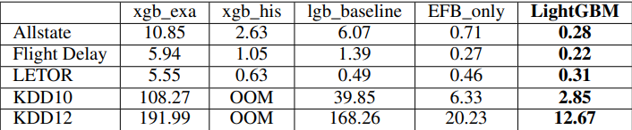Overall training time cost comparison from the LightGBM paper[2]

xgb\_exa is the original XGBoost, xgb\_his is the histogram based version(which came out later), lgb\_baseline is the LightGBM without EFB and GOSS, and LightGBM is with EFB and GOSS. It is quite evident that the improvement in GOSS and EFB is phenomenal as compared to lgb\_baseline.

The rest of the improvements in performance is derived from the ability to parallelize the learning. There are two main ways of parallelizing the learning process:

### Feature Parallel

Feature Parallel tries to parallelize the “Find the best split” part in a distributed manner. Evaluating different splits are done in parallel across multiple workers, and then they communicate with each other to decide among themselves who has the best split.

### Data Parallel

Data Parallel tries to parallelize the whole decision learning. In this, we typically split the data and send different parts of the data to different workers who calculate the histograms based on the section of the data they receive. Then they communicate to merge the histogram at a global level and this global level histogram is what is used in the tree learning process.

### Voting Parallel

Voting Parallel is a special case of Data Parallel, where the communication cost in Data Parallel is capped to a constant.

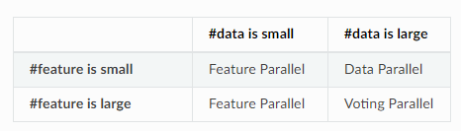When to use which Parallel type? (Source: [LightGBM Parallel Learning Guide](https://lightgbm.readthedocs.io/en/latest/Parallel-Learning-Guide.html))

## HyperParameters

LightGBM is one of those algorithms which has a lot, and I mean a lot, of hyperparameters. It is so flexible that it is intimidating for the beginner. But there is a way to use the algorithm and still not tune like 80% of those parameters. Let’s look at a few parameters that you can start tuning and then build up confidence and start tweaking the rest.

* objective [︎](https://github.com/microsoft/LightGBM/blob/master/docs/Parameters.rst#objective), default = regression, type = enum, options: regression, regression\_l1, huber, fair, poisson, quantile, mape, gamma, tweedie, binary, multiclass, multiclassova, cross\_entropy, cross\_entropy\_lambda, lambdarank, rank\_xendcg, aliases: objective\_type, app, application
* boosting [︎](https://github.com/microsoft/LightGBM/blob/master/docs/Parameters.rst#boosting), default = gbdt, type = enum, options: gbdt, rf, dart, goss, aliases: boosting\_type, boost
  + gbdt, traditional Gradient Boosting Decision Tree, aliases: gbrt
  + rf, Random Forest, aliases: random\_forest
  + dart, [Dropouts meet Multiple Additive Regression Trees](https://arxiv.org/abs/1505.01866)
  + goss, Gradient-based One-Side Sampling
* learning\_rate [︎](https://github.com/microsoft/LightGBM/blob/master/docs/Parameters.rst#learning_rate), default = 0.1, type = double, aliases: shrinkage\_rate, eta, constraints: learning\_rate > 0.0
  + shrinkage rate
  + in dart, it also affects on normalization weights of dropped trees
* num\_leaves [︎](https://github.com/microsoft/LightGBM/blob/master/docs/Parameters.rst#num_leaves), default = 31, type = int, aliases: num\_leaf, max\_leaves, max\_leaf, constraints: 1 < num\_leaves <= 131072
  + max number of leaves in one tree
* max\_depth [︎](https://github.com/microsoft/LightGBM/blob/master/docs/Parameters.rst#max_depth), default = -1, type = int
  + limit the max depth for tree model. This is used to deal with over-fitting when #data is small. Tree still grows leaf-wise
  + <= 0 means no limit
* min\_data\_in\_leaf [︎](https://github.com/microsoft/LightGBM/blob/master/docs/Parameters.rst#min_data_in_leaf), default = 20, type = int, aliases: min\_data\_per\_leaf, min\_data, min\_child\_samples, constraints: min\_data\_in\_leaf >= 0
  + minimal number of data in one leaf. Can be used to deal with over-fitting
* min\_sum\_hessian\_in\_leaf [︎](https://github.com/microsoft/LightGBM/blob/master/docs/Parameters.rst#min_sum_hessian_in_leaf), default = 1e-3, type = double, aliases: min\_sum\_hessian\_per\_leaf, min\_sum\_hessian, min\_hessian, min\_child\_weight, constraints: min\_sum\_hessian\_in\_leaf >= 0.0
  + minimal sum hessian in one leaf. Like min\_data\_in\_leaf, it can be used to deal with over-fitting
* lambda\_l1 [︎](https://github.com/microsoft/LightGBM/blob/master/docs/Parameters.rst#lambda_l1), default = 0.0, type = double, aliases: reg\_alpha, constraints: lambda\_l1 >= 0.0
  + L1 regularization
* lambda\_l2 [︎](https://github.com/microsoft/LightGBM/blob/master/docs/Parameters.rst#lambda_l2), default = 0.0, type = double, aliases: reg\_lambda, lambda, constraints: lambda\_l2 >= 0.0
  + L2 regularization

In the next part of our series, let’s look at the one who tread a path less taken – **CatBoost**

* Part I – [Gradient boosting Algorithm](https://deep-and-shallow.com/2020/02/02/the-gradient-boosters-i-the-math-heavy-primer-to-gradient-boosting-algorithm/)
* Part II – [Regularized Greedy Forest](https://deep-and-shallow.com/2020/02/09/the-gradient-boosters-ii-regularized-greedy-forest/)
* Part III – [XGBoost](https://deep-and-shallow.com/2020/02/12/the-gradient-boosters-iii-xgboost/)
* Part IV – [LightGBM](https://deep-and-shallow.com/2020/02/21/the-gradient-boosters-iii-lightgbm/)
* Part V – [CatBoost](https://deep-and-shallow.com/2020/02/29/the-gradient-boosters-v-catboost/)
* Part VI – NGBoost
* Part VII – The Battle of the Boosters

## References

1. Friedman, Jerome H. Greedy function approximation: A gradient boosting machine. Ann. Statist. 29 (2001), no. 5, 1189–1232.
2. Ke, Guolin et.al. (2017). LightGBM: A Highly Efficient Gradient Boosting Decision Tree. In Advances in Neural Information Processing Systems, pages 3149-3157
3. Walter D. Fisher. “[On Grouping for Maximum Homogeneity](http://www.csiss.org/SPACE/workshops/2004/SAC/files/fisher.pdf).” Journal of the American Statistical Association. Vol. 53, No. 284 (Dec., 1958), pp. 789-798.
4. LightGBM Parameters. <https://github.com/microsoft/LightGBM/blob/master/docs/Parameters.rst#core-parameters>

# **CatBoost**

While XGBoost and LightGBM reigned the ensembles in Kaggle competitions, another contender took its birth in Yandex, the Google from Russia. It decided to take the path less read, and took a different approach to Gradient Boosting. They sought to fix a key problem, as they see it, in all the other GBMs in the world.

Let’s take a look at what made it different:

# Categorical Encoding

Let’s take a look at the innovation which gave the algorithm its name — CatBoost. Unlike XGBoost, CatBoost deals with Categorical variables in a native way. Many studies have shown that One-Hot encoding high cardinality categorical features is not the best way to go, especially in tree based algorithms. And other popular alternatives all come under the umbrella of [Target Statistics — Target Mean Encoding, Leave-One-Out Encoding, etc.](https://www.coursera.org/lecture/competitive-data-science/concept-of-mean-encoding-b5Gxv)

The basic idea of Target Statistics is simple. We replace a categorical value by the mean of all the targets for the training samples with the same categorical value. For example, we have a Categorical value called weather, which has four values — sunny, rainy, cloudy, and snow. The most naive method is something called Greedy Target Statistics, where we replace “sunny” with the average of the target value for all the training samples where weather was “sunny”.

If M is the categorical feature we are encoding and mᵢ is the specific value in M, and n is the number of training samples with M = mᵢ



But this is unstable when the number of samples with mᵢ is too low or zero. Therefore we use the [Laplace Smoothing used in Naive Bayes Classifier](https://towardsdatascience.com/introduction-to-na%C3%AFve-bayes-classifier-fa59e3e24aaf) to make the statistics much more robust.





where a > 0 is a parameter. A common setting for p (prior) is the average target value in the dataset.

But these methods usually suffer from something called Target Leakage because we are using our targets to calculate a representation for the categorical variables and then using those features to predict the target. Leave-One-Out Encoding tries to reduce this by excluding the sample for which it is calculating the representation, but is not foolproof.

CatBoost authors propose another idea here, which they call Ordered Target Statistics. This is inspired by Online Learning algorithms which get the training examples sequentially in time. And in such cases, the Target Statistics will only rely on the training examples in the past. To adapt this idea to a standard offline training paradigm, they imagine a concept of artificial time, but randomly permuting the dataset and considering them sequential in nature.

Then they calculate the target statistics using only the samples which occurred before that particular sample in the artificial time. It is important to note that if we use just one permutation as the artificial time, it would not be very stable and to this end, they do this encoding with multiple permutations.

# Ordered Boosting

The main motivation for the CatBoost algorithm is, as argued by the authors of the paper, the target leakage, which they call Prediction Shift, inherent in the traditional Gradient Boosting models. The high-level idea is quite simple. As we know, any Gradient Boosting model works iteratively by building base learners over base learners in an additive fashion. But since each base learner is build based on the same dataset, the authors argue that there is a bit of target leakage which affects the generalization capabilities of the model. Empirically, we know that Gradient Boosted Trees has an overwhelming tendency to overfit the data. The only countermeasures against this leakage are features like subsampling, which they argue is a heuristic way of handling the problem and only alleviates it and not completely removes it.

The authors formalize the proposed target leakage and mathematically show us that it is present. Another interesting observation that they had is that the target shift or the bias is inversely proportional to the size of the dataset, i.e. if the dataset is small, the target leak is much more pronounced. This observation also agrees with our empirical observation that Gradient Boosted Trees tend to overfit to a small dataset.

To combat this issue, they propose a new variant of Gradient Boosting, called Ordered Boosting. The idea, at its heart, is quite intuitive. The main problem with previous Gradient Boosting was the reuse of the same dataset for each iteration. So, if we have a different dataset for each of the iteration, we would be solving the problem of leakage. But since none of the datasets are infinite, this idea, purely applied, will not be feasible. So, the authors have proposed a practical implementation of the above concept.

It starts out with creating s+1 permutations of the dataset. This permutation is the artificial time that the algorithm takes into account. Let’s call it σ₀ to σₛ. The permutations σ₁ to σₛ is used for constructing the tree splits and σ₀ is used to choose the leaf values bⱼ. In the absence of multiple permutations, the training samples with short “history” will have high variance and hence having multiple permutations ease out that defect.

We saw the way CatBoost deals with Categorical variables earlier and we mentioned that there we use multiple permutations to calculate the target statistics. This is implemented as part of the boosting algorithm which uses a particular permutation from σ₁ to σₛ in any iteration. The gradient statistics required for the tree splits and the target statistics required for the categorical encoding are calculated using the sampled permutation.

And once all the trees are built, the leaf values of the final model F are calculated by the standard gradient boosting procedure(that we saw in the previous articles) using permutation σ₀. When the final model F is applied to new examples from test set, the target statistics are calculated on the entire training data.

One important thing to note it that CatBoost supports the traditional Gradient Boosting also, apart from the Ordered Boosting (boosting\_type = ‘Plain’ or ‘Ordered’). If it is ‘Plain’, and there are categorical features, the permutations are still created for the target statistic, but the tree building and boosting is done without the permutations.

# Oblivious Trees

CatBoost also differs from the rest of the flock in another key aspect — the kind of trees that is built in its ensemble. CatBoost, by default, builds Symmetric Trees or Oblivious Trees. These are trees the same features are responsible for splitting learning instances into the left and the right partitions for each level of the tree.

This has a two-fold effect in the algorithm -

1. Regularization: Since we are restricting the tree building process to have only one feature split per level, we are essentially reducing the complexity of the algorithm and thereby regularization.
2. Computational Performance: One of the most time consuming part of any tree-based algorithm is the search for the optimal split at each nodes. But because we are restricting the features split per level to one, we only have to search for a single feature split instead of k splits, where k is the number of nodes in the level. Even during inference, these trees make it lightning fast. It was shown to be 8X faster than XGBoost in inference.

Although the default option is “ SymmetricTree”, there is also the option to switch to “ Depthwise”(XGBoost) or “ Lossguide”(LightGBM) using the parameter “ grow\_policy “,

# Categorical Feature Combinations

Another important detail of CatBoost is that it considers combinations of categorical variables implicitly in the tree building process. This helps it consider joint information of multiple categorical features. But since the total number of combinations possible can explode quickly, a greedy approach is undertaken in the tree building process. For each split in the current tree, CatBoost concatenates all previously used Categorical Features in the leaf with all the rest of the categorical features as combinations and target statistics are calculated on the fly.

# Overfitting Detector

Another interesting feature in CatBoost is the inbuilt Overfitting Detector. CatBoost can stop training earlier than the number of iterations we set if it detects overfitting. there are two overfitting detectors implemented in CatBoost:

1. Iter
2. IncToDec

Iter is the equivalent of early stopping where the algorithm waits for n iterations since an improvement in validation loss value before stopping the iterations

IncToDec is more slightly involved. It takes a slightly complicated route by keeping track of the improvement of the metric iteration after iteration and also smooths the progression using an approach similar to exponential smoothing and sets a threshold to stop training whenever that smoothed value falls below it.

# Missing Values

Following XGBoost’s footsteps, CatBoost also deals with missing values separately. There are two ways of handling missing values in CatBoost — Min and Max.

If you select “Min”, the missing values are processed as the minimum value for the feature. And if you select “Max”, the missing values are processed as the maximum value for the feature. In both cases, it is guaranteed that the split between missing values and others are considered in every tree split.

# HyperParameters

If LightGBM had a lot of hyperparameters, CatBoost has even more. With so many hyperparameters to tune, GridSearch stops being feasible. It becomes more of an art to get the right combination of parameters for any given problem. But still I’ll try to summarize a few key parameters which you have to keep in mind.

* one\_hot\_max\_size : This sets the maximum number of unique values in a categorical feature below which it will be one-hot encoded and not using Target statistics. It is recommended that you do not do your one-hot encoding before you feed in the feature set, because it will hurt both accuracy and performance of the algorithm.
* iterations — The number of trees to be built in the ensemble. This has to be tuned with a cv or one of the overfitting detection methods should be employed to make the iteration stop at the ideal iteration.
* od\_type, od\_pval, od\_wait — These three parameters configure the overfitting detector.
* od\_type is the type of overfitting detector.
* od\_pval is the threshold for IncToDec(Recommended Range: [10e-10, 10e-2]). Larger the value, earlier Overfitting is detected.
* od\_wait has different meaning depending on the od\_type. If it is IncToDec, the od\_wait is the number of iterations it has to run before the overfitting detector kicks in. If it is Iter, the od\_wait is the number of iterations it will wait without an improvement of the metric before it stops training.
* learning\_rate — The usual meaning. But CatBoost automatically set the learning rate based on the dataset properties and the number of iterations set.
* depth — This is the depth of the tree. Optimal values range from 4 to 10. Default Value: 6 and 16 if boosting\_type is Lossguide
* l2\_leaf\_reg — This is the regularization along the leaves. Any positive value is allowed as the value. Increase this value to increase the regularization effect.
* has\_time — We have already seen that there is an artificial time which is taken to accomplish ordered boosting. But what if your data actually have a temporal order? In such cases set has\_time = True to avoid using permutations in ordered boosting, but instead use the order in which the data was provided as the one and only permutation.
* grow\_policy — As discussed earlier, CatBoost builds “SymmetricTree” by default. But sometimes “Depthwise” and “Lossguide” might give better results.
* min\_data\_in\_leaf is the usual parameter to control the minimum number of training samples in each leaf. This can only be used in Lossguide and Depthwise.
* max\_leaves is the maximum number of leaves in any given tree. This can only be used in Lossguide. It is not recommended to have values greater than 64 here as it significantly slow down the training process.
* rsm or colsample\_bylevel — The percentage of features to be used in each split selection. This helps us control overfitting and the values range from (0,1].
* nan\_mode — Can take values “Forbidden”, “Min”, “Max” as the three options. “Forbidden” does not allow missing values and will throw an error. Min and Max we have discussed earlier.

Other Articles in [The Gradient Boosters](http://towardsdatascience.com/tagged/the-gradient-boosters)

* [The Good Old Gradient Boosting](https://towardsdatascience.com/the-good-old-gradient-boosting-f4614b0e62b0)
* [Regularized Greedy Forest](https://towardsdatascience.com/regularized-greedy-forest-a17cd0c85f06)
* [XGBoost](https://towardsdatascience.com/xgboost-b736c2ab10ce)
* [LightGBM](https://towardsdatascience.com/lightgbm-800340f21415)
* CatBoost (you are here)

# **Getting Deeper into Categorical Encodings for Machine Learning**

[](https://towardsdatascience.com/@pgrover3?source=post_page-----2312acd347c8----------------------)

[Prince Grover](https://towardsdatascience.com/@pgrover3?source=post_page-----2312acd347c8----------------------)

[Follow](https://medium.com/m/signin?operation=register&redirect=https%3A%2F%2Ftowardsdatascience.com%2Fgetting-deeper-into-categorical-encodings-for-machine-learning-2312acd347c8&source=-2f052b054cee-------------------------follow_byline-)

[Jul 9, 2019](https://towardsdatascience.com/getting-deeper-into-categorical-encodings-for-machine-learning-2312acd347c8?source=post_page-----2312acd347c8----------------------) · 14 min read

**Bonus: Ordered target encoding proposed by**[**Catboost**](https://catboost.ai/)



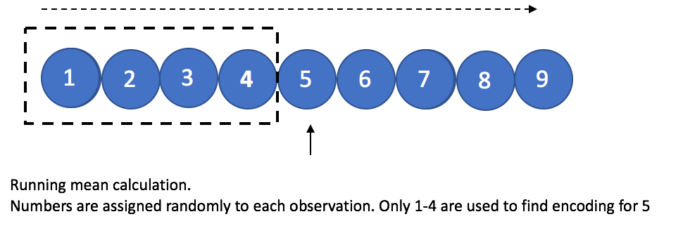

# Introduction

In my experience with supervised learning, improving the model performance from decent to human-like requires creative feature engineering. Jumping from simple algorithms to complex ones does not always boost performance if the feature engineering is not done right. The goal of supervised learning is to extract all the juice from the relevant features and to do that, we generally have to enrich and transform features in order to make it easier for the algorithm to see how the target variable depends on given data. One type of features that do not easily give away the information they contain are **categorical features**. They keep on hiding the information until we transform them smartly. In this particular post, I am focussing on one particular categorical encoding technique called **target encoding** which works really well most of the times, but it has a risk of target leakage if not done correctly. Target leakage means using some information from target to predict the target itself (you see the issue here?). This leakage consequently increases the risk of overfitting on the training data, especially when the data is small. Similar target leakage also exists in standard gradient boosting algorithms. [Catboost](https://catboost.ai/) has implemented a technique called **ordering principle** which solves the problem of target leakage in both cases. Based on this technique plus numerous other small improvements, Catboost outperforms other publicly available gradient boosting libraries on a set of popular publicly available datasets. The comparison experiments done by Catboost are summarized in this paper — [CatBoost: unbiased boosting with categorical features](https://papers.nips.cc/paper/7898-catboost-unbiased-boosting-with-categorical-features.pdf).

# Standard Approches

**One-hot Encoding**— One common technique for dealing categorical features is **one-hot-encoding**, i.e. for each level of category, we create a binary feature. However, in the case of high cardinality (e.g. city ID , region ID, zip codes), this technique leads to infeasibly large number of features. Tree based models particularly suffer from such a large number of one-hot features because; 1) tree only grows in the direction of zeroes of one hot feature (shown in figure below), 2) if tree wants to split on one-hot (0,1) feature, it’s information gain will be low and thus tree will be unable to get splits from the feature near the root if other continuous features are also present.

**Label Encoding** — Another standard encoding technique is **numerical encoding** (aka **label encoding**) where we assign a random number to each category. This technique infuses some form of order in the data and that order generally doesn’t make sense and is random. We are required to maintain a mapping of category to number in order to later apply same mapping for test data. Maintaining the mapping can sometimes become hard for models in production. Tree based models suffer from this encoding too, as trees find best split based on values less than or greater than an optimum value. In case of random ordering, less than or greater than does not really make any sense.

**Hash Encoding —**This commonly used technique converts string type features into a fixed dimension vector using a hash function. The hash function employed in sklearn is the [signed 32-bit version of Murmurhash3](https://scikit-learn.org/stable/modules/generated/sklearn.feature_extraction.FeatureHasher.html). A 32 dimensional vector can hold 2³² unique combinations. This becomes useful for high cardinality variables where one hot encoding will give huge number of features. I have recently noticed this technique to work really well, particularly for cases where categories have some information in their string pattern.

Pros of hashing: 1) No need to maintain a mapping of category to number mapping. Just need to use the same hash function to encode the test data; 2) Reduction of levels specially in case of high cardinality features, which consequently makes it easier for tree to split; 3) Can combine multiple features to create single hash. This helps in capturing feature interactions.

Cons of hashing: 1) Hash collisions. Different levels of categories can fall into the same bucket. If those categories do not affect target equally, then prediction score might suffer; 2) Need to tune another hyper parameter of number of hash vector dimensions.  
  
**Target Encoding**— Another option, which is also the prime focus of this blogpost is **target encoding** (aka **likelihood encoding).** The idea is to replace each level of the categorical feature with a number and that number is calculated from the distribution of the target labels for that particular level of category. For example, if the levels of categorical feature are red, blue and green. Then replace red with some statistical aggregate (mean, median, variance etc.) of all the target labels where-ever the feature value is red in training data.

Below plots show how a decision tree gets constructed for a categorical feature when it is one-hot encoded vs. when it is numerical encoded (a random number for each category). The third plot shows the decision tree with target encoded feature. **For all the plots, a simulated data of 1000 rows with only one categorical feature and a binary target is used. The categorical feature has high cardinality and has 100 different levels labelled from 0 to 99**(keep in mind order doesn’t make sense as we are treating it as nominal categorical feature).**The target is dependent on the feature in such a way that categories that are multiple of 11 (0, 11,22,33 .. 99) have target value of 1 and 0 for all other cases.** T**he data has 897 negative and 103 positive labels).** The plots are constructed using [dtreeviz](https://github.com/parrt/dtreeviz) library for decision tree visualizations with trees having a constraint of max depth 5. [Jupyter notebook link](https://github.com/groverpr/Machine-Learning/blob/master/catboost/ohc_dtreeviz.ipynb) for code to generate these plots.

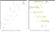

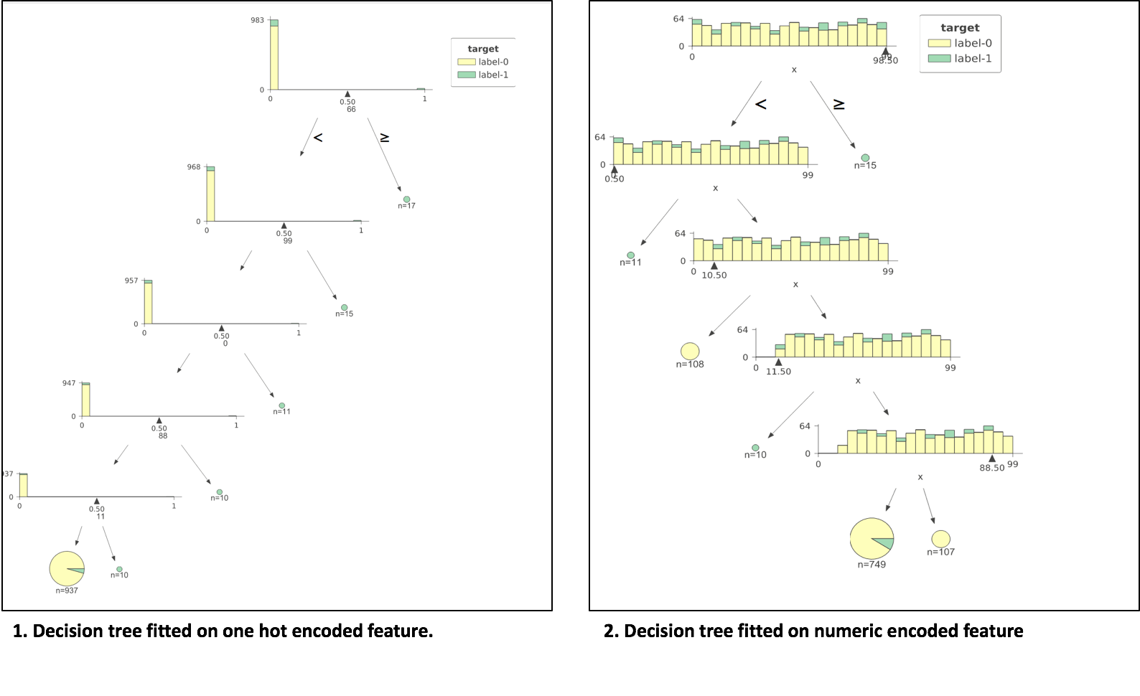

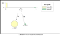

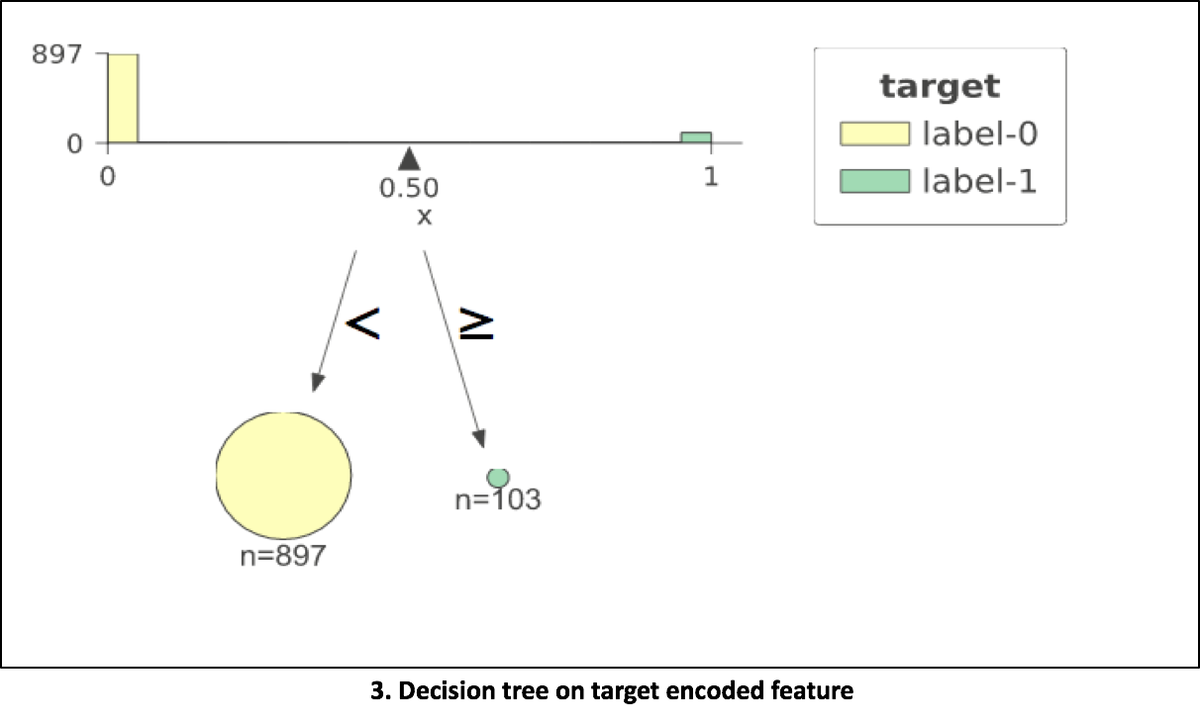

In the 1st plot, we can see that decision tree with one-hot encoded features creates many many splits and the tree is all left-sided. The tree is still getting the work done and is able to separate the data. We observe split values to be 66, 99, 0, 88, 11 respectively from root to leaf. At each split, information gain is low as split focuses only on one level of the categorical feature. If we introduce noisy continuous features, the tree might find more information gain in noise than some one-hot encoded feature and would give those up in feature importance plots, which is sometimes misleading. This issue is discussed in detail in this blogpost — [Are categorical variables getting lost in your random forests?](https://roamanalytics.com/2016/10/28/are-categorical-variables-getting-lost-in-your-random-forests/) and this kaggle discussion page — [Why one-hot-encoding gives worse scores?](https://www.kaggle.com/c/zillow-prize-1/discussion/38793)  
  
In the 2nd plot, tree splits on 98.5, 0, 10.5, 11.5, 88.5 respectively from root to leaf. So this tree is also getting to the right answer and finding splits close to multiple of 11. It is assuming an order in the numbers assigned to categories, which in reality is random assignment. We see that the tree finds it difficult to get to a good decision boundary even for this perfect rule based data. In practice, I have noticed this technique to work well with random forest or gradient boosting techniques as long as cardinality is not high. If cardinality is high numerical encoding is likely to make your computational costs explode before you get any benefit. A workaround to this problem of computational cost is to assign number/rank based on the frequency of that level.  
  
In the 3rd plot, tree with target mean encoding found the perfect division of data in just 1 decision stomp/split. We see that this encoding worked great in our toy example. Let’s dig into this further and limit the scope of this article to target encoding, target leakage/prediction shift, overfitting caused due to this type of encoding; and finally Catboost’s solution to this problem.

# Target Encoding

## Different types of target encoding

Target encoding is substituting the category of k-th training example with one numeric feature equal to some target statistic (e.g. mean, median or max of target).

1. Greedy
2. Holdout
3. K-fold
4. Ordered (the one proposed by Catboost)

Now let’s discuss pros and cons of each of these types.

## Greedy target encoding

This is the most straightforward approach. Just substitute the category with the average value of target label over the training examples with the same category. We are only getting to see the labels of the training data. So, we find the mean encoding of all categories from the training data and map as it is to the test data. For the cases where some new category is found in test and not available in training data, we substitute values of that category with overall mean of the target. This works fine as long as we have large amount of training data, categorical features with low cardinality and the target distribution is in training and test data. But this fails to work in the other cases.

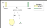

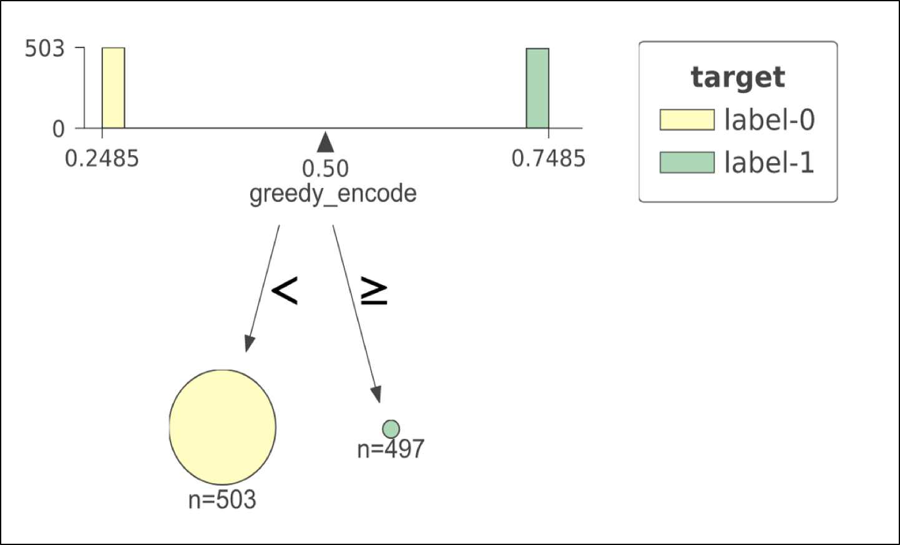

**Decision tree on greedy target encoded feature**

Let’s look at an extreme example to show failure of this encoding technique. On the left, we see a decision tree plot with perfect split at 0.5 threshold. The training data used for this model has 1000 observations with only one categorical feature having 1000 unique levels. Think of User ID as an example of such unique categorical feature. The labels (0,1) have been assigned randomly to the training data. That means that the target doesn’t have any relationship with the feature. But what decision tree shows us? The tree shows us a perfect split at the very first node, even though in reality the perfect split doesn’t exists. The model will show near perfect score on the training data. Is that true? No. Test data might have new User IDs not seen in training data and our model will suck on the test data. This is the case of “overfitting on the training data”. Later we will solve this issue.

## K-fold target encoding



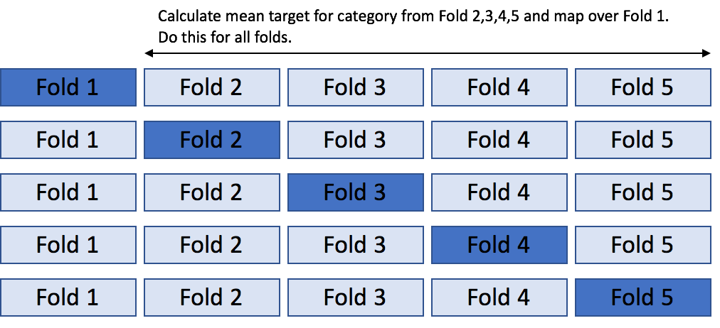

This is the most commonly used approach and solves the issue of overfitting on the training data (“mostly”, not always). The idea is similar to [k-fold cross validation](https://scikit-learn.org/stable/modules/cross_validation.html). We divide the data in K- stratified or random folds, replace the observations present in M-th fold with mean target of data from all others except M-th fold. We are basically trying to 1) Use all of the training data given to us, 2) Not leak the information from self-target label by allowing target information to flow from other fellow observations (same category but other folds). Most of the times, I personally use this approach with K=5 and so-far it has worked well for small to large datasets.

**Holdout target encoding -**special case of K-fold when K=2.

Another option is to partition the training dataset into 2 parts. First part to calculate target statistic and the second part to do model training. This way we are not leaking any information from the target of second part which is actually being used for training. But this technique leads to the problem of data reduction as we are basically using less training data than we actually have. With this approach we are not effectively using all the training data we have at our hand. Works when we have large amount of data, still not a great solution though.

**Leave one out target encoding -** special case of K-fold when K=length of training data.

This is particularly used when we have small dataset. We calculate target statistic for each observation by using labels from all except that particular observation. But this technique can also lead to overfitting in some cases. Let’s see one such failure example using the decision tree visualization.



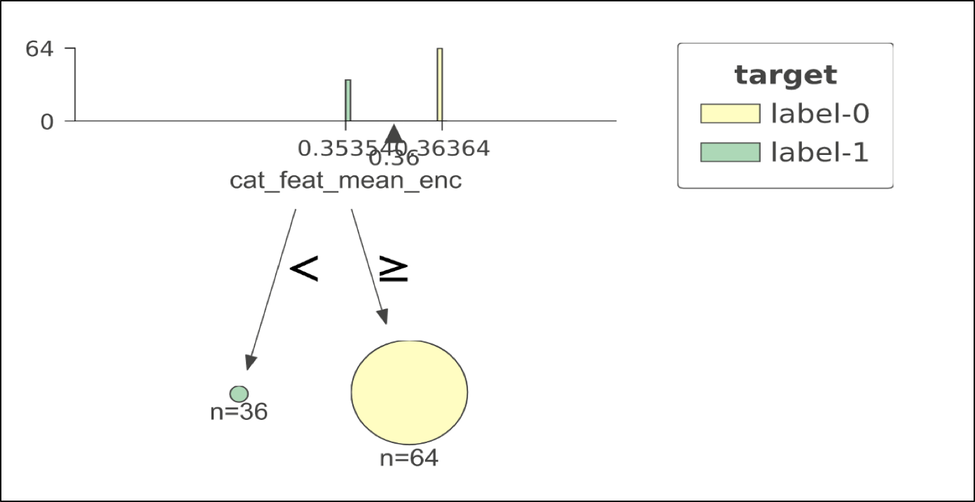

**Decision tree on leave one out encoded feature**

In this example our training data has 100 observations and only 1 feature; call it color and it is always red. It is obvious that this feature is useless. If we try to fit a decision tree with leave one out encoding on this feature, we might end up with a perfect split of the training data (as shown below). This is misleading as this perfect split doesn’t exists. The reason it gives this split is because when we use leave one out, it either leaves 0 out or leaves 1 out, giving us only two unique encodings. When we train model on this, it uses those two unique values to find perfect split.

## Ordered target encoding

This is not a commonly used approach. But this is the core idea behind Catboost library, which works really well for categorical data as shown in [this](https://papers.nips.cc/paper/7898-catboost-unbiased-boosting-with-categorical-features.pdf) paper. This technique is motivated from the validation techniques used to handle the time series data. When the distribution of target is not consistent with time, we need to take special care to not leak any information from the future while tuning hyper-parameters. Different ways to do hyper-parameter tuning or splitting validating set in time series data are discussed in this blogpost — [Time Series Nested Cross-Validation](https://towardsdatascience.com/time-series-nested-cross-validation-76adba623eb9). The basic idea is to use**out of time validation** approaches as traditional k-fold methods do not work well in such cases. Similar to that, ordered target encoding relies on the concept of artificial time dependency. We calculate target statistic for each example by only using the target from the history. To generate the proxy concept of time, we randomly shuffle the data. To simplify, we randomize the rows and take running average of target label grouped by each category.





But there is a problem in taking group-wise running averages. For the initial few rows in the randomized data, the mean encoding will have high variance as it only saw a few points from the history. But as it sees more data, the running average starts to get stable. This instability due to randomly chosen initial data points makes the initial part of dataset to have weak estimates. Catboost handles this problem by using more than one random permutations. It trains several models simultaneously, each one is trained on its own permutation. All the models share the same tree forest i.e the same tree structures. But leaf values of these models are different. Before building the next tree, CatBoost selects one of the models, which will be used to select tree structure. The structure is selected using this model, and is then used to calculate leaf values for all the models.

Let’s see if the ordered encoding solves the failure cases we discussed for the leave one out and greedy target encoding techniques.



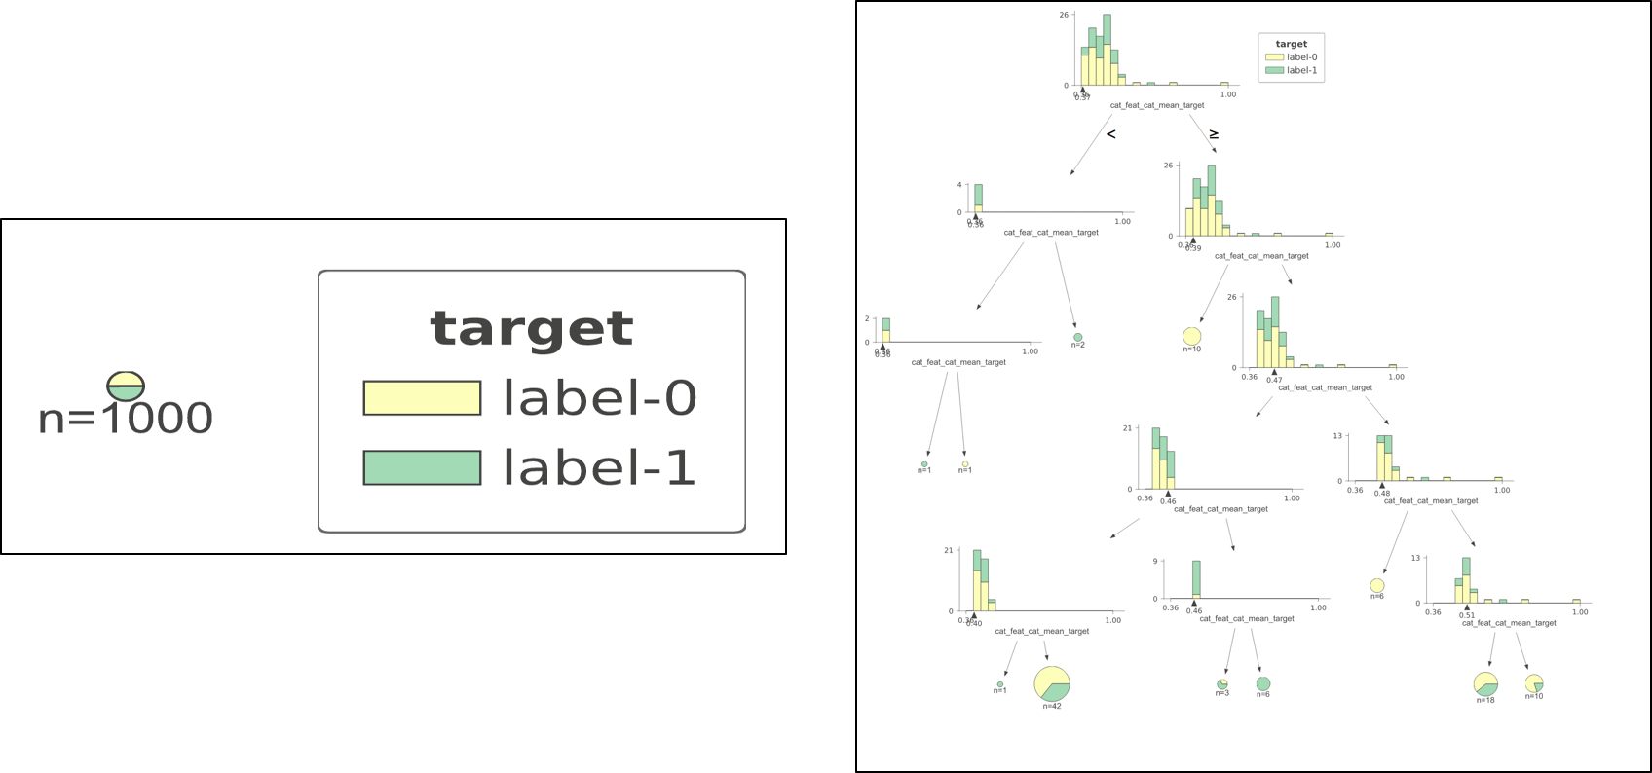

**Left: No successful split in case of all unique categories. Right: Decision tree construction for case of all same category.**

Case 1 (left plot). When we have all unique categories and greedy approach fails. We see that ordered encoding just can’t simply find any good split at the first place. Case 2 (right plot). When we have all same category. Leave one out fails in this by giving perfect split in the first node. But ordered encoding struggles to find a good model as it should be.

*CatBoost also uses ordered target encoding for categorical feature combinations, which is useful for some datasets. The combinations are selected during training in a greedy fashion. We are not discussing the procedure here. But curious readers can read*[*this*](https://papers.nips.cc/paper/7898-catboost-unbiased-boosting-with-categorical-features.pdf)*paper to learn the procedure for combining features.*

## Leaderboard

Having seen different types of encodings, let’s do some fun stuff. Let’s compare performance of a Random Forest on a couple of datasets for all these encodings and see which comes to the top of the leaderboard. Also adding the performance of Catboost on each dataset.

Below experiments are run on the datasets:  
1. Random Forest (500 trees, 10 max\_depth) on One Hot Encoded feature  
2. Random Forest (500 trees, 10 max\_depth) on Numeric Labels  
3. Random Forest (500 trees, 10 max\_depth) on Hash Encoded feature  
4. Random Forest (500 trees, 10 max\_depth) on K-fold Target Encoding  
5. Random Forest (500 trees, 10 max\_depth) on Ordered/Catboost Target Encoding  
6. Catboost (500 iterations, 20 early stopping rounds); categorical indexes

## Dataset 1.

Simulated dataset with just one categorical feature. 10,000 data points, 100 level cardinality. The feature is creating using random string generator. Each string is of length 5 and 100 such unique strings are generated. These 100 strings are resampled with replacement to give 10,000 data points. Strings starting with vowel have target label 1 and others have target label 0. Around 20% of data has positive labels.

**Results**



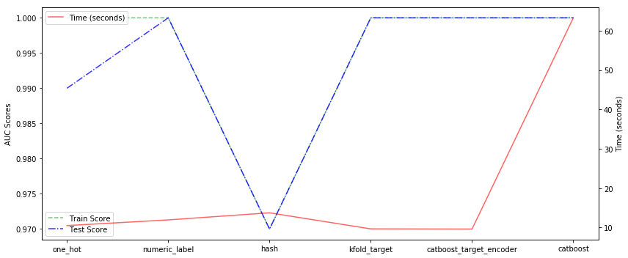

**Left to right. 1–5 are categorical encodings on RF. 6 is Catboost GBM.**

We see that target encodings and number encodings give perfect scores on test data. The trees in all the cases have been regularized to maximum depth of 10. One hot encoding and hash encodings do not give perfect scores on the test data. The hash encoding must have encountered some collisions and would have put some words starting with vowel in same bucket as words starting with consonants, which is why we see some score reduction. In terms of time, 500 iterations in Catboost take a lot more time as compared to 500 trees of Random Forest. The best way to efficiently use a gradient boosting algorithm is to use early stopping rounds and better learning rate.

## Dataset 2.

Kaggle data. [Amazon.com — Employee Access Challenge](https://www.kaggle.com/c/amazon-employee-access-challenge). This dataset has 8 features and all are categorical features with cardinalities ranging from low to high values. (0.2% to 22% unique categories).

**Results**



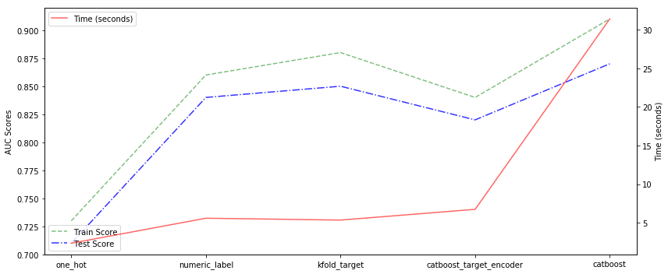

**Left to right. 1–4 are categorical encodings on RF. 5 is Catboost GBM.**

We see that the catboost outperforms the random forest in terms of performance but is relatively slower. The best random forest model is attained when we used K-fold target encoding, following by number and ordered/catboost target encodings. There is no string type feature in the dataset, so we haven’t used hash encoding. The one hot encoding doesn’t give good performance with fixed depth RF.

Jupyter notebook with comparisons of different encoding techniques

## Conclusion

By experiments we learnt that in practice, numeric encoded features do pretty well with random forests. Target encoding gives a little bit of improvement on top of numerical encoding. In terms of time efficiency, target encoded features help trees to find solution with much lesser splits. Traditional greedy and leave one out target encodings have a risk of overfitting. Such overfitting  
can be solved by either using 5/10-fold target encoding or ordered target encoding. The ordered target encoding introduces an artificial concept of time in data by random permutation of rows. Catboost creates multiple trees with different random permutations to generate a strong model without any target leakage.

[Link](https://github.com/groverpr/Machine-Learning/tree/master/catboost) to code repository

## **Recommended Readings**

1. [Transforming categorical features to numerical features](https://catboost.ai/docs/concepts/algorithm-main-stages_cat-to-numberic.html) - Catboost
2. Paper that motivated this post: [CatBoost: unbiased boosting with categorical feature](https://papers.nips.cc/paper/7898-catboost-unbiased-boosting-with-categorical-features.pdf)s
3. Another great post on visualization of trees for categorical features: [Visiting: Categorical Features and Encoding in Decision Trees](https://medium.com/data-design/visiting-categorical-features-and-encoding-in-decision-trees-53400fa65931)
4. Chapter of ML book by [Terence Parr](http://parrt.cs.usfca.edu/) and [Jeremy Howard](http://www.fast.ai/about/#jeremy): [Categorically Speaking](https://mlbook.explained.ai/catvars.html)
5. If don’t know about gradient boosting, read this simple to understand post: [Gradient Boosting from scratch](https://medium.com/mlreview/gradient-boosting-from-scratch-1e317ae4587d)
6. [Let’s Write a Decision Tree Classifier from Scratch — Machine Learning Recipes #8](https://www.youtube.com/watch?v=LDRbO9a6XPU&t=292s)
7. [One-Hot Encoding is making your Tree-Based Ensembles worse, here’s why?](https://towardsdatascience.com/one-hot-encoding-is-making-your-tree-based-ensembles-worse-heres-why-d64b282b5769)

## [Towards Data Science](https://towardsdatascience.com/?source=post_sidebar--------------------------post_sidebar-)

#### **A Medium publication sharing concepts, ideas, and codes.**

# **Visiting: Categorical Features and Encoding in Decision Trees**

[](https://medium.com/@Laurae2?source=post_page-----53400fa65931----------------------)

[Laurae](https://medium.com/@Laurae2?source=post_page-----53400fa65931----------------------)

Follow

[Apr 23, 2017](https://medium.com/data-design/visiting-categorical-features-and-encoding-in-decision-trees-53400fa65931?source=post_page-----53400fa65931----------------------) · 10 min read

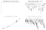

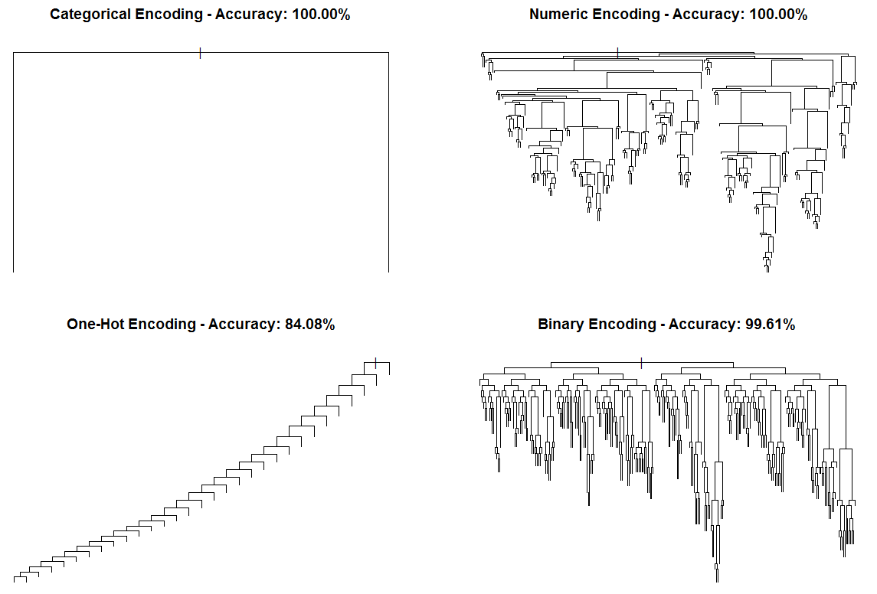

Full source code for the experiment and plots can be found here: <https://github.com/Laurae2/CategoricalAnalysis>

When you have categorical features and you are using decision trees, you often have a major issue: how to deal with categorical features?

Often you see the following…:

* Postponing the problem: use a machine learning model which handle categorical features, the greatest of solutions!
* Deal with the problem now: design matrix, one-hot encoding, binary encoding…

Usually, you WILL want to deal with the problem now, because if you postpone the problem, it means you already found the solution:

* You do not postpone problems because in Data Science, they accumulate quickly like hell (good luck remembering every problem encountered, then come back 1 month later without thinking about them and recite them each).
* You do not postpone problems without knowing the potential remedy afterwards (otherwise, you might have a working pipeline but no solution to solve it!).

So what is the matter? Let’s go back to the basics of decision trees and encoding, then we can test some good stuff… in three parts:

* **Machine Learning Implementations: specifications differ**
* **Example ways of Encoding categorical features**
* **Benchmarking Encodings versus vanilla Categorical features**

# Decision Trees and Encoding

## Machine Learning Specification

When using decision tree models and categorical features, you mostly have **three types of models**:

1. Models handling categorical features **CORRECTLY**. You just throw the categorical features at the model in the appropriate format (ex: as factors in R), **AND** the machine learning model processes categorical features **correctly** as categoricals. **BEST CASE because it fits your needs.**
2. Models handling categorical features **INCORRECTLY**. You just throw the categorical features at the model in the appropriate format (ex: as factors in R), **BUT** the machine learning model processes categorical features **incorrectly** by doing wizardry processing to transform them into something usable (like one-hot encoding), unless you are aware of it. **WORST CASE EVER because it does not do what you expected to do.**
3. Models **NOT** handling categorical features at all. You have to **preprocess manually** the categorical features to have them in an appropriate format for the machine learning model (usually: numeric features). But how do you transform (aka **ENCODE**) them?

We will target specifically the **third type** of model, because it is what we want to **assess**. There are **many methods to encode categorical features**. We are going to check three of them: **numeric encoding, one-hot encoding, and binary encoding**.

## Categorical Encoding Specification

Categorical Encoding refers to **transforming a categorical feature into one or multiple numeric features**. You can use **any mathematical method or logical method** you wish to transform the categorical feature, the sky is the limit for this task.

* **Numeric Encoding**



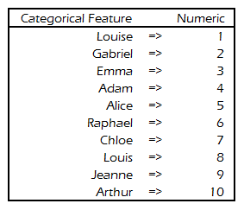

Are you transforming your categorical features by hand or are you doing the work with a computer?

**Numerical Encoding** is very simple: **assign an arbitrary number to each category**.

There is no rocket science for the transformation, except perhaps… **how do you assign the arbitrary number**? Is there a simple way?

The typical case is **to let your favorite programming language do the work**.

For instance, you might do like this in R…

my\_data$cat\_feature <- as.numeric(as.factor(my\_data$cat\_feature))

Such as this:

as.numeric(as.factor(c("Louise",  
 "Gabriel",  
 "Emma",  
 "Adam",  
 "Alice",  
 "Raphael",  
 "Chloe",  
 "Louis",  
 "Jeanne",  
 "Arthur")))

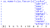

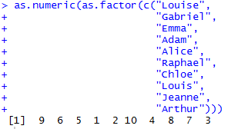

This works, this is not brainer, and it encodes the way it wants deterministically (check the ordering and you will see).

* **One-Hot Encoding**



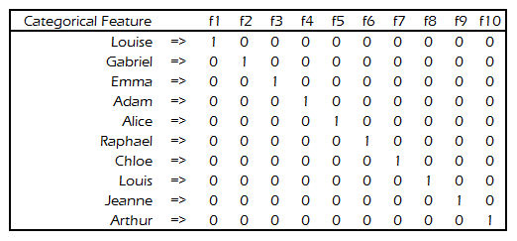

One-Hot Encoding is just a design matrix with the first factor kept. A design matrix removes the first factor to avoid the matrix inversion problem in linear regressions.

Ever heard about **One-Hot Encoding** and its magic? Here you have it: this is a **design matrix where you keep the first factor instead of removing it** (how simple!).

To put it clear, just check the picture as it talks for itself better than 1,000 words.

In addition to thinking about what One-Hot Encoding does, you will notice something very quickly:

* You have **as many columns as you have cardinalities** (values) in the categorical variable.
* You have a **bunch of zeroes and only few 1s**! (one 1 per new feature)

Therefore, you have to **choose between two representations** of One-Hot Encoding:

* **Dense Representation**: **0s are stored in memory**, which ballons the RAM usage a LOT if you have many cardinalities. But at least, the support for such representation is typically… worldwide.
* **Sparse Repsentation**: **0s are not stored in memory**, which makes RAM efficiency a LOT better even if you have millions of cardinalities. However, good luck finding support for sparse matrices for machine learning, because it is not widespread (think: xgboost, LightGBM, etc.).

Again, you usually **let your favorite programming language doing the work**. Do not loop through each categorical value and assign a column, because this is NOT an efficient at all. It is not difficult, right?

Example in R, “one line”!:

model.matrix(~ cat + 0,  
 data = data.frame(  
 cat = as.factor(c("Louise",  
 "Gabriel",  
 "Emma",  
 "Adam",  
 "Alice",  
 "Raphael",  
 "Chloe",  
 "Louis",  
 "Jeanne",  
 "Arthur"))))

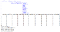

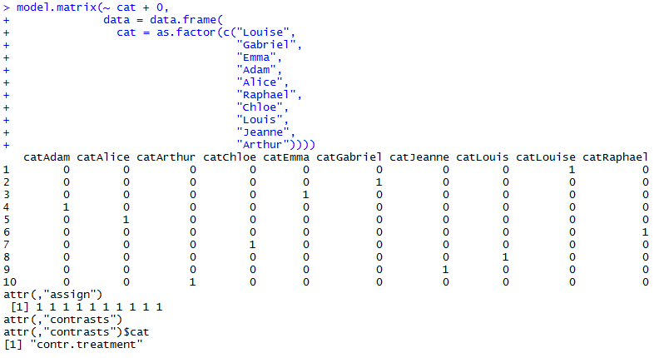

Dense One-Hot Encoding in R example. As usual, the specific order is identical to the numeric version due to as.factor choosing the order arbitrarily!

If you are **running out of available memory**, what about working with **sparse matrices**? Doing it in R is no brainer in “one line”!

library(Matrix)  
sparse.model.matrix(~ cat + 0,  
 data = data.frame(  
 cat = as.factor(c("Louise",  
 "Gabriel",  
 "Emma",  
 "Adam",  
 "Alice",  
 "Raphael",  
 "Chloe",  
 "Louis",  
 "Jeanne",  
 "Arthur"))))

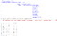

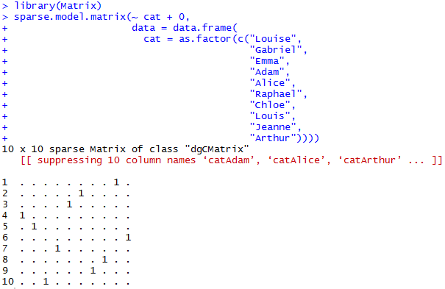

Sparse One-Hot Encoding in R. There is no difference to the Dense version, except we end up with a sparse matrix (dgCMatrix: sparse column compressed matrix).

* **Binary Encoding**



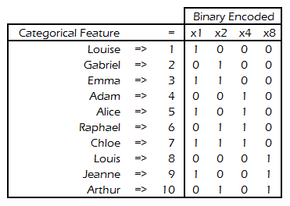

Power of binaries!

The objective of **Binary Encoding**… is to **use binary encoding to hash the cardinalities** into binary values.

By using the **power** law of binary encoding, we are able to **store N cardinalities using ceil(log(N+1)/log(2))** **features**.

**It means we can store 4294967295 cardinalities using only 32 features with Binary Encoding!** Isn’t it awesome to not have those 4294697295 features from One-Hot Encoding? (how are you going to learn 4 billion features in a decision tree…? you need a depth of 32 and it is not readable…)

Still as easy in (base) R, you just need to think you are **limited to a specified number of bits** (will you ever **reach 4294967296 cardinalities**? If yes, **get rid of some categories because you got too many of them**…):

my\_data <- c("Louise",  
 "Gabriel",  
 "Emma",  
 "Adam",  
 "Alice",  
 "Raphael",  
 "Chloe",  
 "Louis",  
 "Jeanne",  
 "Arthur")  
matrix(  
 as.integer(intToBits(as.integer(as.factor(my\_data)))),  
 ncol = 32,  
 nrow = length(my\_data),  
 byrow = TRUE  
)[, 1:ceiling(log(length(unique(my\_data)) + 1)/log(2))]



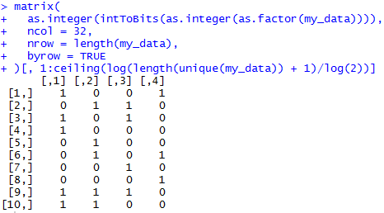

Binary Encoding in base R.

Ugh, the formula is a bit larger than expected. But you get the idea:



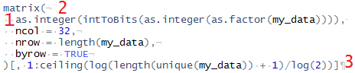

Three key operations to perform for binary encoding.

* **Operation 1**: convert my\_data to factor, then to integer (“numeric”), then to numeric binary representation (as a vector of length 32 for each observation), then to integer (“numeric”).
* **Operation 2**: convert the “numeric” to a matrix with 32 columns and the same number of rows as the number of original observations.
* **Operation 3**: using the inverse of the binary power property (ceil(log(N+1)/log(2))), remove all the unused columns (the columns with zeroes).

There are, obviously, easier ways to do this. But I am doing this example to show you can do this in base R. No need fancy package stuff.

# Benchmarking Performance of Encoding

We are going to benchmark the performance of four types of encoding:

* **Categorical Encoding** (raw, as is)
* **Numeric Encoding**
* **One-Hot Encoding**
* **Binary Encoding**

We will use rpart as the decision tree learning model, as it is also independent to random seeds.

The experimental design is the following:

* We create datasets of **one categorical feature with 8 to 8,192 cardinalities** (steps of power of 2).
* We use **25% or 50% of cardinalities as positive labels to assess performance** of the decision tree. This means a **ratio of 1:3 or 1:1**.
* We **run 250 times each combination of cardinalities and percentage of positive labels** to get a **better expected value** (mean) of performance.
* To speed up the computations, we are using **6 parallel threads** as One-Hot Encoding is computationally intensive.
* The rpart function is **limited to a maximum depth of 30 for practical usage**, and used with the following parameters:

rpart(label ~ .,  
 data = my\_data,  
 method = "class",  
 parms = list(split = "information"),  
 control = rpart.control(minsplit = 1,  
 minbucket = 1,  
 cp = 1e-15,  
 maxcompete = 1,  
 maxsurrogate = 1,  
 usesurrogate = 0,  
 xval = 1,  
 surrogatestyle = 1,  
 maxdepth = 30))

Warning: remember we are doing this on a synthetic dataset with perfect rules. You may get contradictory performance on real world datasets.

## Sneak Peak: how are the decision trees looking?

For the sake of example, with 1024 categories and 25% positive labels.

* **Categorical Encoding**



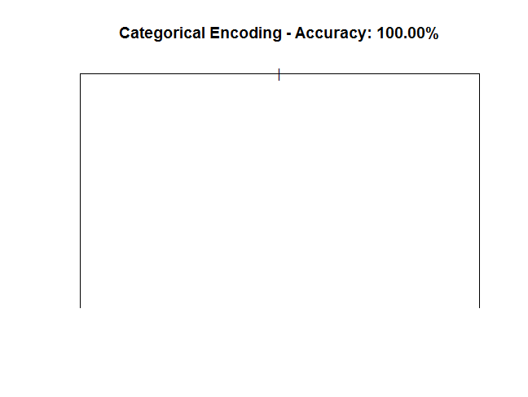

* **Numeric Encoding**

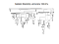

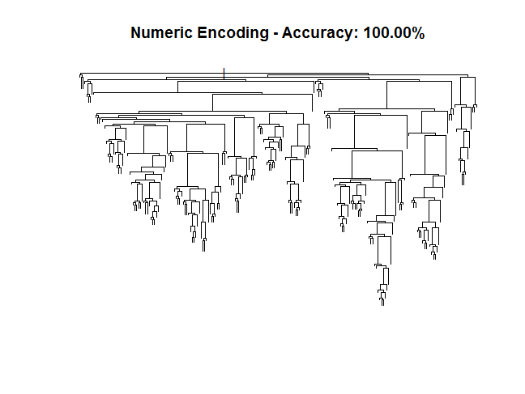

* **One-Hot Encoding**

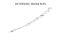

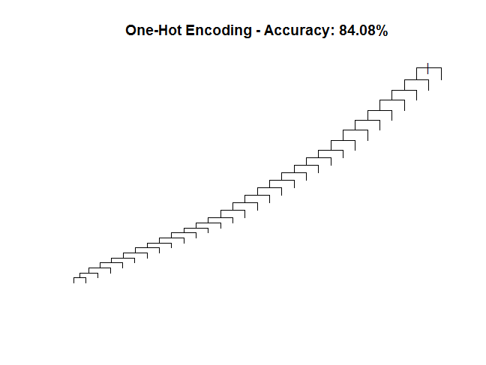

* **Binary Encoding**

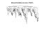

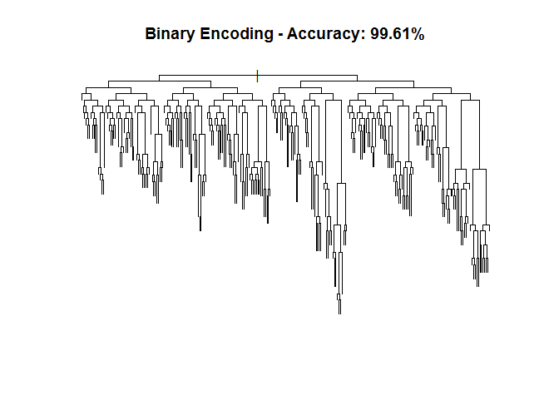

One can understand it as the following:

* **Categorical encoding** well… **equality rules so it’s easy to split**.
* **Numeric encoding requires splitting itself**, if it splits 30 times in a row on the same branch then it’s over. **If a split is frozen afterwards, then it is also over for that branch. Therefore, lot of RNG shaping!**
* **One hot encoding requires.. as many splits as there are categories, which means a crazy lot** and so much **it stops very quickly because if you do one split, one part of the split will be frozen (because it is a perfect rule dataset)** => it gives this **escalator-like shape**, thus very poorly performing.
* **Binary encoding** has less than 30 features in all my cases, therefore **each tree should be able to depict all the rules** (theory is true, **practice is wrong because you need splits to not close** on themselves, which is not possible in theory, but possible in practice) => it gives this **right-tailed tree shape**. When the **unbalancing increases, the performance increases** because it requires a **lower expected value (mean) of splits to perform a perfect split** than a perfectly balanced case.

## General Accuracy of Encodings

Without looking in depth into the accuracy, we are going to look quickly at the general accuracy of the four encodings we have.

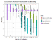

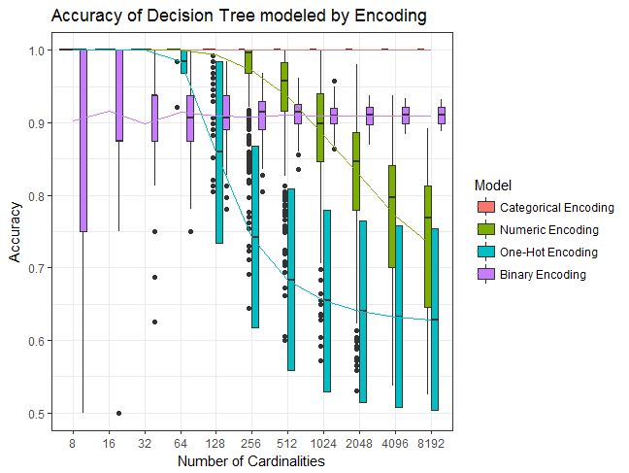

On the picture, we can clearly notice a trend:

* **Categorical Encoding is the clear winner**, with an exact 100% Accuracy at any time.
* **Numeric Encoding is doing an excellent job as long as the number of cardinalities is not too large**: from 1,024 cardinalities, its accuracy falls off drastically. Its accuracy over all the tests is around 92%.
* **One-Hot Encoding is doing an excellent job like Numeric Encoding, except it falls down very quickly**: from 128 cardinalities, performing consistency worse than Binary Encoding. Its accuracy over all the runs is around 80%.
* **Binary Encoding is very consistent in performance but not perfect**, even with 8,192 cardinalities. Its exact accuracy is approximately 91%.

## Balancing Accuracy of Encodings

To look further at the details, we are splitting the balancing ratio (25% and 50%) of the positive label to check for discrepancies.

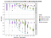

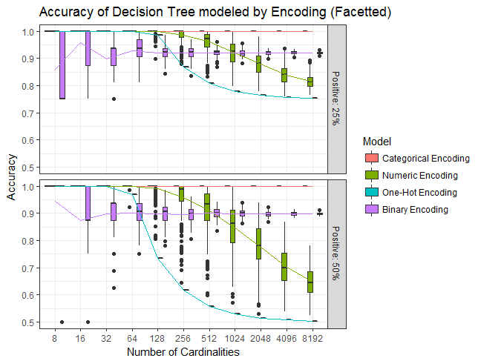

We are clearly noticing one **major trend**:

* **The more the dataset is unbalanced, the more accurate the encodings become.**
* Inversely: **the more the dataset is balanced, the less accurate the encodings become**.

We can also notice our **Numeric Encoding is getting worse faster versus Binary Encoding when the dataset becomes more balanced**: it becomes worse from 1024 cardinalities on a perfectly balanced dataset, while it becomes worse only from 2048 cardinalities on a 1:3 unbalanced dataset.

For **One-Hot Encoding, it is even more pronounced**: worse 256 cardinalities on a perfectly balanced dataset, to 128 cardinalities on a 1:3 unbalanced dataset.

In addition, there seems to be no reason to use One-Hot Encoding over Numeric Encoding according to the picture.

In addition, there are three specific trends we can capture:

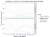

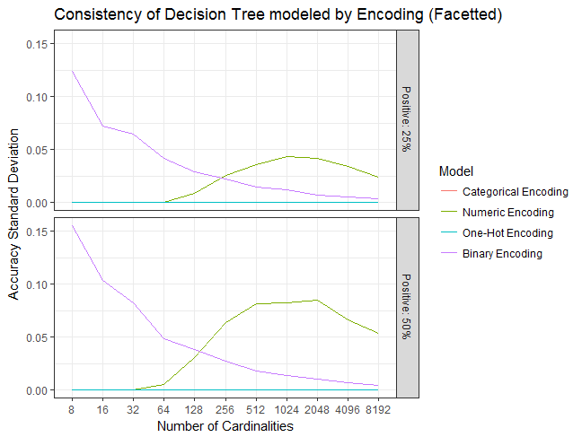

* **Numeric Encoding is not giving consistent results**, as the results are flying around a bit (compare the box plot sizes and you will notice it). It seems it requires **a lot more cardinalities to converge to a stable performance**. It depicts also more consistency “as the balancing becomes more unbalanced”.
* **One-Hot Encoding is extremely consistent.** So much consistent there is not much to say about if you want to approximate the predictive power of a categorical feature when alone.
* **Binary Encoding gets consistent when the cardinality increases, while maintaining a stable performance.** It depicts also more consistency “as the balancing becomes more unbalanced”. Perhaps someone has a mathematical proof of convergence towards a specific limit, given the cardinality and the balancing ratio?

## Training Time

**The training time is provided here as an example on dense data** using rpart. Each model was run 250 times, with the median for:

* 25 times per run for Categorical Encoding.
* 25 times per run for Numeric Encoding.
* 1 time per run for One-Hot Encoding (too long…).
* 10 times per run for Binary Encoding.

It shows why you should **avoid One-Hot Encoding on rpart**, as the training time of the decision tree literally explodes!:

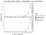

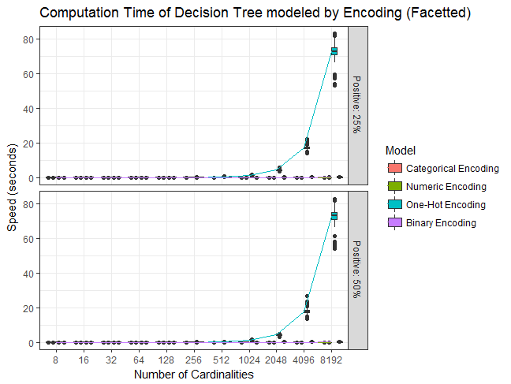

Data is dominated by One-Hot Encoding slowness.

Without One-Hot Encoding scaling issue, we have the following:

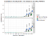

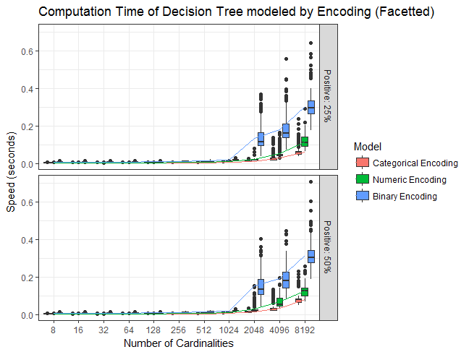

A more fair comparison.

**As we can clearly notice, if you are ready to spend a bit more time doing computations, then Numeric and Binary Encodings are fine.**

# Conclusion (tl;dr)

A simple resume with a picture and two lines of text:





* Categorical features with large cardinalities (over 1000): **Binary**
* Categorical features with small cardinalities (less than 1000): **Numeric**

*There seems to be no reason to use One-Hot Encoding over Numeric Encoding.*

# 6 Categorically Speaking

[Terence Parr](http://parrt.cs.usfca.edu/) and [Jeremy Howard](http://www.fast.ai/about/#jeremy)

Copyright © 2018-2019 Terence Parr. All rights reserved.  
*Please don't replicate on web or redistribute in any way.*  
This book generated from markup+markdown+python+latex source with [Bookish](https://github.com/parrt/bookish).

You can make **comments or annotate** this page by going to the [annotated version of this page](https://via.hypothes.is/https:/mlbook.explained.ai/catvars.html). You'll see existing annotated bits highlighted in yellow. They are *PUBLICLY VISIBLE*. Or, you can send comments, suggestions, or fixes directly to [Terence](mailto:parrt@cs.usfca.edu).

**Contents**

* [Getting a baseline](https://mlbook.explained.ai/catvars.html#sec:6.1)
* [Encoding categorical variables](https://mlbook.explained.ai/catvars.html#sec:catvars)
* [Extracting features from strings](https://mlbook.explained.ai/catvars.html#sec:6.3)
* [Synthesizing numeric features](https://mlbook.explained.ai/catvars.html#sec:6.4)
* [Target encoding categorical variables](https://mlbook.explained.ai/catvars.html#target-encoding)
* [Injecting external neighborhood info](https://mlbook.explained.ai/catvars.html#sec:6.6)
* [Our final model](https://mlbook.explained.ai/catvars.html#sec:6.7)
* [Summary of categorical feature engineering](https://mlbook.explained.ai/catvars.html#sec:6.8)

“*Coming up with features is difficult, timeconsuming, requires expert domain knowledge. When working applications of learning, we spend a lot of time tuning the features.*” — Andrew Ng in a Stanford plenary talk on AI, 2011

Creating a good model is more about *feature engineering* than it is about choosing the right model; well, assuming your go-to model is a good one like Random Forest. Feature engineering means improving, acquiring, and even *synthesizing* features that are strong predictors of your model's target variable. Synthesizing features means deriving new features from existing features or injecting features from other data sources. For example, we could synthesize the name of an apartment's New York City neighborhood from it's latitude and longitude. It doesn't matter how sophisticated our model is if we don't give it something useful to chew on. If there is no relationship to discover, because the features are not predictive, no machine learning model is going to give accurate predictions.

So far we've dropped nonnumeric features, such as apartment description strings and manager ID categorical values, because machine learning models can only learn from numeric values. But, there is potentially predictive power that we could exploit in these string values. In this chapter, we're going to learn the basics of feature engineering in order to squeeze a bit more juice out of the nonnumeric features found in the New York City apartment rent data set.

Most of the predictive power for rent price comes from apartment location, number of bedrooms, and number of bathrooms, so we shouldn't expect a massive boost in model performance. The primary goal of this chapter is to learn the techniques for use on real problems in your daily work. Or, if you've entered a Kaggle competition, the difference between the top spot and position 1000 is often razor thin, so even a small advantage from feature engineering could be useful in that context.

## 6.1 Getting a baseline

2See **Section 3.2.1** *Loading and sniffing the training data* for instructions on downloading JSON rent data from Kaggle and creating the CSV files.

1Don't forget the [notebooks](https://mlbook.explained.ai/notebooks/) aggregating the code snippets from the various chapters.

In order to measure any improvements in model accuracy, let's get a baseline using just the cleaned up numeric features from rent.csv in the data directory underneath where we started Jupyter.2 As we did in **Chapter 5** *Exploring and Denoising Your Data Set*, let's load the rent data, strip extreme prices, and remove apartments not in New York City:1

df = pd.read\_csv("data/rent.csv", parse\_dates=['created']) df\_clean = df[(df.price>1\_000) & (df.price<10\_000)] df\_clean = df\_clean[(df\_clean.longitude!=0) | (df\_clean.latitude!=0)] df\_clean = df\_clean[(df\_clean['latitude']>40.55) & (df\_clean['latitude']<40.94) & (df\_clean['longitude']>-74.1) & (df\_clean['longitude']<-73.67)] df = df\_clean

Now train an RF using just the numeric features and print the out-of-bag (OOB)  score:

numfeatures = ['bathrooms', 'bedrooms', 'longitude', 'latitude'] X, y = df[numfeatures], df['price'] rf = RandomForestRegressor(n\_estimators=100, n\_jobs=-1, oob\_score=True) rf.fit(X, y) oob\_baseline = rf.oob\_score\_ print(oob\_baseline)

0.8677576247438816

The 0.868 OOB score is pretty good as it's close to 1.0. (Recall that a score of 0 indicates our model does know better than simply guessing the average rent price for all apartments and 1.0 means a perfect predictor of rent price.) Let's also get an idea of how much work the RF has to do in order to capture the relationship between those features and rent price. The rfpimp package provides a few simple measures we can use: the total number of nodes in all decision trees of the forest and the height (in nodes) of the typical tree.

print(f"{rfnnodes(rf):,d} tree nodes and {np.median(rfmaxdepths(rf))} median tree height")

2,432,836 tree nodes and 35.0 median tree height

The tree height matters because that is the path taken by the RF prediction mechanism and so tree height effects prediction speed.

Let's also get a baseline for feature importances so that, as we introduce new features, we can get a sense of their predictive power. Longitude and latitude are really one meta-feature called “location,” so we can combine those two using the features parameter to the importances() function. We're going to ask for feature importances a lot in this chapter so let's make a handy function:

» *Generated by code to left*

def showimp(rf, X, y): features = list(X.columns) features.remove('latitude') features.remove('longitude') features += [['latitude','longitude']] I = importances(rf, X, y, features=features) plot\_importances(I, color='#4575b4') showimp(rf, X, y)

Now that we have a good benchmark for model and feature performance, let's try to improve our model by converting some existing nonnumeric features into numeric features.

## 6.2 Encoding categorical variables

The interest\_level feature is a categorical variable that seems to encode interest in an apartment, no doubt taken from webpage activity logs. It's a categorical variable because it takes on values from a finite set of choices: low, medium, and high. More specifically, interest\_level is an *ordinal* categorical variable, which means that the values can be ordered even if they are not actual numbers. Looking at the count of each ordinal value is a good way to get an overview of an ordinal feature:

print(df['interest\_level'].value\_counts())

low 33270 medium 11203 high 3827 Name: interest\_level, dtype: int64

Ordinal variables are the easiest to convert from strings to numbers because we can simply assign a different integer for each possible ordinal value. One way to do the conversion is to use the Pandas map() function and a dictionary argument:

df['interest\_level'] = df['interest\_level'].map({'low':1,'medium':2,'high':3}) print(df['interest\_level'].value\_counts())

1 33270 2 11203 3 3827 Name: interest\_level, dtype: int64

The key here is to ensure that the numbers we use for each category maintains the same ordering so, for example, medium's value of 2 is bigger than low's value of 1. We could also have chosen {'low':10,'medium':20,'high':30} as the encoding because RFs care about the order and not the scale of the features.

Let's see how an RF model performs using the numeric features and this newly converted interest\_level feature:

def test(X, y): rf = RandomForestRegressor(n\_estimators=100, n\_jobs=-1, oob\_score=True) rf.fit(X, y) oob = rf.oob\_score\_ n = rfnnodes(rf) h = np.median(rfmaxdepths(rf)) print(f"OOB R^2 {oob:.5f} using {n:,d} tree nodes with {h} median tree height") return rf, oob X, y = df[['interest\_level']+numfeatures], df['price'] rf, oob = test(X, y)

OOB R^2 0.87037 using 3,025,158 tree nodes with 36.0 median tree height

That 0.870 score is only a little bit better than our baseline of 0.868, but it's still useful. As you approach an  of 1.0, it gets harder and harder to nudge model performance. The difference in scores actually represents a few percentage points of the remaining accuracy, so we can be happy with this bump. Also, remember that using a single OOB score is a fairly blunt metric that aggregates the performance of the model on 50,000 records. It's possible that a certain type of apartment got a really big accuracy boost. The only cost to this accuracy boost is an increase in the number of tree nodes, but the typical decision tree height in the forest remains the same as our baseline. Prediction using this model should be just as fast as the baseline.

The easy way to remember the difference between ordinal and nominal variables is that ordinal variables have order and nominal comes from the word for “name” in Latin (*nomen*) or French (*nom*).

Ordinal categorical variables are simple to encode numerically. Unfortunately, there's another kind of categorical variable called a *nominal* variable for which there is no meaningful order between the category values. For example, in this data set, columns manager\_id, building\_id, and display address are nominal features. Without an order between categories, it's hard to encode nominal variables as numbers in a meaningful way, particularly when there are very many category values:

print(len(df['manager\_id'].unique()), len(df['building\_id'].unique()), len(df['display\_address'].unique()))

(3409, 7417, 8692)

So-called high-cardinality (many-valued) categorical variables such as manager\_id, building\_id, and display address are best handled using more advanced techniques such as [embeddings](https://developers.google.com/machine-learning/crash-course/embeddings/video-lecture) or *mean encoding* as we'll see in **Section 6.5** *Target encoding categorical variables*, but we'll introduce two simple encoding approaches here that are often useful.

The first technique is called *label encoding* and simply converts each category to a numeric value, as we did before, while ignoring the fact that the categories are not really ordered. Sometimes an RF can get some predictive power from features encoded in this way but typically requires larger trees in the forest.

To label encode any categorical variable, convert the column to an ordered categorical variable and then convert the strings to the associated categorical code (which is computed automatically by Pandas):

df['display\_address\_cat'] = df['display\_address'].astype('category').cat.as\_ordered() df['display\_address\_cat'] = df['display\_address\_cat'].cat.codes + 1

The category codes start with 0 and the code for “not a number” (nan) is -1. To bring everything into the range 0 or above, we add one to the category code. (Sklearn has equivalent functionality in its OrdinalEncoder transformer but it can't handle object columns with both integers and strings, plus it's get an error for missing values represented as np.nan.)

Let's see if this new feature improves performance over the baseline model:

X, y = df[['display\_address\_cat']+numfeatures], df['price'] rf, oob = test(X, y)

OOB R^2 0.86583 using 3,120,336 tree nodes with 37.5 median tree height

Unfortunately, the  score is roughly the same as the baseline's score and it increases the tree height. Not a good trade.

Let's try another encoding approach called *frequency encoding* and apply it to the manager\_id feature. Frequency encoding converts categories to the frequencies with which they appear in the training. For example, here are the category value counts for the top 5 manager\_ids:

print(df['manager\_id'].value\_counts().head(5))

e6472c7237327dd3903b3d6f6a94515a 2509 6e5c10246156ae5bdcd9b487ca99d96a 695 8f5a9c893f6d602f4953fcc0b8e6e9b4 404 62b685cc0d876c3a1a51d63a0d6a8082 396 cb87dadbca78fad02b388dc9e8f25a5b 370 Name: manager\_id, dtype: int64

The idea behind this transformation is that there might be predictive power in the number of apartments managed by a particular manager.

Function value\_counts() gives us the encoding and from there we can use map() to transform the manager\_id into a new column called mgr\_apt\_count:

managers\_count = df['manager\_id'].value\_counts() df['mgr\_apt\_count'] = df['manager\_id'].map(managers\_count)

Again, we could actually divide the accounts by len(df), but that just scales the column and won't affect predictive power.

Let's see how a model does with both of these categorical variables encoded:

X, y = df[['display\_address\_cat','mgr\_apt\_count']+numfeatures], df['price'] rf, oob = test(X, y)

OOB R^2 0.86434 using 4,569,236 tree nodes with 41.0 median tree height

The model accuracy does not improve and the complexity of the trees goes up, so we should avoid introducing these features. The feature importance plot confirms that these features are unimportant.

We can conclude that, for this data set, label encoding and frequency encoding of high-cardinality categorical variables is not helpful. These encoding techniques could, however, be useful on other data set so it's worth learning them. We'll learn about another categorical variable encoding technique called “one-hot encoding” in [chp:onehot], but we avoid one-hot encoding here because it would add thousands of new columns to our data set.

## 6.3 Extracting features from strings

The apartment data set also has some variables that are both nonnumeric and noncategorical, description and features. Such arbitrary strings have no obvious numerical encoding, but we can extract bits of information from them to create new features. For example, an apartment with parking, doorman, dishwasher, and so on might fetch a higher price so let's synthesize some Boolean features derived from string features.

First let's normalize the string columns to be lowercase and convert any missing values (represented as “not a number” np.nan values) to be empty strings; otherwise, applying split() to the columns will fail because split() does not apply to floating-point numbers (np.nan).

df['description'] = df['description'].fillna('') df['description'] = df['description'].str.lower() # normalize to lower case df['features'] = df['features'].fillna('') # fill missing w/blanks df['features'] = df['features'].str.lower() # normalize to lower case

Now we can create new columns by applying contains() to the string columns, once for each new column:

# has apartment been renovated? df['renov'] = df['description'].str.contains("renov") for w in ['doorman', 'parking', 'garage', 'laundry', 'Elevator', 'fitness center', 'dishwasher']: df[w] = df['features'].str.contains(w) df[['doorman', 'parking', 'garage', 'laundry']].head(5)

|  | **doorman** | **parking** | **garage** | **laundry** |
| --- | --- | --- | --- | --- |
|  |  |  |  |  |
| **0** | False | False | False | False |
| **1** | True | False | False | False |
| **2** | False | False | False | True |
| **3** | False | False | False | False |
| **4** | False | False | False | False |

Another trick is to count the number of words in a string

df["num\_desc\_words"] = df["description"].apply(lambda x: len(x.split())) df["num\_features"] = df["features"].apply(lambda x: len(x.split(",")))

There's not much we can do with the list of photo URLs in the other photos string column, but the number of photos might be slightly predictive of price, so let's create a feature for that as well:

df["num\_photos"] = df["photos"].apply(lambda x: len(x.split(",")))

Let's see how our new features affect performance above the baseline numerical features:

textfeatures = [ 'num\_photos', 'num\_desc\_words', 'num\_features', 'doorman', 'parking', 'garage', 'laundry', 'Elevator', 'fitness center', 'dishwasher', 'renov' ] X, y = df[textfeatures+numfeatures], df['price'] rf, oob = test(X, y)

OOB R^2 0.86242 using 4,767,582 tree nodes with 43.0 median tree height

» *Generated by code to left*

showimp(rf, X, y)

It's disappointing that the accuracy does not improve with these features and that the complexity of the model is higher, but this does provide useful marketing information. Apartment features such as parking, laundry, and dishwashers are attractive but there's little evidence that people are willing to pay more for them (except maybe for having a doorman).

## 6.4 Synthesizing numeric features

If you grew up with lots of siblings, you're likely familiar with the notion of waiting to use the bathroom in the morning. Perhaps there is some predictive power in the ratio of bedrooms to bathrooms, so let's try synthesizing a new column that is the ratio of two numeric columns:

df["beds\_to\_baths"] = df["bedrooms"]/(df["bathrooms"]+1) # avoid div by 0 X, y = df[['beds\_to\_baths']+numfeatures], df['price'] rf, oob = test(X, y)

OOB R^2 0.86831 using 2,433,878 tree nodes with 35.0 median tree height

Combining numerical columns is a useful technique to keep in mind, but unfortunately this combination doesn't affect our model significantly here. Perhaps we'd have better luck combining a numeric column with the target, such as the ratio of bedrooms to price:

df["beds\_per\_price"] = df["bedrooms"] / df["price"] X, y = df[['beds\_per\_price']+numfeatures], df['price'] rf, oob = test(X, y)

OOB R^2 0.98601 using 1,313,390 tree nodes with 31.0 median tree height

Wow! That's almost a perfect score, which should trigger an alarm that it's too good to be true. In fact, we do have an error, but it's not a code bug. We have effectively copied the price column into the feature set, kind of like studying for a quiz by looking at the answers. This is a form of *data leakage*, which is a general term for the use of features that directly or indirectly hint at the target variable.

To illustrate how this leakage causes overfitting, let's split out 20% of the data as a validation set and compute the beds\_per\_price feature for the training set:

from sklearn.model\_selection import train\_test\_split df\_train, df\_test = train\_test\_split(df, test\_size=0.20) df\_train = df\_train.copy() df\_train['beds\_per\_price'] = df\_train['bedrooms'] / df\_train["price"] df\_train[['beds\_per\_price','bedrooms']].head(5)

|  | **beds\_per\_price** | **bedrooms** |
| --- | --- | --- |
|  |  |  |
| **23525** | 0.0003 | 1 |
| **22736** | 0.0002 | 1 |
| **22860** | 0.0006 | 3 |
| **25510** | 0.0003 | 1 |
| **40540** | 0.0008 | 2 |

As a general principle, you can't compute features for the validation set using information from the validation set. Only information computed directly from the training set can be used during feature engineering.

While we do have price information for the validation set in df\_test, we can't use it to compute beds\_per\_price for the validation set. In production, the model will not have the validation set prices and so df['beds\_per\_price'] must be created only from the training set. (If the model had apartment prices in practice, we wouldn't be the model.) To avoid this common pitfall, it's helpful to imagine computing features for and sending validation records to the model one by one, rather than all at once.

Once we have the beds\_per\_price feature for the training set, we can compute a dictionary mapping bedrooms to the beds\_per\_price feature. Then, we can synthesize the beds\_per\_price in the validation set using map() on the bedrooms column:

bpmap = dict(zip(df\_train["bedrooms"],df\_train["beds\_per\_price"])) df\_test = df\_test.copy() df\_test["beds\_per\_price"] = df\_test["bedrooms"].map(bpmap) avg = np.mean(df\_test['beds\_per\_price']) df\_test['beds\_per\_price'].fillna(avg, inplace=True) print(df\_test['beds\_per\_price'].head(5))

2125 0.000332 47172 0.000667 5584 0.000000 860 0.000294 49025 0.000332 Name: beds\_per\_price, dtype: float64

The fillna() code deals with the situation where the validation set has a number of bedrooms that is not in the training set; for example, sometimes the validation set has an apartment with 7 bedrooms, but there is no bedroom key equal to 7 in the bpmap.

Now that we have beds\_per\_price for both training and validation sets, we can train an RF model using just the training set and evaluate its performance using just the validation set:

X\_train, y\_train = df\_train[['beds\_per\_price']+numfeatures], df\_train['price'] X\_test, y\_test = df\_test[['beds\_per\_price']+numfeatures], df\_test['price'] rf = RandomForestRegressor(n\_estimators=100, n\_jobs=-1) rf.fit(X\_train, y\_train) oob\_overfit = rf.score(X\_test, y\_test) # don't test training set print(f"OOB R^2 {oob\_overfit:.5f}") print(f"{rfnnodes(rf):,d} nodes, {np.median(rfmaxdepths(rf))} median height")

OOB R^2 -0.41233 1,169,770 nodes, 31.0 median height

An  of -0.412 on the validation set is terrible and indicates that the model lacks generality. In this situation, overfitting means that the model has put too much emphasis on the beds\_per\_price feature, which is strongly predictive of price in the training but not the validation set. (The feature was computed using just data from the training set.) We get a whiff of overfitting even in the complexity of the model, which has half the number of nodes as a model trained just on the numeric features. It's not always an error to derive features from the target; we just have to be more careful.

## 6.5 Target encoding categorical variables

Creating features that incorporate information about the target variable is called *target encoding* and is often used to derive features from categorical variables to great effect. One of the most common target encodings is called *mean encoding*, which replaces each category value with the average target value associated with that category. For example, building managers in our apartment data set might rent apartments in certain price ranges. The manager IDs by themselves carry little predictive power but converting IDs to the average rent price for apartments they manage could be predictive. Similarly, certain buildings might have more expensive apartments than others. The average rent price per building is easy enough to get with Pandas by grouping the data by building\_id and asking for the mean:

df.groupby('building\_id').mean()[['price']].head(5)

|  | **price** |
| --- | --- |
| **building\_id** |  |
| **0** | 3195.9321 |
| **00005cb939f9986300d987652...** | 3399.0000 |
| **00024d77a43f0606f926e2312...** | 2000.0000 |
| **000ae4b7db298401cdae2b0ba...** | 2400.0000 |
| **0012f1955391bca600ec30103...** | 3700.0000 |

Unfortunately, as we saw in the last section, it's easy to overfit models when incorporating target information. Preventing overfitting is nontrivial and it's best to rely on a vetted library, such as the [category\_encoders](http://contrib.scikit-learn.org/categorical-encoding/) package contributed to sklearn. (To prevent overfitting, the idea is to compute the mean from a subset of the training data targets for each category.) You can install category\_encoders with pip on the commandline:

pip install category\_encoders

{TODO: Maybe show my mean encoder. much faster. worth explaining somewhere. rent/mean-encoder.ipynb sees like we need an alpha parameter that gets rare cats towards avg; supposed to work better.}

Here's how to use the TargetEncoder object to encode three categorical variables from the data set and get an OOB score:

from category\_encoders.target\_encoder import TargetEncoder df = df.reset\_index() # not sure why TargetEncoder needs this but it does targetfeatures = ['building\_id'] encoder = TargetEncoder(cols=targetfeatures) encoder.fit(df, df['price']) df\_encoded = encoder.transform(df, df['price']) X, y = df\_encoded[targetfeatures+numfeatures], df['price'] rf, oob = test(X, y)

OOB R^2 0.87236 using 2,746,024 tree nodes with 39.0 median tree height

That  score is a bit better than the baseline of 0.868 for numeric-only features. Given the tendency to overfit the model with target encoding, however, it's a good idea to test the model with a validation set. Let's split out 20% as a validation set and get a baseline for numeric features:

df\_train, df\_test = train\_test\_split(df, test\_size=0.20) # TargetEncoder needs the resets, not sure why df\_train = df\_train.reset\_index(drop=True) df\_test = df\_test.reset\_index(drop=True) X\_train = df\_train[numfeatures] y\_train = df\_train['price'] X\_test = df\_test[numfeatures] y\_test = df\_test['price'] rf = RandomForestRegressor(n\_estimators=100, n\_jobs=-1) rf.fit(X\_train, y\_train) s\_validation = rf.score(X\_test, y\_test) print(f"{s\_validation:4f} score {rfnnodes(rf):,d} tree nodes and {np.median(rfmaxdepths(rf))} median tree height")

0.845264 score 2,126,222 tree nodes and 35.0 median tree height

The validation score and the OOB score are very similar, confirming that OOB scores are an excellent approximation to validation scores. With that baseline, let's see what happens when we properly target encode the validation set, that is, using only data from the training set (warning: this takes several minutes to execute):

enc = TargetEncoder(cols=targetfeatures) enc.fit(df\_train, df\_train['price']) df\_train\_encoded = enc.transform(df\_train, df\_train['price']) df\_test\_encoded = enc.transform(df\_test) X\_train = df\_train\_encoded[targetfeatures+numfeatures] y\_train = df\_train\_encoded['price'] X\_test = df\_test\_encoded[targetfeatures+numfeatures] y\_test = df\_test\_encoded['price'] rf = RandomForestRegressor(n\_estimators=100, n\_jobs=-1) rf.fit(X\_train, y\_train) s\_tenc\_validation = rf.score(X\_test, y\_test) print(f"{s\_tenc\_validation:.4f} score {rfnnodes(rf):,d} tree nodes and {np.median(rfmaxdepths(rf))} median tree height")

0.8488 score 2,378,442 tree nodes and 38.0 median tree height

The validation score for numeric plus target-encoded feature (0.849) is less than the validation score for numeric-only features (0.845). The model finds the target-encoded feature strongly predictive of the training set prices, causing it to overfit by overemphasizing this feature. This loss of generality explains the drop in validation scores. The feature importance graph provides evidence of this overemphasis because it shows the target-encoded building\_id feature as the most important.

While not beneficial for this data set, target encoding is reported to be useful by many practitioners and Kaggle competition winners. It's worth knowing about this technique and learning to apply it properly (computing validation set features using data only from the training set).

When we've exhausted our bag of tricks deriving features from a given data set, sometimes it's fruitful to inject features derived from external data sources.

## 6.6 Injecting external neighborhood info

Our data set has longitude and latitude coordinates, but a more obvious price predictor would be a categorical variable identifying the neighborhood because some neighborhoods are more desirable than others. Given the trouble we've seen with categorical variables above, though, a numeric feature would be more useful. Instead of identifying the neighborhood, let's use proximity to highly desirable neighborhoods as a numeric feature. Forbes magazine has an article, [The Top 10 New York City Neighborhoods to Live In, According to the Locals](https://www.forbes.com/sites/trulia/2016/10/04/the-top-10-new-york-city-neighborhoods-to-live-in-according-to-the-locals/#17bf6ff41494), from which we can get neighborhood names. Then, using a mapping website, we can estimate the longitude and latitude of those neighborhoods and record them like this:

hoods = { "hells" : [40.7622, -73.9924], "astoria" : [40.7796684, -73.9215888], "Evillage" : [40.723163774, -73.984829394], "Wvillage" : [40.73578, -74.00357], "LowerEast" : [40.715033, -73.9842724], "UpperEast" : [40.768163594, -73.959329496], "ParkSlope" : [40.672404, -73.977063], "Prospect Park" : [40.93704, -74.17431], "Crown Heights" : [40.657830702, -73.940162906], "financial" : [40.703830518, -74.005666644], "brooklynheights" : [40.7022621909, -73.9871760513], "gowanus" : [40.673, -73.997] }

To synthesize new features, we compute the so-called *Manhattan distance* (also called *L1 distance*) from each apartment to each neighborhood center, which measures the number of blocks one must walk to reach the neighborhood. In contrast, the *Euclidean distance* would measure distance as the crow flies, cutting through the middle of buildings.

for hood,loc in hoods.items(): # compute manhattan distance df[hood] = np.abs(df.latitude - loc[0]) + np.abs(df.longitude - loc[1])

Training a model on the numeric features and these new neighborhood features, gives us a decent bump in performance:

hoodfeatures = list(hoods.keys()) X, y = df[numfeatures+hoodfeatures], df['price'] rf, oob\_hood = test(X, y)

OOB R^2 0.87213 using 2,412,662 tree nodes with 43.0 median tree height

An OOB score of 0.872 is noticeably better than the baseline 0.868 for numeric features. The number of trees increased significantly, but the number of nodes is about the same. The model works a little bit harder to associate similar apartments with similar rent prices, but it's worth the extra complexity for the performance boost.

The new proximity features effectively triangulate an apartment relative to desirable neighborhoods, which means we probably don't need apartment longitude and latitude anymore. Dropping longitude and latitude and retraining a model shows a similar OOB score and shallower trees:

X = X.drop(['longitude','latitude'],axis=1) rf = RandomForestRegressor(n\_estimators=100, n\_jobs=-1, oob\_score=True) rf.fit(X, y) print(f"{rf.oob\_score\_:.4f} score {rfnnodes(rf):,d} tree nodes and {np.median(rfmaxdepths(rf))} median tree height")

0.8700 score 2,421,776 tree nodes and 41.0 median tree height

Injecting outside data is definitely worth trying as a general rule. As another example, consider predicting sales at a store or website. We've found that injecting columns indicating paydays or national holidays often helps predict fluctuations in sales volume that are not explained well with existing features.

## 6.7 Our final model

We've explored a lot of common feature engineering techniques for categorical variables in this chapter, so let's put them all together to see how a combined model performs:

X = df[['interest\_level']+textfeatures+hoodfeatures+numfeatures] rf, oob\_combined = test(X, y)

OOB R^2 0.87876 using 4,842,474 tree nodes with 44.0 median tree height

While OOB score 0.879 is not too much larger than our numeric-only model baseline of 0.868 in absolute terms, it means we've squeezed an extra 8.321% relative accuracy out of our data (computed using ((oob\_combined-oob\_baseline) / (1-oob\_baseline))\*100).

Something to notice is that the RF model does not get confused with a combination of all of these features, which is one of the reasons we recommend RFs. RFs simply ignore features without much predictive power. The feature importance graph to the right indicates what the model finds predictive. For model accuracy reasons, it's a good idea to keep all features, but we might want to remove unimportant features to simplify the model for interpretation purposes (when explaining model behavior).

## 6.8 Summary of categorical feature engineering

# **Boosting Algorithms Explained**

Unlike many ML models which focus on high quality prediction done by a single model, boosting algorithms seek to improve the prediction power by training a sequence of weak models, each compensating the weaknesses of its predecessors.

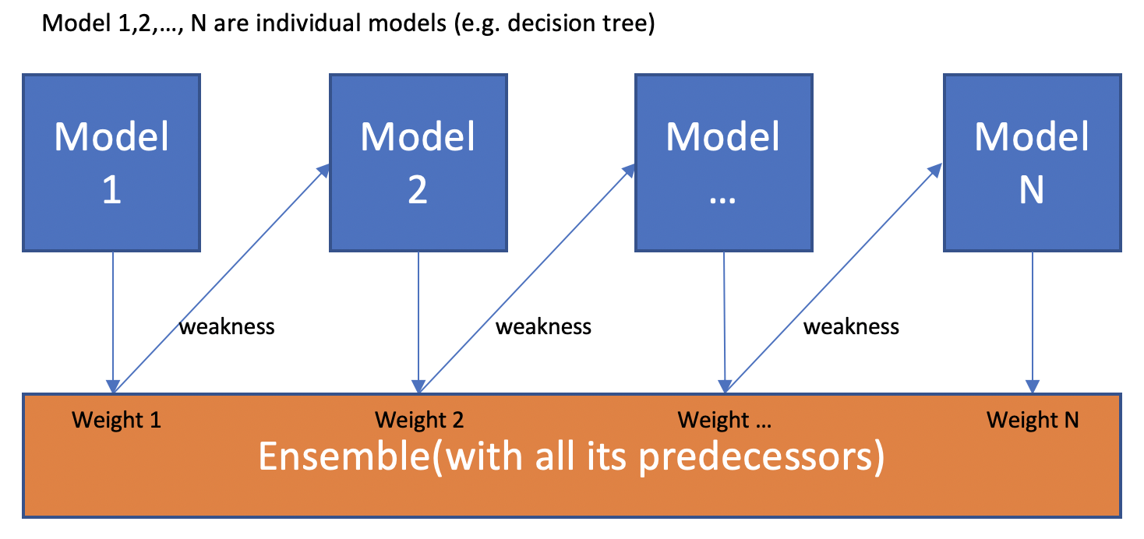

One is weak, together is strong, learning from past is the best

To understand Boosting, it is crucial to recognize that boosting **is a generic algorithm rather than a specific model**. Boosting needs you to specify a weak model (e.g. regression, shallow decision trees, etc) and then improves it.

With that sorted out, it is time to explore different definitions of weakness and their corresponding algorithms. I’ll introduce two major algorithms: Adaptive Boosting (AdaBoost) and Gradient Boosting.

# 1.AdaBoost

## 1.1 Definition of Weakness

AdaBoost is a specific Boosting algorithm developed for classification problems (also called discrete AdaBoost). The weakness is identified by the weak estimator’s error rate:

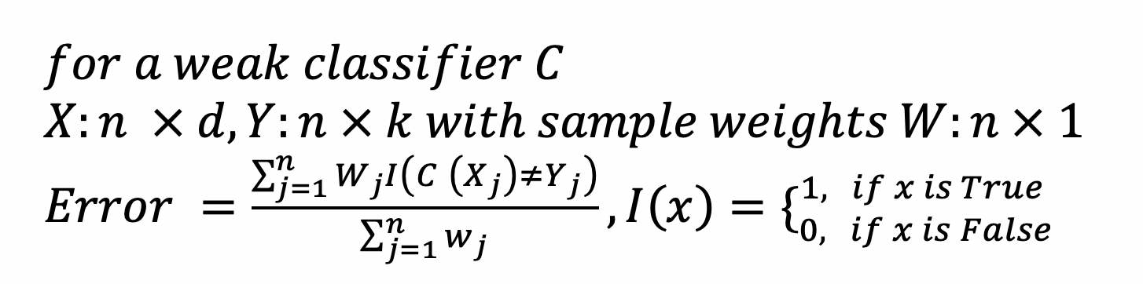

In each iteration, AdaBoost identifies miss-classified data points, increasing their weights (and decrease the weights of correct points, in a sense) so that the next classifier will pay extra attention to get them right. The following figure illustrates how weights impact the performance of a simple decision stump(tree with depth 1)

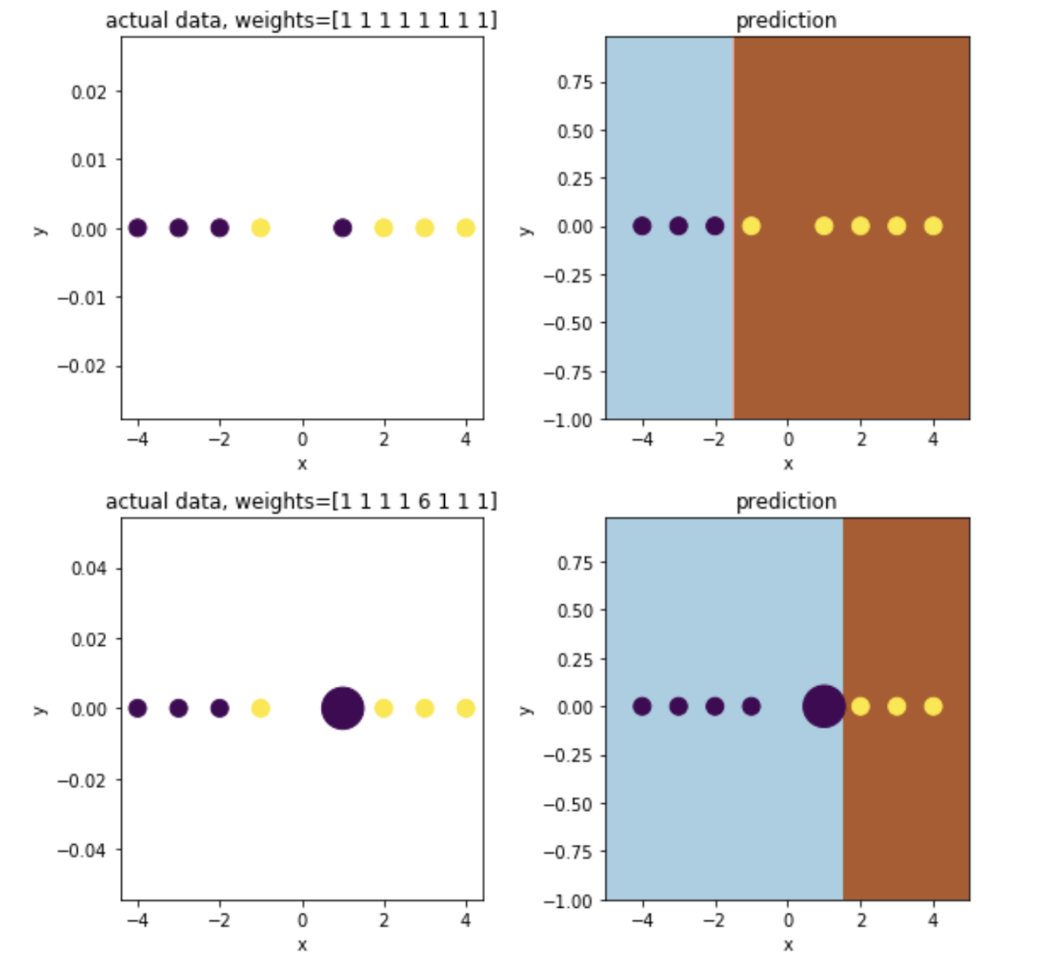

How sample weights affect the decision boundary

Now with weakness defined, the next step is to figure out how to combine the sequence of models to make the ensemble stronger overtime.

## 1.2 Pseudocode

There are several different algorithms proposed by researchers. Here I’ll introduce the most popular method called SAMME, a specific method that deals with multi-classification problems. ([Zhu, H. Zou, S. Rosset, T. Hastie, “Multi-class AdaBoost”, 2009](https://web.stanford.edu/~hastie/Papers/samme.pdf)).

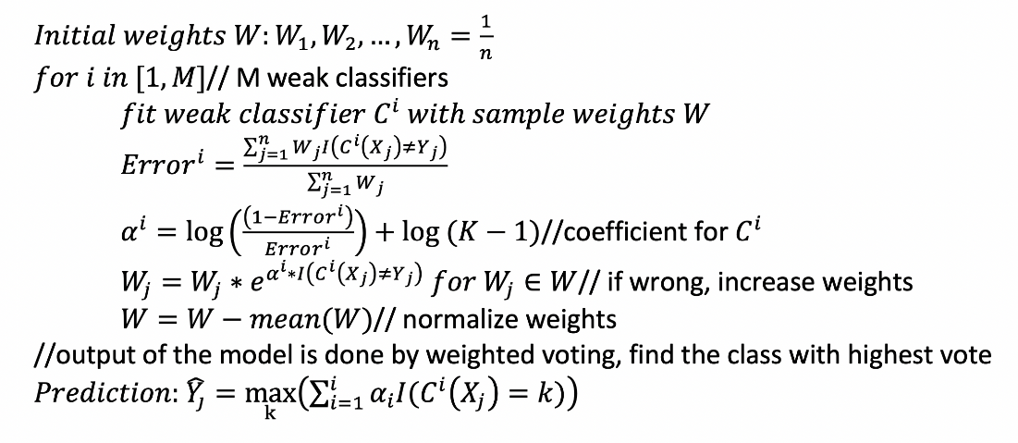

AdaBoost trains a sequence of models with augmented sample weights, generating ‘confidence’ coefficients Alpha for individual classifiers based on errors. Low errors leads to large Alpha, which means higher importance in the voting.

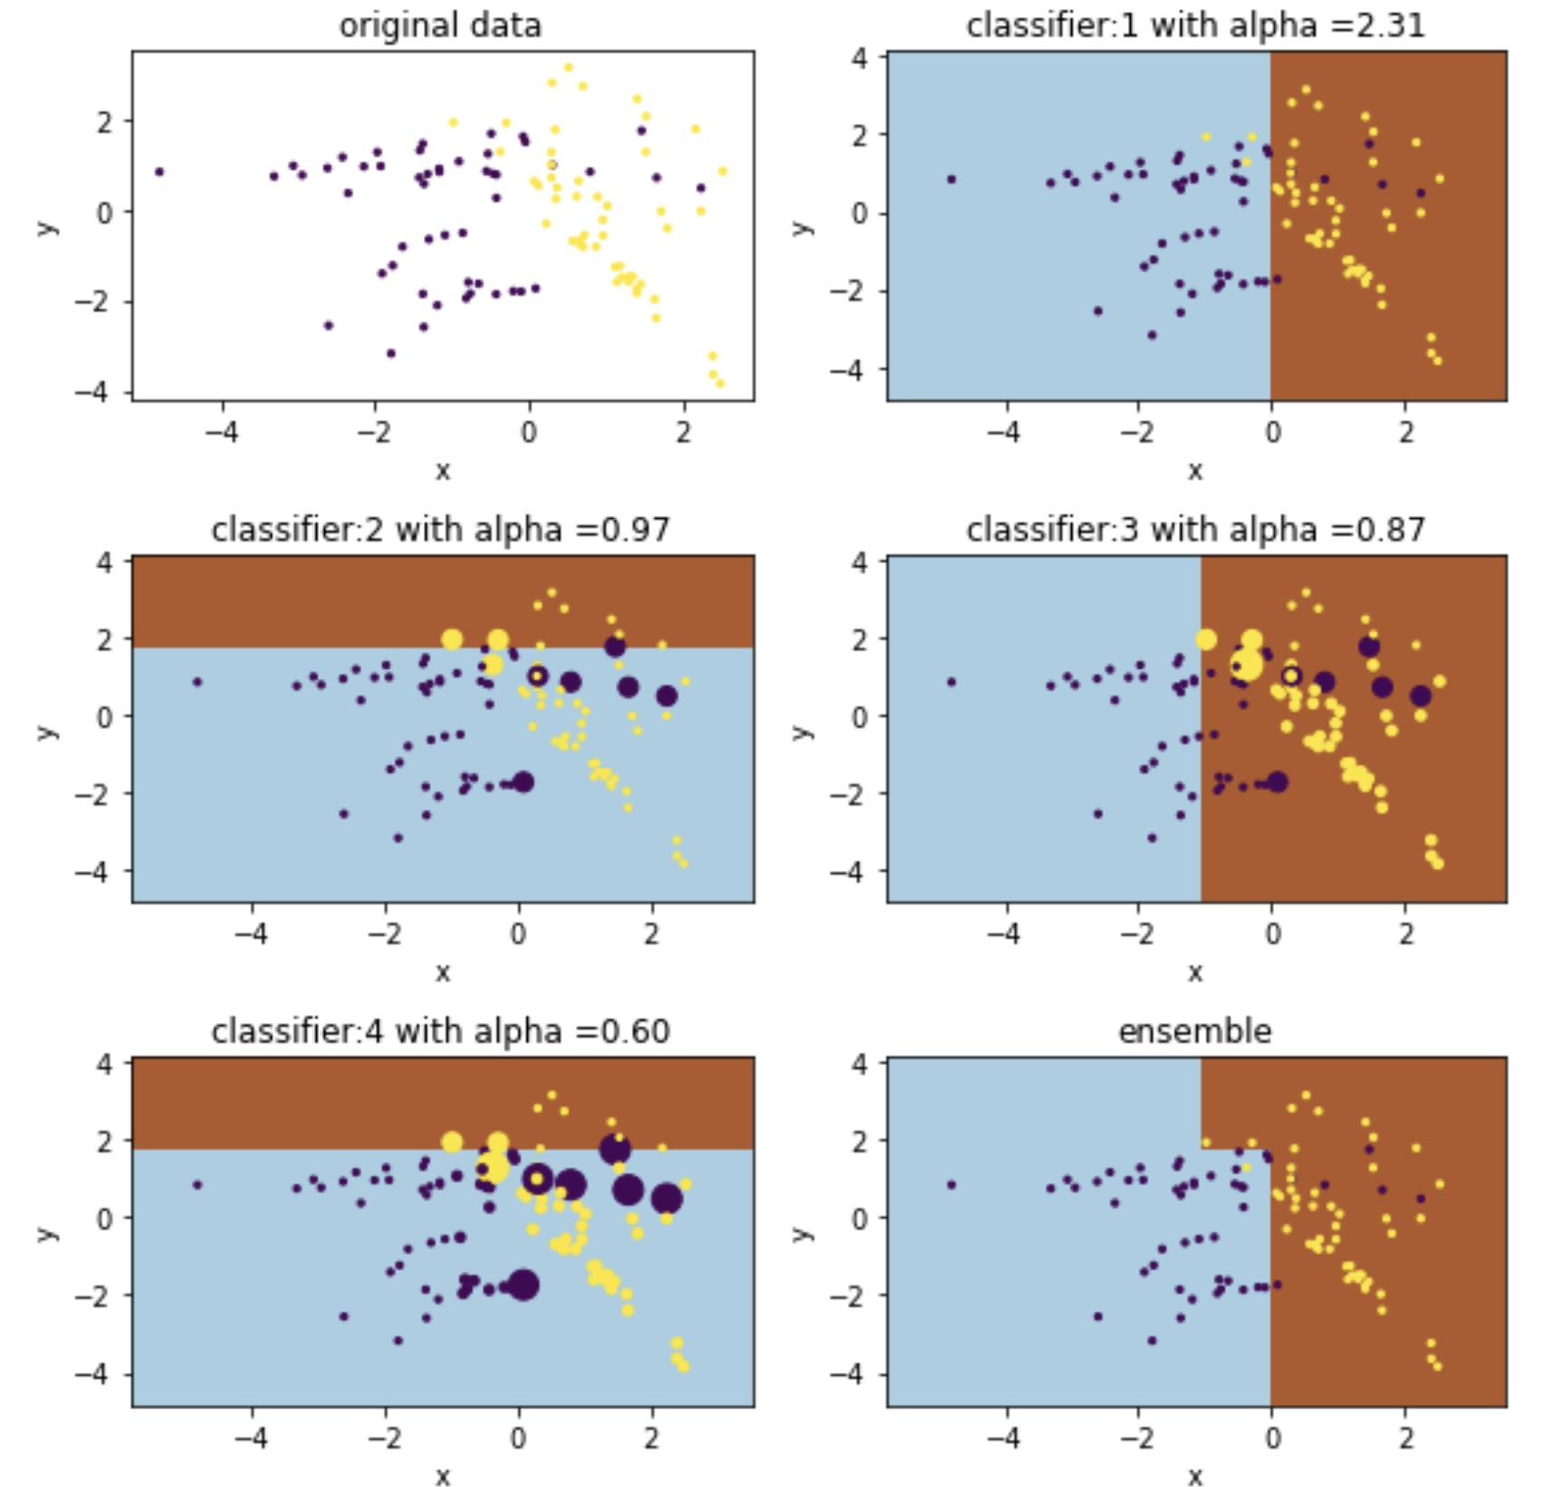

the size of dots indicates their weights

## 1.3 Implementation in Python

Scikit-Learn offers a nice implementation of AdaBoost with [SAMME](https://web.stanford.edu/~hastie/Papers/samme.pdf) (a specific algorithm for Multi classification).

*Parameters:****base\_estimator****: object, optional (default=None)*

*The base estimator from which the boosted ensemble is built. If None, then the base estimator is DecisionTreeClassifier(max\_depth=1)*

***n\_estimators****: integer, optional (default=50)*

*The maximum number of estimators at which boosting is terminated. In case of perfect fit, the learning procedure is stopped early.*

***learning\_rate****: float, optional (default=1.)*

*Learning rate shrinks the contribution of each classifier by learning\_rate.*

***algorithm****: {‘SAMME’, ‘SAMME.R’}, optional (default=’SAMME.R’)*

*If ‘SAMME.R’ then use the SAMME.R real boosting algorithm. base\_estimator must support calculation of class probabilities. If ‘SAMME’ then use the SAMME discrete boosting algorithm.*

***random\_state****: int, RandomState instance or None, optional (default=None)*

# 2. Gradient Boosting

## 2.1 Definition of Weakness

Gradient boosting approaches the problem a bit differently. Instead of adjusting weights of data points, Gradient boosting focuses on the difference between the prediction and the ground truth.

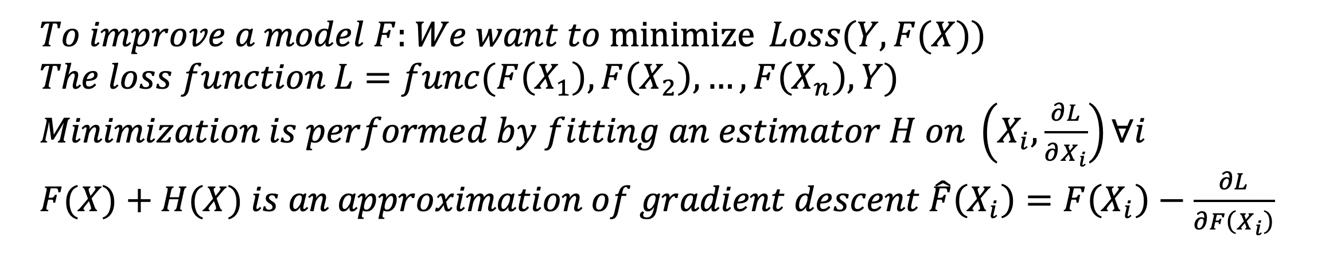

weakness is defined by gradients

## 2.2 Pseudocode

Gradient boosting requires a differential loss function and works for both regression and classifications. I’ll use a simple Least Square as the loss function (for regression). The algorithm for [classifications](http://www.ccs.neu.edu/home/vip/teach/MLcourse/4_boosting/slides/gradient_boosting.pdf) shares the same idea, but the math is slightly more complicated.([J. Friedman, Greedy Function Approximation: A Gradient Boosting Machine](https://statweb.stanford.edu/~jhf/ftp/trebst.pdf))

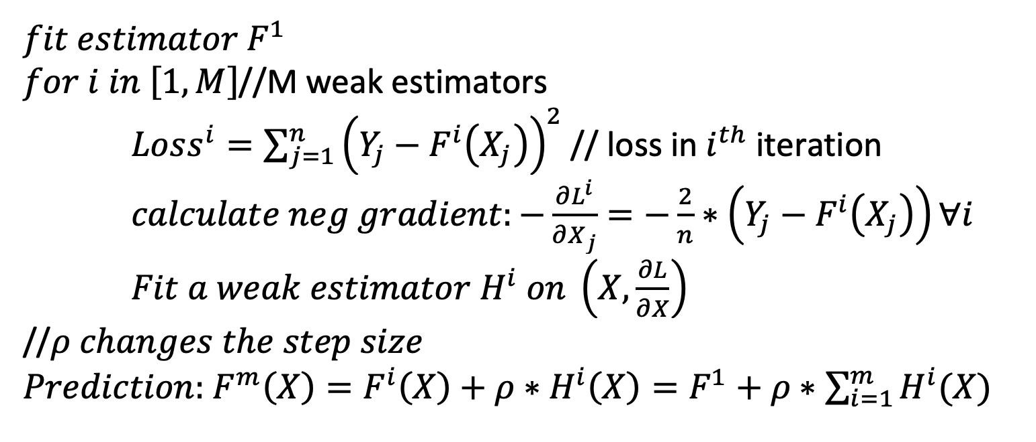

Gradient Boosting with Least Square

Following is a visualization of how weak estimators H are built over time. Each time we fit a new estimator (regression tree with max\_depth =3 in this case) to the gradient of loss(LS in this case).

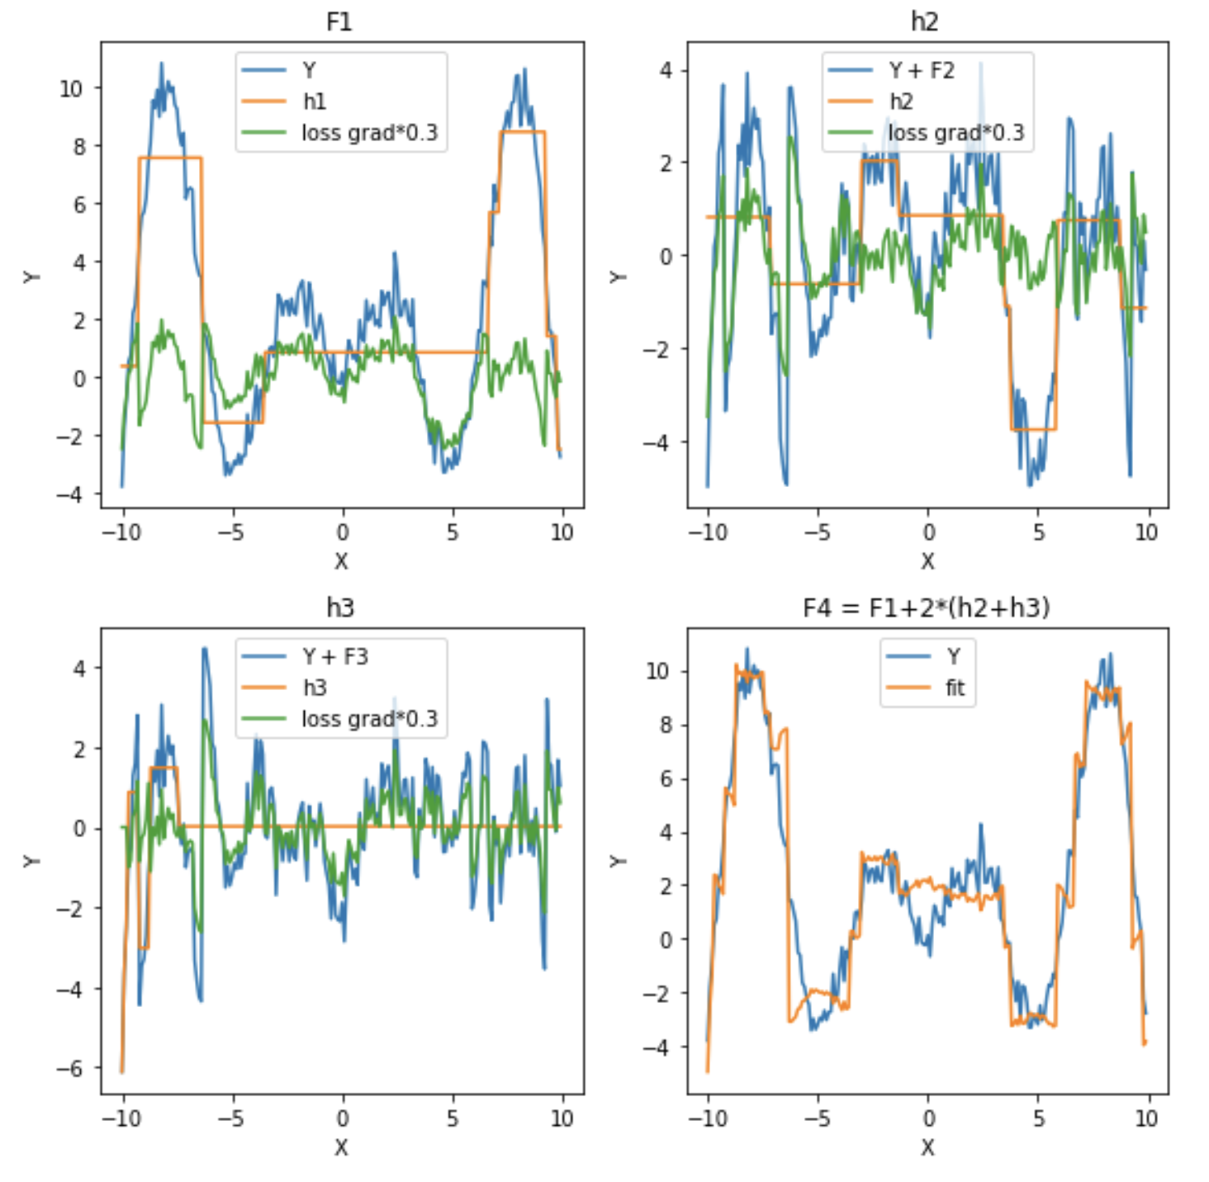

gradient is scaled down for visualization purpose

## 2.3 Implementation in Python

Again, you can find Gradient Boosting function in Scikit-Learn’s [library](https://scikit-learn.org/stable/modules/generated/sklearn.ensemble.GradientBoostingRegressor.html).

*Regression:*

***loss****: {‘ls’, ‘lad’, ‘huber’, ‘quantile’}, optional (default=’ls’)*

*Classification:*

***loss****: {‘deviance’, ‘exponential’}, optional (default=’deviance’)*

*The rest are the same*

***learning\_rate****: float, optional (default=0.1)*

***n\_estimators****: int (default=100)*

*Gradient boosting is fairly robust to over-fitting so a large number usually results in better performance.*

***subsample****: float, optional (default=1.0)*

*The fraction of samples to be used for fitting the individual base learners. If smaller than 1.0 this results in Stochastic Gradient Boosting. subsample interacts with the parameter n\_estimators. Choosing subsample < 1.0 leads to a reduction of variance and an increase in bias.*

***criterion****: string, optional (default=”friedman\_mse”)*

*The function to measure the quality of a split.*

# Strength and Weakness

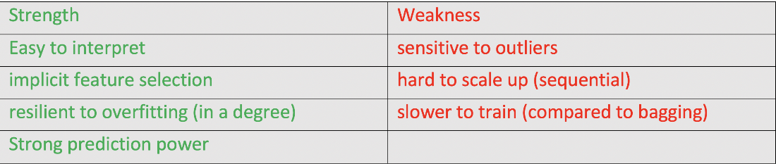

1. Easy to interpret: boosting is essentially an ensemble model, hence it is easy to interpret it’s prediction
2. strong prediction power: usually boosting > bagging (random forrest) > decision tree
3. resilient to overfitting: [See this article](https://jeremykun.com/2015/09/21/the-boosting-margin-or-why-boosting-doesnt-overfit/)
4. sensitive to outliers: since each weak classifier is dedicated to fix its predecessors’ shortcomings, the model may pay too much attention to outliers
5. hard to scale up: since each estimator is built on its predecessors, the process is hard to parallelize.

# **Summary**

Boosting algorithms represent a different machine learning perspective: turning a weak model to a stronger one to fix its weaknesses. Now you understand how boosting works, it is time to try it in real projects!

# **Gradient Boosting and XGBoost**

Starting from where we ended, let’s continue on discussing different boosting algorithm. If you have not read the previous article which explains boosting and AdaBoost, please have a look.

Link: <https://medium.com/@grohith327/boosting-algorithms-adaboost-gradient-boosting-and-xgboost-f74991cad38c>

## Gradient Boosting:

Moving on, let’s have a look another boosting [algorithm](https://hackernoon.com/tagged/algorithm), gradient boosting. Gradient Boosting is also a boosting algorithm(Duh!), hence it also tries to create a strong learner from an ensemble of weak learners. This is algorithm is similar to Adaptive Boosting(AdaBoost) but differs from it on certain aspects. In this method we try to visualise the boosting problem as an optimisation problem, i.e we take up a loss function and try to optimise it. This idea was first developed by [Leo Breiman](https://en.wikipedia.org/wiki/Leo_Breiman).

## How is Gradient Boosting interpreted as an optimisation problem?

We take up a weak learner(in previous case it was decision stump) and at each step, we add another weak learner to increase the performance and build a strong learner. This reduces the loss of the loss function. We iteratively add each model and compute the loss. The loss represents the error residuals(the difference between actual value and predicted value) and using this loss value the predictions are updated to minimise the residuals.

Let us break it down step by step.

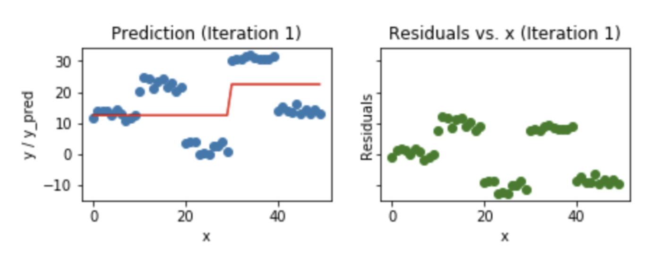

In the first iteration, we take a simple model and try to fit the complete data. You can from the above image that the prediction values of the model of the ground truth are different. The error residuals are plotted on the right side of the image. The loss function is trying to reduce these error residuals by adding more weak learners. The new weak learners are added to concentrate on the areas where the existing learners are performing poorly.

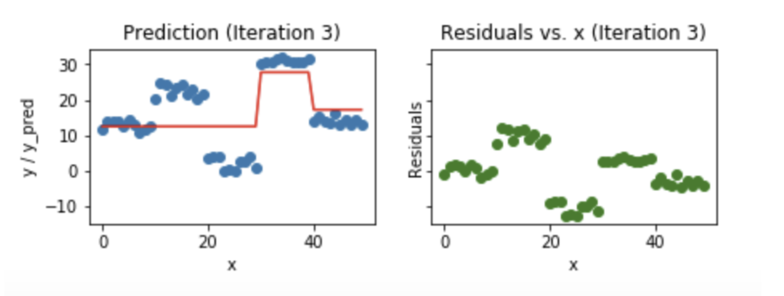

After three iterations, you can observe that model is able to fit the data better. This process is iteratively carried out until the residuals are zero.

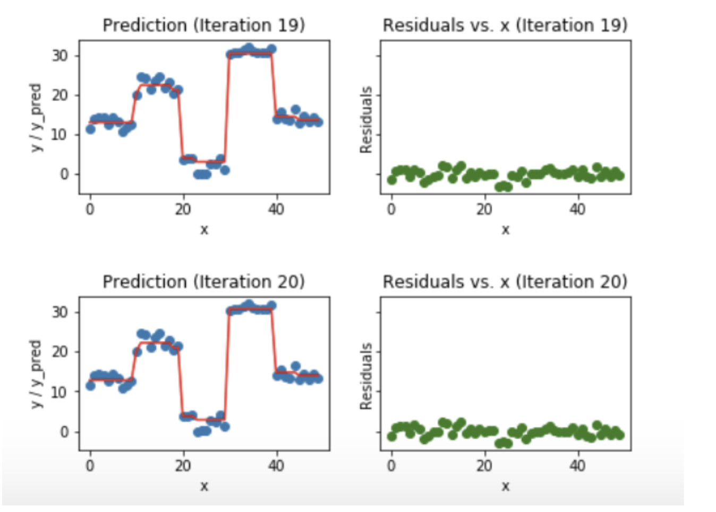

After 20 iterations, the model almost fits the data exactly and the residuals drop to zero.

# Gradient Boosting   
from sklearn.ensemble import GradientBoostingClassifierclf = GradientBoostingClassifier()  
# n\_estimators = 100 (default)  
# loss function = deviance(default) used in Logistic Regression  
clf.fit(x\_train,y\_train)  
clf.predict(x\_test)

**XGBoost(Extreme Gradient Boosting):**

[XGBoost](https://hackernoon.com/tagged/xgboost) has taken data science competition by storm. XGBoost seems to be a part of an ensemble of classifiers/predictors which are used to win data science competitions. Why is this so? why is XGBoost so powerful ?

XGBoost is similar to gradient boosting algorithm but it has a few tricks up its sleeve which makes it stand out from the rest.

Features of XGBoost are:

* Clever Penalisation of Trees
* A Proportional shrinking of leaf nodes
* [Newton Boosting](https://en.wikipedia.org/wiki/Newton%27s_method_in_optimization)
* Extra Randomisation Parameter

In XGBoost the trees can have a varying number of terminal nodes and left weights of the trees that are calculated with less evidence is shrunk more heavily. Newton Boosting uses Newton-Raphson method of approximations which provides a direct route to the minima than gradient descent. The extra randomisation parameter can be used to reduce the correlation between the trees, as seen in the previous article, the lesser the correlation among classifiers, the better our ensemble of classifiers will turn out. Generally, XGBoost is faster than gradient boosting but gradient boosting has a wide range of application

# XGBoost   
from xgboost import XGBClassifier  
clf = XGBClassifier()  
# n\_estimators = 100 (default)  
# max\_depth = 3 (default)  
clf.fit(x\_train,y\_train)  
clf.predict(x\_test)

## Conclusion

These tree boosting algorithms have gained huge popularity and are present in the repertoire of almost all kagglers. I hope these two-part articles would’ve given you some basic understanding of the three algorithms

# **Boosting Algorithms: AdaBoost, Gradient Boosting and XGBoost**

[](https://medium.com/@grohith327?source=post_page-----f74991cad38c----------------------)

[Rohith Gandhi](https://medium.com/@grohith327?source=post_page-----f74991cad38c----------------------)

Follow

[May 6, 2018](https://medium.com/hackernoon/boosting-algorithms-adaboost-gradient-boosting-and-xgboost-f74991cad38c?source=post_page-----f74991cad38c----------------------) · 5 min read

Neural networks and Genetic algorithms are our naive approach to imitate nature. They work well for a class of problems but they do have various hurdles such as overfitting, local minima, vanishing gradient and much more. There is another set of algorithms that do not get much recognition(in my opinion) compared to others and they are boosting algorithms.

## What is Boosting?

Boosting is a method of converting a set of weak learners into strong learners. Suppose we have a binary classification task. A weak learner has an error rate that is slightly lesser than 0.5 in classifying the object, i.e the weak learner is slightly better than deciding from a coin toss. A strong learner has an error rate closer to 0. To convert a weak learner into strong learner, we take a family of weak learners, combine them and vote. This turns this family of weak learners into strong learners.

The idea here is that the family of weak learners should have a minimum correlation between them.

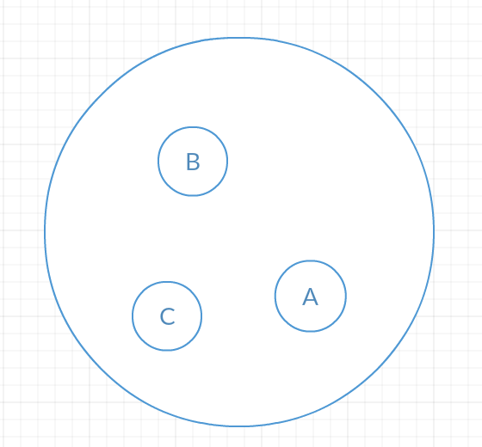

Here, let A, B and C be different classifiers. Their area A represents where the classifier A misclassifies(goes wrong) and area B represents where the classifier B misclassifies and area C represents where the classifier C misclassifies. Since there is no correlation between the errors of each classifier, combining them and using a technique of democratic voting to classify each object, this family of classifiers will never go wrong. I guess this would’ve provided a basic understanding of boosting. Moving on to types of boosting [algorithm](https://hackernoon.com/tagged/algorithm).

## Types of boosting algorithms:

I would like to explain different boosting algorithms without any of the math involved in it cause I feel it would complicate things and defeat the purpose of this article, which is simplicity(hopefully). The different types of boosting algorithms are:

* AdaBoost
* Gradient Boosting
* XGBoost

These three algorithms have gained huge popularity, especially XGBoost, which has been responsible for winning many data science competitions.

## AdaBoost(Adaptive Boosting):

The Adaptive Boosting technique was formulated by Yoav Freund and Robert Schapire, who won the Gödel Prize for their work. AdaBoost works on improving the areas where the base learner fails. The base learner is a [machine learning](https://hackernoon.com/tagged/machine-learning) algorithm which is a weak learner and upon which the boosting method is applied to turn it into a strong learner. Any machine learning algorithm that accept weights on training data can be used as a base learner. In the example taken below, [Decision stumps](https://en.wikipedia.org/wiki/Decision_stump) are used as the base learner.

We take the training data and randomly sample points from this data and apply decision stump algorithm to classify the points. After classifying the sampled points we fit the decision tree stump to the complete training data. This process iteratively happens until the complete training data fits without any error or until a specified maximum number of estimators.

After sampling from training data and applying the decision stump, the model fits as showcased below.

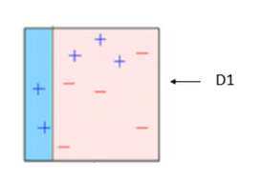

Decision Stump 1

We can observe that three of the positive samples are misclassified as negative. Therefore, we exaggerate the weights of these misclassified samples so that that they have a better chance of being selected when sampled again.

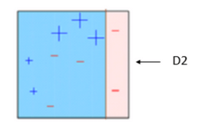

Decision Stump 2

When data is sampled next time, the decision stump 2 is combined with decision stump 1 to fit the training data. Therefore we have a miniature ensemble here trying to fit the data perfectly. This miniature ensemble of two decision stumps misclassifies three negative samples as positive. Therefore, we exaggerate the weights of these misclassified samples so that that they have a better chance of being selected when sampled again.

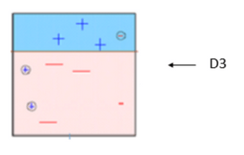

Decision Stump 3

The previously misclassified samples are chosen and decision stump 3 is applied to fit the training data. We can find that two positive samples are classified as negative and one negative sample is classified as positive. Then the ensemble of three decision stumps(1, 2 and 3) are used to fit the complete training data. When this ensemble of three decision stumps are used the model fits the training data perfectly.

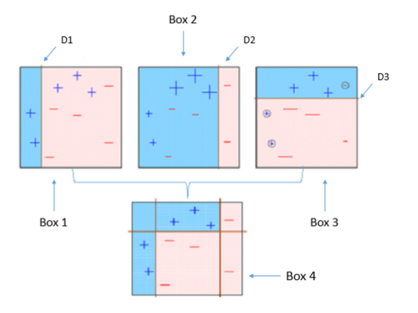

Ensemble of 3 Decision Stumps

The drawback of AdaBoost is that it is easily defeated by noisy data, the efficiency of the algorithm is highly affected by outliers as the algorithm tries to fit every point perfectly. You might be wondering since the algorithm tries to fit every point, doesn’t it overfit? No, it does not. The answer has been found out through experimental results, there has been speculations but no concrete reasoning available.

Code:

# AdaBoost Algorithm  
from sklearn.ensemble import AdaBoostClassifierclf = AdaBoostClassifier()  
# n\_estimators = 50 (default value)   
# base\_estimator = DecisionTreeClassifier (default value)  
clf.fit(x\_train,y\_train)  
clf.predict(x\_test)

Continuing to explain Gradient Boosting and XGBoost will further increase the length of this already pretty long article. Therefore I have decided to write them as another article. Please follow the link below.

Link: <https://medium.com/@grohith327/gradient-boosting-and-xgboost-90862daa6c77>

**A PRIMER TO ENSEMBLE LEARNING – BAGGING AND BOOSTING**

Ensemble is a machine learning concept in which multiple models are trained using the same learning algorithm. Bagging is a way to decrease the variance in the prediction by generating additional data for training from dataset using combinations with repetitions to produce multi-sets of the original data. Boosting is an iterative technique which adjusts the weight of an observation based on the last classification. If an observation was classified incorrectly, it tries to increase the weight of this observation. Boosting in general builds strong predictive models.

**Ensemble Methods:**

**Definition and Objective of Analysis**

**Definition:** Ensemble methods combine several decision trees classifiers to produce better predictive performance than a single decision tree classifier. The main principle behind the ensemble model is that a group of weak learners come together to form a strong learner, thus increasing the accuracy of the model.

**Objective of Analysis:**Minimization of risk and maximization of profit for the bank. To minimize loss from the bank’s perspective, the bank needs a decision rule regarding loan approval. An applicant’s demographic and socio-economic profiles are considered by loan managers before a decision is taken regarding his/her loan application. **The dataset contains data on 13 variables and the classification whether an applicant is considered a credit worthy (1) or a non-credit worthy (0) for 1000 loan applicants.** A predictive model developed on this data should provide the bank manager guidance for making a decision whether to approve a loan to a prospective applicant based on his/her profile.

**Cost-Profit Consideration:**The statistical decisions must be translated into profit consideration for the bank. Let us assume:

* Correct decision: A correct decision of the bank manager would result in 35% profit at the end of 5 years. A correct decision here means that the bank manager predicts an application to be good or credit-worthy and it actually turns out to be credit worthy.
* Wrong decision: When the bank manager predicts the application to be good but it turns out to be bad credit, then the loss is 100%.
* If the bank manager predicts an application to be non-creditworthy, then loan facility is not extended to that applicant and bank does not incur any loss. The cost matrix, therefore, is as follows:

[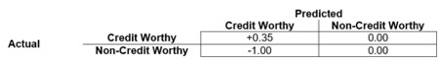](https://analyticsindiamag.com/primer-ensemble-learning-bagging-boosting/a-primer-to-ensemble-learning-bagging-and-boosting/)

### Dataset Source and Contents

The following is a description of the dataset:

* **of Classes:**2 (‘Credit Worthy’ and ‘Non-Credit Worthy’)
* **of attributes (Columns):** 13
* **of instances (Rows):**1,000

This data was extracted from the census bureau database found at:

**http://archive.ics.uci.edu/ml/datasets**

### Exploratory Data Analysis

[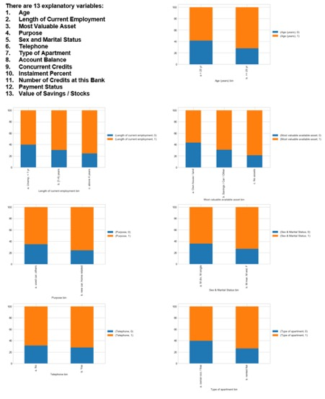](https://analyticsindiamag.com/primer-ensemble-learning-bagging-boosting/a-primer-to-ensemble-learning-bagging-and-boosting-2/)

[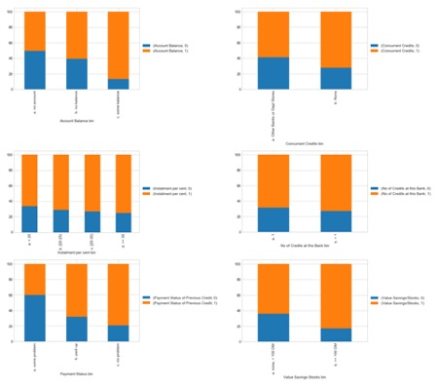](https://analyticsindiamag.com/primer-ensemble-learning-bagging-boosting/a-primer-to-ensemble-learning-bagging-and-boosting-3/)

# Bagging and Boosting

### Bagging

|  |  |
| --- | --- |
| **Partitioning of data** | **Random** |
| **Goal to achieve** | **Minimum variance** |
| **Methods used** | **Random subspace** |
| **Functions to combine single model** | **Weighted average** |
| **Example** | **Random Forest** |

**Definition:**

Bagging is used when the goal is to reduce the variance of a decision tree classifier. **Here the objective is to create several subsets of data from training sample chosen randomly with replacement. Each collection of subset data is used to train their decision trees.** As a result, we get an ensemble of different models. Average of all the predictions from different trees are used which is more robust than a single decision tree classifier.

**Bagging Steps:**

* Suppose there are N observations and M features in training data set. A sample from training data set is taken randomly with replacement.
* A subset of M features are selected randomly and whichever feature gives the best split is used to split the node iteratively.
* The tree is grown to the largest.
* Above steps are repeated n times and prediction is given based on the aggregation of predictions from n number of trees.

**Advantages:**

* Reduces over-fitting of the model.
* Handles higher dimensionality data very well.
* Maintains accuracy for missing data.

**Disadvantages:**

* Since final prediction is based on the mean predictions from subset trees, it won’t give precise values for the classification and regression model.

**[Also Read  10 Popular IDEs Java Developers Can Use](https://analyticsindiamag.com/10-popular-js-ides-java-developers-can-use/" \t "_self)**

**Python Syntax:**

* rfm = RandomForestClassifier(n\_estimators=80, oob\_score=True, n\_jobs=-1, random\_state=101, max\_features = 0.50, min\_samples\_leaf = 5)
* fit(x\_train, y\_train)
* predicted = rfm.predict\_proba(x\_test)

### Boosting

|  |  |
| --- | --- |
| **Partitioning of data** | **Higher vote to misclassified samples** |
| **Goal to achieve** | **Increase accuracy** |
| **Methods used** | **Gradient descent** |
| **Functions to combine single model** | **Weighted majority vote** |
| **Example** | **Ada Boost** |

**Definition:**

Boosting is used to create a collection of predictors. **In this technique, learners are learned sequentially with early learners fitting simple models to the data and then analysing data for errors. Consecutive trees (random sample) are fit and at every step, the goal is to improve the accuracy from the prior tree.**When an input is misclassified by a hypothesis, its weight is increased so that next hypothesis is more likely to classify it correctly. This process converts weak learners into better performing model.

**Boosting Steps:**

* Draw a random subset of training samples d1 without replacement from the training set D to train a weak learner C1
* Draw second random training subset d2 without replacement from the training set and add 50 percent of the samples that were previously falsely classified/misclassified to train a weak learner C2
* Find the training samples d3 in the training set D on which C1 and C2 disagree to train a third weak learner C3
* Combine all the weak learners via majority voting.

**Advantages:**

* Supports different loss function (we have used ‘binary:logistic’ for this example).
* Works well with interactions.

**Disadvantages:**

* Prone to over-fitting.
* Requires careful tuning of different hyper-parameters.

**Python Syntax:**

* from xgboost import XGBClassifier
* xgb = XGBClassifier(objective=’binary:logistic’, n\_estimators=70, seed=101)
* fit(x\_train, y\_train)
* predicted = xgb.predict\_proba(x\_test)

# Conclusion

### Comparison Matrix

* **Accuracy: (True Positive + True Negative) / Total Population**
  + **Accuracy is a ratio of correctly predicted observation to the total observations. Accuracy is the most intuitive performance measure.**
  + True Positive: The number of correct predictions that the occurrence is positive
  + True Negative: The number of correct predictions that the occurrence is negative
* **F1-Score: (2 x Precision x Recall) / (Precision + Recall)**
  + **F1-Score is the weighted average of Precision and Recall. Therefore, this score takes both false positives and false negatives into account. F1-Score is usually more useful than accuracy, especially if you have an uneven class distribution.**
  + Precision: When a positive value is predicted, how often is the prediction correct?
  + Recall: When the actual value is positive, how often is the prediction correct?

|  |  |  |
| --- | --- | --- |
| **Classification Algorithms** | **Accuracy** | **F1-Score** |
| Decision Tree | 76.67 % | 0.74 |
| Bagging | 77.67 % | 0.77 |
| Boosting | 78.67 % | 0.78 |

Code location: https://github.com/f2005636/Ensemble

### Cost-Profit Consideration

Although the improvement in **Accuracy** and **F1-Score** for Bagging and Boosting is not significant when compared to the Decision Tree, **significant improvement is seen for overall profit.**

[](https://analyticsindiamag.com/primer-ensemble-learning-bagging-boosting/a-primer-to-ensemble-learning-bagging-and-boosting-4/)

NCW (0): Non-Credit Worthy

CW (1): Credit Worthy

|  |  |  |
| --- | --- | --- |
| **Classification Algorithms** | **Calculation** | **Profit** |
| Decision Tree | 0.35 \* 196 -1.00 \* 56 | 12.60 |
| Bagging | 0.35 \* 185 -1.00 \* 42 | 22.75 |
| Boosting | 0.35 \* 186 -1.00 \* 40 | 25.10 |

**Bagging and Boosting are both ensemble methods in Machine Learning, but what’s the key behind them?**

Bagging and Boosting are similar in that they are both **ensemble techniques**, where a set of weak learners are combined to create a strong learner that obtains better performance than a single one. So, let’s start from the beginning:

## What is an ensemble method?

Ensemble is a Machine Learning concept in which the idea is to train **multiple models** using the same learning algorithm. The ensembles take part in a bigger group of methods, called **multiclassifiers,** where a set of hundreds or thousands of learners with a common objective are fused together to solve the problem.

The second group of multiclassifiers contain **the hybrid methods**. They use a set of learners too, but they can be trained using different learning techniques. Stacking is the most well-known. If you want to learn more about Stacking, you can read my previous post, “[**Dream team combining classifiers**](http://quantdare.com/dream-team-combining-classifiers-2/)“.

The main causes of error in learning are due to **noise, bias and variance**. Ensemble helps to minimize these factors. These methods are designed to improve the stability and the accuracy of Machine Learning algorithms. Combinations of multiple classifiers decrease variance, especially in the case of unstable classifiers, and may produce a more reliable classification than a single classifier.

To use Bagging or Boosting you must select a base learner algorithm. For example, if we choose a classification tree, Bagging and Boosting would consist of a pool of trees as big as we want. 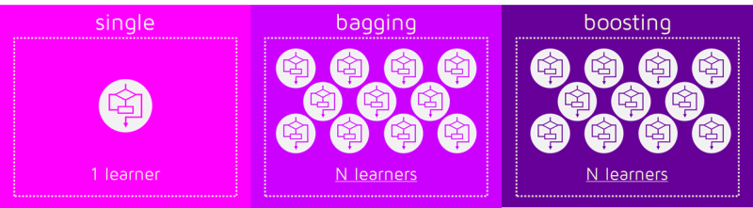

## How do Bagging and Boosting get N learners?

Bagging and Boosting get N learners by generating additional data in the training stage. N new training data sets are produced by **random sampling with replacement** from the original set. By sampling with replacement some observations may be repeated in each new training data set.

In the case of Bagging, any element has the same probability to appear in a new data set. However, for Boosting the observations are weighted and therefore some of them will take part in the new sets more often:

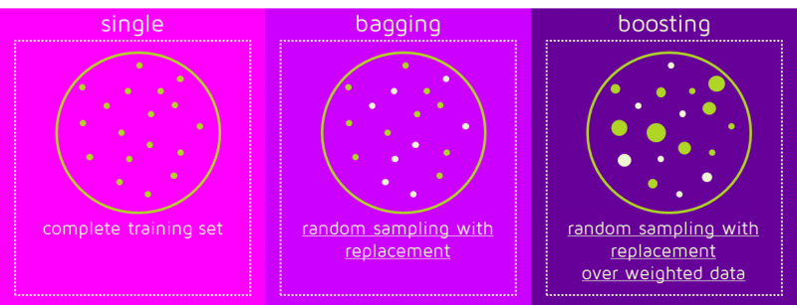These multiple sets are used to train the same learner algorithm and therefore different classifiers are produced.

## Why are the data elements weighted?

At this point, we begin to deal with the main difference between the two methods. While the training stage is parallel for Bagging (i.e., each model is built independently), Boosting builds the new learner in a sequential way: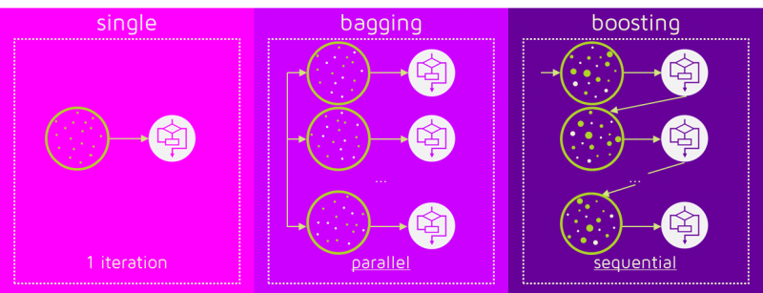In Boosting algorithms each classifier is trained on data, taking into account the previous classifiers’ success. After each training step, the weights are redistributed. M**isclassified data increases its weights** to emphasise the most difficult cases. In this way, subsequent learners will focus on them during their training.

## How does the classification stage work?

To predict the class of new data we only need to **apply the N learners to the new observations.** In Bagging the result is obtained by averaging the responses of the N learners (or majority vote). However, Boosting assigns a second set of weights, this time for the N classifiers, in order to take a **weighted average** of their estimates.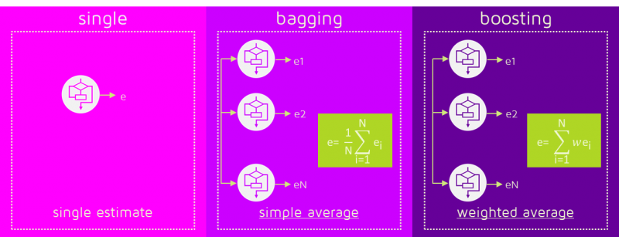In the Boosting training stage, the algorithm allocates weights to each resulting model. A learner with good a classification result on the training data will be assigned a higher weight than a poor one. So when evaluating a new learner, Boosting needs to keep track of learners’ errors, too. Let’s see the differences in the procedures: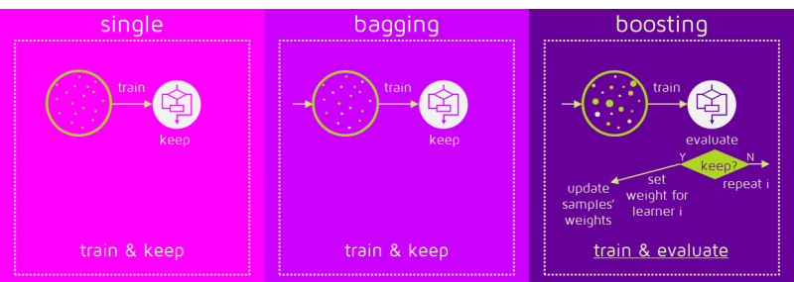

Some of the Boosting techniques include an extra-condition to keep or discard a single learner. For example, in AdaBoost, the most renowned, an error less than 50% is required to maintain the model; otherwise, the iteration is repeated until achieving a learner better than a random guess.

The previous image shows the general process of a Boosting method, but several alternatives exist with different ways to determine the weights to use in the next training step and in the classification stage. Click here if you like to go into detail: [**AdaBoost**](https://en.wikipedia.org/wiki/AdaBoost), [**LPBoost**](https://en.wikipedia.org/wiki/LPBoost), [**XGBoost**](http://arxiv.org/pdf/1603.02754v1.pdf), [**GradientBoost**](https://en.wikipedia.org/wiki/Gradient_boosting), [**BrownBoost**](https://en.wikipedia.org/wiki/BrownBoost).

## Which is the best, Bagging or Boosting?

There’s not an outright winner; it depends on the data, the simulation and the circumstances.  
Bagging and Boosting decrease the variance of your single estimate as they combine several estimates from different models. So the result may be a model with **higher stability**.

If the problem is that the single model gets a very low performance, Bagging will rarely get a **better bias**. However, Boosting could generate a combined model with lower errors as it optimises the advantages and reduces pitfalls of the single model.

By contrast, if the difficulty of the single model is **over-fitting**, then Bagging is the best option. Boosting for its part doesn’t help to avoid over-fitting; in fact, this technique is faced with this problem itself. For this reason, Bagging is effective more often than Boosting.

## To sum up:

|  |  |
| --- | --- |
| **Similarities** | **Differences** |
| Both are ensemble methods to get N learners from 1 learner… | … but, while they are built independently for Bagging, Boosting tries to add new models that do well where previous models fail. |
| Both generate several training data sets by random sampling… | … but only Boosting determines weights for the data to tip the scales in favor of the most difficult cases. |
| Both make the final decision by averaging  the N learners (or taking the majority of them)… | … but it is an equally weighted average for Bagging and a weighted average for Boosting, more weight to those with better performance on training data. |
| Both are good at reducing variance and provide higher stability… | … but only Boosting tries to reduce bias. On the other hand, Bagging may solve the over-fitting problem, while Boosting can increase it. |

# **Ensemble methods: bagging, boosting and stacking**

## **Understanding the key concepts of ensemble learning.**

# Introduction

“Unity is strength”. This old saying expresses pretty well the underlying idea that rules the very powerful “ensemble methods” in machine learning. Roughly, ensemble learning methods, that often trust the top rankings of many machine learning competitions (including Kaggle’s competitions), are based on the hypothesis that combining multiple models together can often produce a much more powerful model.

The purpose of this post is to introduce various notions of ensemble learning. We will give the reader some necessary keys to well understand and use related methods and be able to design adapted solutions when needed. We will discuss some well known notions such as boostrapping, bagging, random forest, boosting, stacking and many others that are the basis of ensemble learning. In order to make the link between all these methods as clear as possible, we will try to present them in a much broader and logical framework that, we hope, will be easier to understand and remember.

## Outline

In the first section of this post we will present the notions of weak and strong learners and we will introduce three main ensemble learning methods: bagging, boosting and stacking. Then, in the second section we will be focused on bagging and we will discuss notions such that bootstrapping, bagging and random forests. In the third section, we will present boosting and, in particular, its two most popular variants: adaptative boosting (adaboost) and gradient boosting. Finally in the fourth section we will give an overview of stacking.

# What are ensemble methods?

Ensemble learning is a machine learning paradigm where multiple models (often called “weak learners”) are trained to solve the same problem and combined to get better results. The main hypothesis is that when weak models are correctly combined we can obtain more accurate and/or robust models.

## Single weak learner

In machine learning, no matter if we are facing a classification or a regression problem, the choice of the model is extremely important to have any chance to obtain good results. This choice can depend on many variables of the problem: quantity of data, dimensionality of the space, distribution hypothesis…

A low bias and a low variance, although they most often vary in opposite directions, are the two most fundamental features expected for a model. Indeed, to be able to “solve” a problem, we want our model to have enough degrees of freedom to resolve the underlying complexity of the data we are working with, but we also want it to have not too much degrees of freedom to avoid high variance and be more robust. This is the well known **bias-variance tradeoff**.

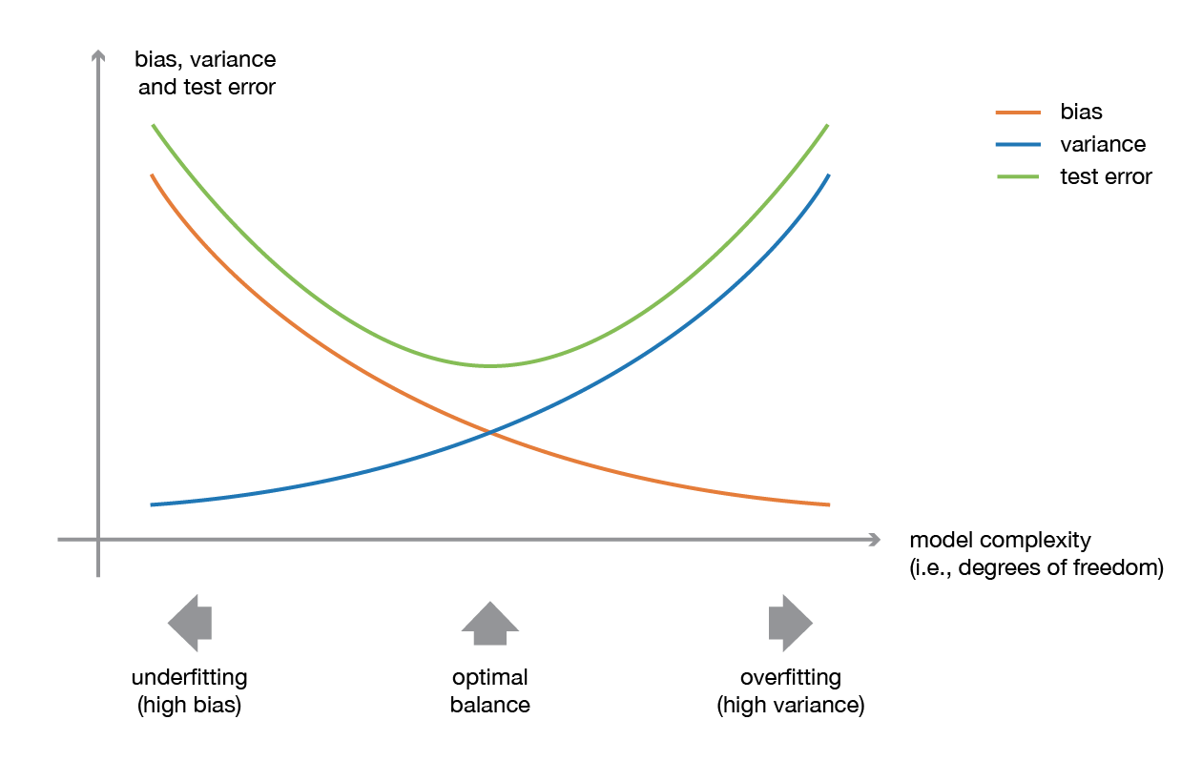

Illustration of the bias-variance tradeoff.

In ensemble learning theory, we call **weak learners** (or **base models**) models that can be used as building blocks for designing more complex models by combining several of them. Most of the time, these basics models perform not so well by themselves either because they have a high bias (low degree of freedom models, for example) or because they have too much variance to be robust (high degree of freedom models, for example). Then, the idea of ensemble methods is to try reducing bias and/or variance of such weak learners by combining several of them together in order to create a **strong learner** (or **ensemble model**) that achieves better performances.

## Combine weak learners

In order to set up an ensemble learning method, we first need to select our base models to be aggregated. Most of the time (including in the well known bagging and boosting methods) a single base learning algorithm is used so that we have homogeneous weak learners that are trained in different ways. The ensemble model we obtain is then said to be “homogeneous”. However, there also exist some methods that use different type of base learning algorithms: some heterogeneous weak learners are then combined into an “heterogeneous ensembles model”.

One important point is that our choice of weak learners should be **coherent with the way we aggregate these models**. If we choose base models with low bias but high variance, it should be with an aggregating method that tends to reduce variance whereas if we choose base models with low variance but high bias, it should be with an aggregating method that tends to reduce bias.

This brings us to the question of how to combine these models. We can mention three major kinds of meta-algorithms that aims at combining weak learners:

* **bagging**, that often considers homogeneous weak learners, learns them independently from each other in parallel and combines them following some kind of deterministic averaging process
* **boosting**, that often considers homogeneous weak learners, learns them sequentially in a very adaptative way (a base model depends on the previous ones) and combines them following a deterministic strategy
* **stacking**, that often considers heterogeneous weak learners, learns them in parallel and combines them by training a meta-model to output a prediction based on the different weak models predictions

Very roughly, we can say that bagging will mainly focus at getting an ensemble model with less variance than its components whereas boosting and stacking will mainly try to produce strong models less biased than their components (even if variance can also be reduced).

In the following sections, we will present in details bagging and boosting (that are a bit more widely used than stacking and will allow us to discuss some key notions of ensemble learning) before giving a brief overview of stacking.

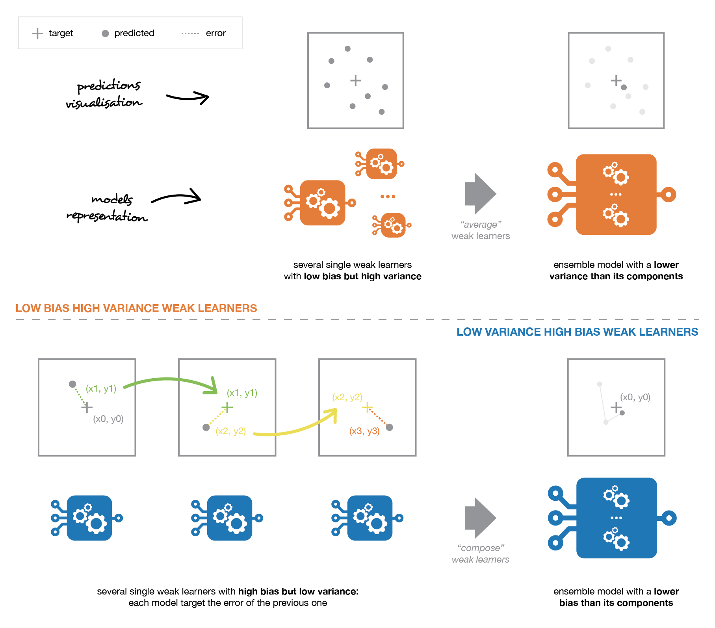

Weak learners can be combined to get a model with better performances. The way to combine base models should be adapted to their types. Low bias and high variance weak models should be combined in a way that makes the strong model more robust whereas low variance and high bias base models better be combined in a way that makes the ensemble model less biased.

# Focus on bagging

In **parallel methods** we fit the different considered learners independently from each others and, so, it is possible to train them concurrently. The most famous such approach is “bagging” (standing for “bootstrap aggregating”) that aims at producing an ensemble model that is **more robust** than the individual models composing it.

## Bootstrapping

Let’s begin by defining bootstrapping. This statistical technique consists in generating samples of size B (called bootstrap samples) from an initial dataset of size N by randomly drawing with replacement B observations.

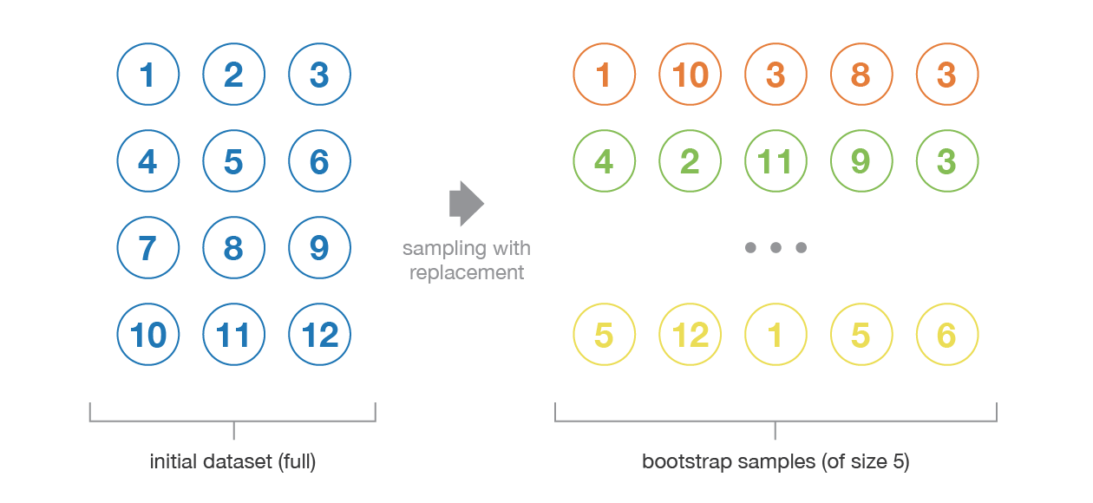

Illustration of the bootstrapping process.

Under some assumptions, these samples have pretty **good statistical properties**: in first approximation, they can be seen as being drawn both directly from the true underlying (and often unknown) data distribution and independently from each others. So, they can be considered as representative and independent samples of the true data distribution (almost i.i.d. samples). The hypothesis that have to be verified to make this approximation valid are twofold. First, the size N of the initial dataset should be large enough to capture most of the complexity of the underlying distribution so that sampling from the dataset is a good approximation of sampling from the real distribution (**representativity**). Second, the size N of the dataset should be large enough compared to the size B of the bootstrap samples so that samples are not too much correlated (**independence**). Notice that in the following, we will sometimes make reference to these properties (representativity and independence) of bootstrap samples: the reader should always keep in mind that **this is only an approximation**.

Bootstrap samples are often used, for example, to evaluate variance or confidence intervals of a statistical estimators. By definition, a statistical estimator is a function of some observations and, so, a random variable with variance coming from these observations. In order to estimate the variance of such an estimator, we need to evaluate it on several independent samples drawn from the distribution of interest. In most of the cases, considering truly independent samples would require too much data compared to the amount really available. We can then use bootstrapping to generate several bootstrap samples that can be considered as being “almost-representative” and “almost-independent” (almost i.i.d. samples). These bootstrap samples will allow us to approximate the variance of the estimator, by evaluating its value for each of them.

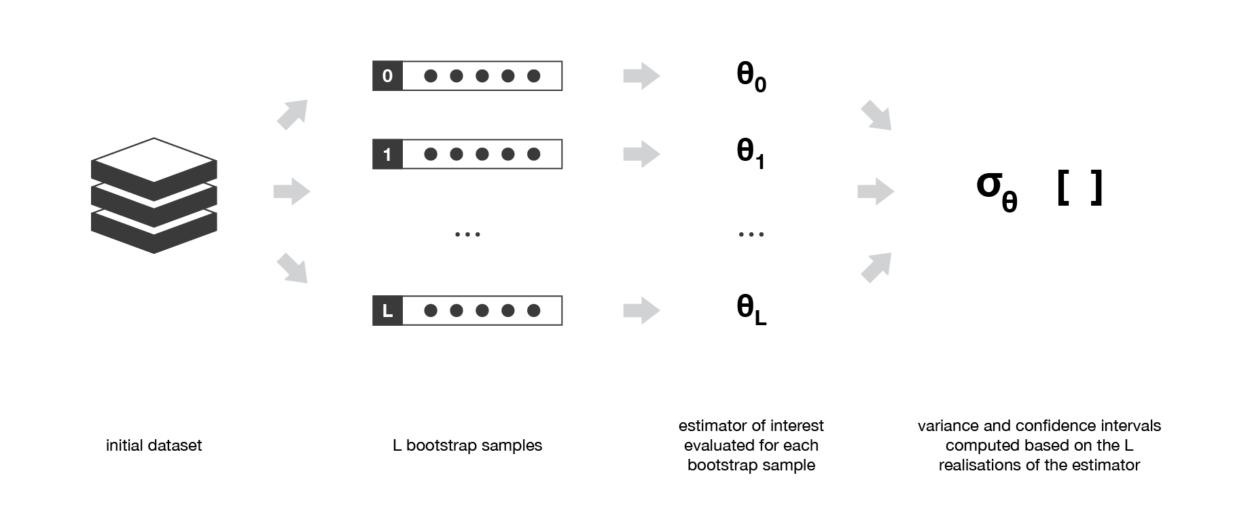

Bootstrapping is often used to evaluate variance or confidence interval of some statistical estimators.

## Bagging

When training a model, no matter if we are dealing with a classification or a regression problem, we obtain a function that takes an input, returns an output and that is defined with respect to the training dataset. Due to the theoretical variance of the training dataset (we remind that a dataset is an observed sample coming from a true unknown underlying distribution), the fitted model is also subject to variability: **if another dataset had been observed, we would have obtained a different model**.

The idea of bagging is then simple: we want to fit several independent models and “average” their predictions in order to obtain a model with a lower variance. However, we can’t, in practice, fit fully independent models because it would require too much data. So, we rely on the good “approximate properties” of bootstrap samples (representativity and independence) to fit models that are almost independent.

First, we create multiple bootstrap samples so that each new bootstrap sample will act as another (almost) independent dataset drawn from true distribution. Then, we can **fit a weak learner for each of these samples and finally aggregate them such that we kind of “average” their outputs** and, so, obtain an ensemble model with less variance that its components. Roughly speaking, as the bootstrap samples are approximatively independent and identically distributed (i.i.d.), so are the learned base models. Then, “averaging” weak learners outputs do not change the expected answer but reduce its variance (just like averaging i.i.d. random variables preserve expected value but reduce variance).

So, assuming that we have L bootstrap samples (approximations of L independent datasets) of size B denoted



we can fit L almost independent weak learners (one on each dataset)

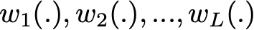

and then aggregate them into some kind of averaging process in order to get an ensemble model with a lower variance. For example, we can define our strong model such that

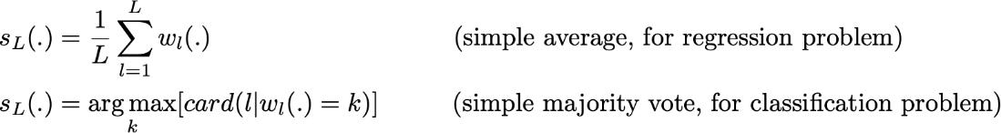

There are several possible ways to aggregate the multiple models fitted in parallel. For a regression problem, the outputs of individual models can literally be averaged to obtain the output of the ensemble model. For classification problem the class outputted by each model can be seen as a vote and the class that receives the majority of the votes is returned by the ensemble model (this is called **hard-voting**). Still for a classification problem, we can also consider the probabilities of each classes returned by all the models, average these probabilities and keep the class with the highest average probability (this is called **soft-voting**). Averages or votes can either be simple or weighted if any relevant weights can be used.

Finally, we can mention that one of the big advantages of bagging is that **it can be parallelised**. As the different models are fitted independently from each others, intensive parallelisation techniques can be used if required.

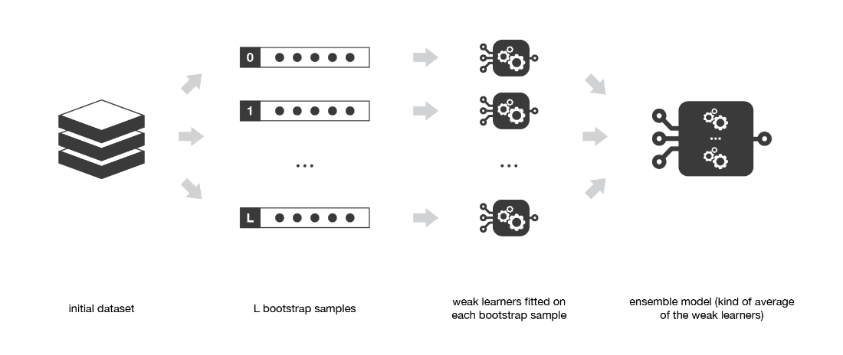

Bagging consists in fitting several base models on different bootstrap samples and build an ensemble model that “average” the results of these weak learners.

## Random forests

Learning trees are very popular base models for ensemble methods. Strong learners composed of multiple trees can be called “forests”. Trees that compose a forest can be chosen to be either shallow (few depths) or deep (lot of depths, if not fully grown). Shallow trees have less variance but higher bias and then will be better choice for sequential methods that we will described thereafter. Deep trees, on the other side, have low bias but high variance and, so, are relevant choices for bagging method that is mainly focused at reducing variance.

The **random forest** approach is a bagging method where **deep trees**, fitted on bootstrap samples, are combined to produce an output with lower variance. However, random forests also use another trick to make the multiple fitted trees a bit less correlated with each others: when growing each tree, instead of only sampling over the observations in the dataset to generate a bootstrap sample, we also **sample over features** and keep only a random subset of them to build the tree.

Sampling over features has indeed the effect that all trees do not look at the exact same information to make their decisions and, so, it reduces the correlation between the different returned outputs. Another advantage of sampling over the features is that**it makes the decision making process more robust to missing data**: observations (from the training dataset or not) with missing data can still be regressed or classified based on the trees that take into account only features where data are not missing. Thus, random forest algorithm combines the concepts of bagging and random feature subspace selection to create more robust models.

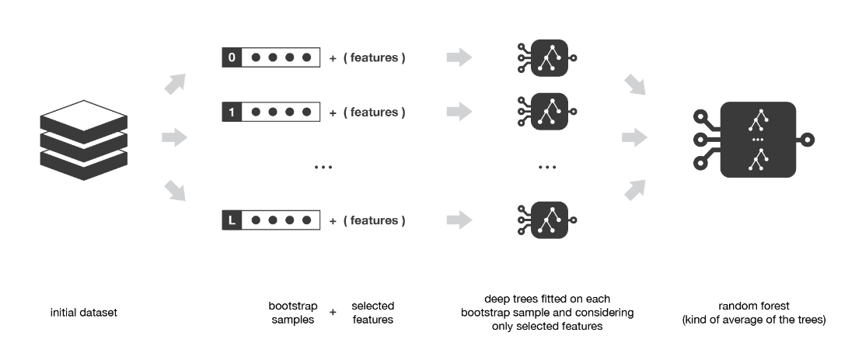

Random forest method is a bagging method with trees as weak learners. Each tree is fitted on a bootstrap sample considering only a subset of variables randomly chosen.

Focus on boosting

In **sequential methods** the different combined weak models are no longer fitted independently from each others. The idea is to fit models **iteratively** such that the training of model at a given step depends on the models fitted at the previous steps. “Boosting” is the most famous of these approaches and it produces an ensemble model that is in general less biased than the weak learners that compose it.

## Boosting

Boosting methods work in the same spirit as bagging methods: we build a family of models that are aggregated to obtain a strong learner that performs better. However, unlike bagging that mainly aims at reducing variance, boosting is a technique that consists in fitting sequentially multiple weak learners in a very adaptative way: each model in the sequence is fitted giving more importance to observations in the dataset that were badly handled by the previous models in the sequence. Intuitively, each new model **focus its efforts on the most difficult observations** to fit up to now, so that we obtain, at the end of the process, a strong learner with lower bias (even if we can notice that boosting can also have the effect of reducing variance). Boosting, like bagging, can be used for regression as well as for classification problems.

Being **mainly focused at reducing bias**, the base models that are often considered for boosting are models with low variance but high bias. For example, if we want to use trees as our base models, we will choose most of the time shallow decision trees with only a few depths. Another important reason that motivates the use of low variance but high bias models as weak learners for boosting is that these models are in general less computationally expensive to fit (few degrees of freedom when parametrised). Indeed, as computations to fit the different models **can’t be done in parallel** (unlike bagging), it could become too expensive to fit sequentially several complex models.

Once the weak learners have been chosen, we still need to define how they will be sequentially fitted (what information from previous models do we take into account when fitting current model?) and how they will be aggregated (how do we aggregate the current model to the previous ones?). We will discuss these questions in the two following subsections, describing more especially two important boosting algorithms: adaboost and gradient boosting.

In a nutshell, these two meta-algorithms differ on how they create and aggregate the weak learners during the sequential process. Adaptive boosting updates the weights attached to each of the training dataset observations whereas gradient boosting updates the value of these observations. This main difference comes from the way both methods try to solve the optimisation problem of finding the best model that can be written as a weighted sum of weak learners.

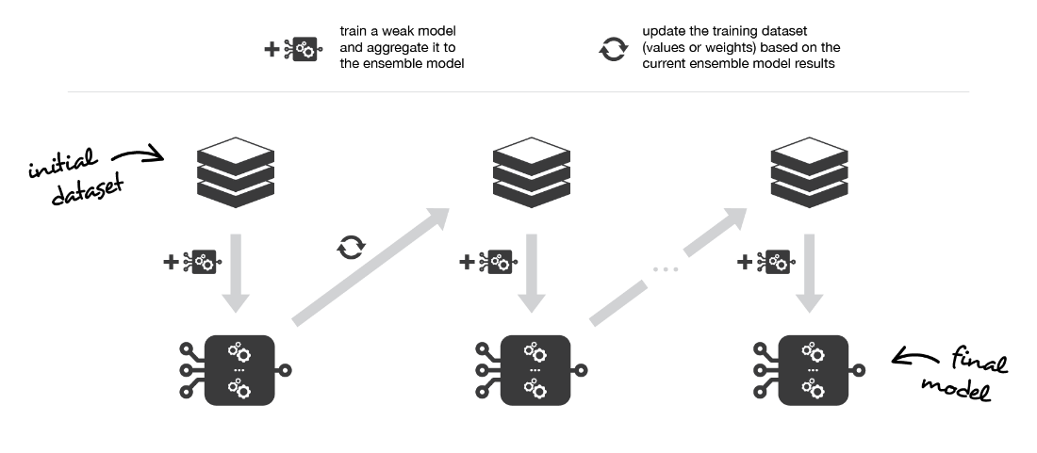

Boosting consists in, iteratively, fitting a weak learner, aggregate it to the ensemble model and “update” the training dataset to better take into account the strengths and weakness of the current ensemble model when fitting the next base model.

## Adaptative boosting

In adaptative boosting (often called “adaboost”), we try to define our ensemble model as a weighted sum of L weak learners



Finding the best ensemble model with this form is a **difficult optimisation problem**. Then, instead of trying to solve it in one single shot (finding all the coefficients and weak learners that give the best overall additive model), we make use of an **iterative optimisation process** that is much more tractable, even if it can lead to a sub-optimal solution. More especially, we add the weak learners one by one, looking at each iteration for the best possible pair (coefficient, weak learner) to add to the current ensemble model. In other words, we define recurrently the (s\_l)’s such that



where c\_l and w\_l are chosen such that s\_l is the model that fit the best the training data and, so, that is the best possible improvement over s\_(l-1). We can then denote



where E(.) is the fitting error of the given model and e(.,.) is the loss/error function. Thus, instead of optimising “globally” over all the L models in the sum, we approximate the optimum by optimising “locally” building and adding the weak learners to the strong model one by one.

More especially, when considering a binary classification, we can show that the adaboost algorithm can be re-written into a process that proceeds as follow. First, it **updates the observations weights** in the dataset and train a new weak learner with a special focus given to the observations misclassified by the current ensemble model. Second, it **adds the weak learner to the weighted sum** according to an update coefficient that expresse the performances of this weak model: the better a weak learner performs, the more it contributes to the strong learner.

So, assume that we are facing a binary classification problem, with N observations in our dataset and we want to use adaboost algorithm with a given family of weak models. At the very beginning of the algorithm (first model of the sequence), all the observations have the same weights 1/N. Then, we repeat L times (for the L learners in the sequence) the following steps:

* fit the best possible weak model with the current observations weights
* compute the value of the update coefficient that is some kind of scalar evaluation metric of the weak learner that indicates how much this weak learner should be taken into account into the ensemble model
* update the strong learner by adding the new weak learner multiplied by its update coefficient
* compute new observations weights that expresse which observations we would like to focus on at the next iteration (weights of observations wrongly predicted by the aggregated model increase and weights of the correctly predicted observations decrease)

Repeating these steps, we have then build sequentially our L models and aggregate them into a simple linear combination weighted by coefficients expressing the performance of each learner. Notice that there exists variants of the initial adaboost algorithm such that LogitBoost (classification) or L2Boost (regression) that mainly differ by their choice of loss function.

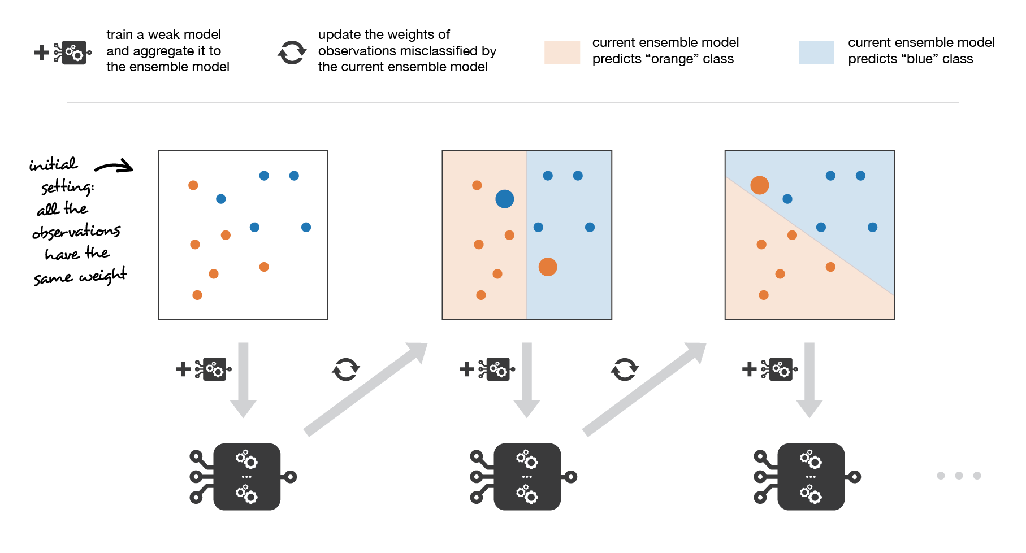

Adaboost updates weights of the observations at each iteration. Weights of well classified observations decrease relatively to weights of misclassified observations. Models that perform better have higher weights in the final ensemble model.

## Gradient boosting

In gradient boosting, the ensemble model we try to build is also a weighted sum of weak learners



Just as we mentioned for adaboost, finding the optimal model under this form is too difficult and an iterative approach is required. The main difference with adaptative boosting is in the definition of the sequential optimisation process. Indeed, gradient boosting **casts the problem into a gradient descent one**: at each iteration we fit a weak learner to the opposite of the gradient of the current fitting error with respect to the current ensemble model. Let’s try to clarify this last point. First, theoretical gradient descent process over the ensemble model can be written



where E(.) is the fitting error of the given model, c\_l is a coefficient corresponding to the step size and

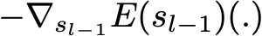

is the opposite of the gradient of the fitting error with respect to the ensemble model at step l-1. This (pretty abstract) opposite of the gradient is a function that can, in practice, only be evaluated for observations in the training dataset (for which we know inputs and outputs): these evaluations are called **pseudo-residuals** attached to each observations. Moreover, even if we know for the observations the values of these pseudo-residuals, we don’t want to add to our ensemble model any kind of function: we only want to add a new instance of weak model. So, the natural thing to do is to **fit a weak learner to the pseudo-residuals** computed for each observation. Finally, the coefficient c\_l is computed following a one dimensional optimisation process (line-search to obtain the best step size c\_l).

So, assume that we want to use gradient boosting technique with a given family of weak models. At the very beginning of the algorithm (first model of the sequence), the pseudo-residuals are set equal to the observation values. Then, we repeat L times (for the L models of the sequence) the following steps:

* fit the best possible weak learner to pseudo-residuals (approximate the opposite of the gradient with respect to the current strong learner)
* compute the value of the optimal step size that defines by how much we update the ensemble model in the direction of the new weak learner
* update the ensemble model by adding the new weak learner multiplied by the step size (make a step of gradient descent)
* compute new pseudo-residuals that indicate, for each observation, in which direction we would like to update next the ensemble model predictions

Repeating these steps, we have then build sequentially our L models and aggregate them following a gradient descent approach. Notice that, while adaptative boosting tries to solve at each iteration exactly the “local” optimisation problem (find the best weak learner and its coefficient to add to the strong model), gradient boosting uses instead a gradient descent approach and can more easily be adapted to large number of loss functions. Thus, **gradient boosting can be considered as a generalization of adaboost to arbitrary differentiable loss functions**.

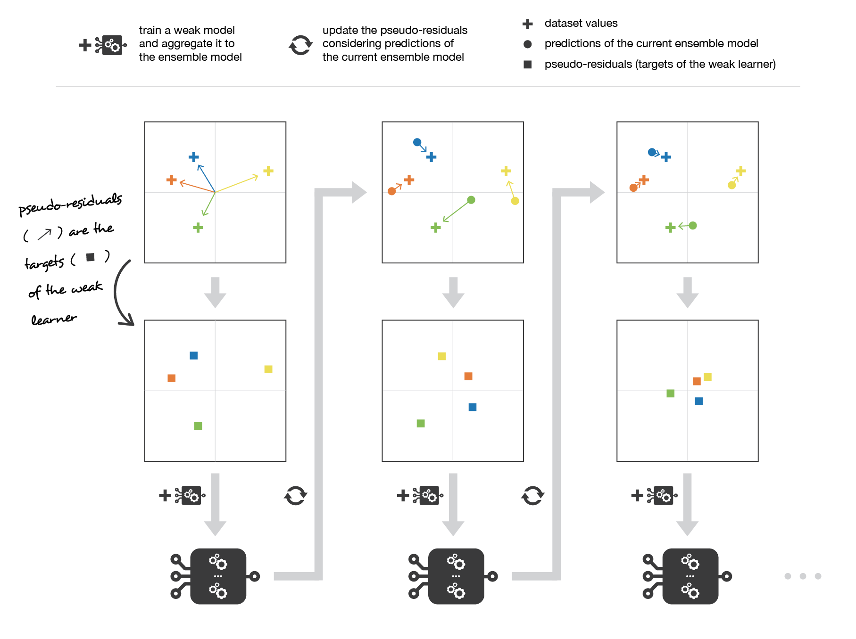

Gradient boosting updates values of the observations at each iteration. Weak learners are trained to fit the pseudo-residuals that indicate in which direction to correct the current ensemble model predictions to lower the error.

# Overview of stacking

Stacking mainly differ from bagging and boosting on two points. First stacking often considers **heterogeneous weak learners** (different learning algorithms are combined) whereas bagging and boosting consider mainly homogeneous weak learners. Second, stacking learns to combine the base models using a meta-model whereas bagging and boosting combine weak learners following deterministic algorithms.

## Stacking

As we already mentioned, the idea of stacking is to learn several different weak learners and **combine them by training a meta-model** to output predictions based on the multiple predictions returned by these weak models. So, we need to define two things in order to build our stacking model: the L learners we want to fit and the meta-model that combines them.

For example, for a classification problem, we can choose as weak learners a KNN classifier, a logistic regression and a SVM, and decide to learn a neural network as meta-model. Then, the neural network will take as inputs the outputs of our three weak learners and will learn to return final predictions based on it.

So, assume that we want to fit a stacking ensemble composed of L weak learners. Then we have to follow the steps thereafter:

* split the training data in two folds
* choose L weak learners and fit them to data of the first fold
* for each of the L weak learners, make predictions for observations in the second fold
* fit the meta-model on the second fold, using predictions made by the weak learners as inputs

In the previous steps, we split the dataset in two folds because predictions on data that have been used for the training of the weak learners are **not relevant for the training of the meta-model**. Thus, an obvious drawback of this split of our dataset in two parts is that we only have half of the data to train the base models and half of the data to train the meta-model. In order to overcome this limitation, we can however follow some kind of “k-fold cross-training” approach (similar to what is done in k-fold cross-validation) such that all the observations can be used to train the meta-model: for any observation, the prediction of the weak learners are done with instances of these weak learners trained on the k-1 folds that do not contain the considered observation. In other words, it consists in training on k-1 fold in order to make predictions on the remaining fold and that iteratively so that to obtain predictions for observations in any folds. Doing so, we can produce relevant predictions for each observation of our dataset and then train our meta-model on all these predictions.

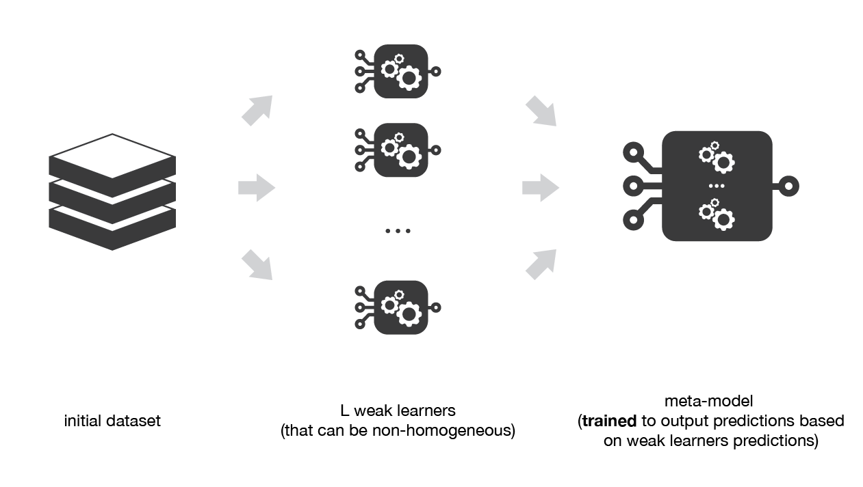

Stacking consists in training a meta-model to produce outputs based on the outputs returned by some lower layer weak learners.

## Multi-levels Stacking

A possible extension of stacking is multi-level stacking. It consists in doing **stacking with multiple layers**. As an example, let’s consider a 3-levels stacking. In the first level (layer), we fit the L weak learners that have been chosen. Then, in the second level, instead of fitting a single meta-model on the weak models predictions (as it was described in the previous subsection) we fit M such meta-models. Finally, in the third level we fit a last meta-model that takes as inputs the predictions returned by the M meta-models of the previous level.

From a practical point of view, notice that for each meta-model of the different levels of a multi-levels stacking ensemble model, we have to choose a learning algorithm that can be almost whatever we want (even algorithms already used at lower levels). We can also mention that **adding levels can either be data expensive** (if k-folds like technique is not used and, then, more data are needed) **or time expensive** (if k-folds like technique is used and, then, lot of models need to be fitted).

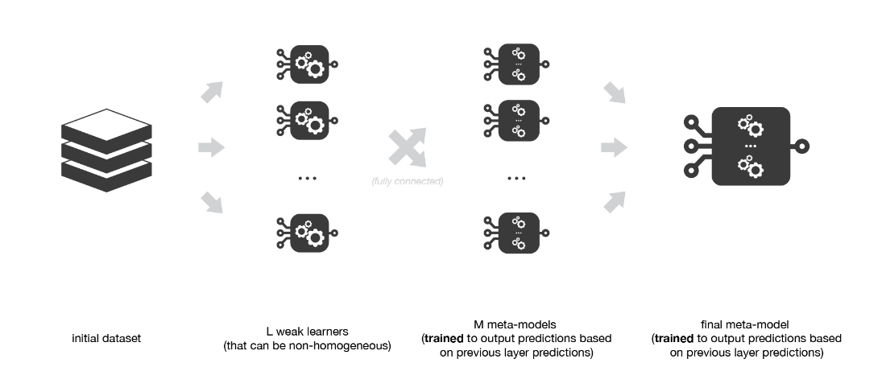

Multi-level stacking considers several layers of stacking: some meta-models are trained on outputs returned by lower layer meta-models and so on. Here we have represented a 3-layers stacking model.

# Takeaways

The main takeaways of this post are the following:

* ensemble learning is a machine learning paradigm where multiple models (often called weak learners or base models) are trained to solve the same problem and combined to get better performances
* the main hypothesis is that if we combine the weak learners the right way we can obtain more accurate and/or robust models
* in bagging methods, several instance of the same base model are trained in parallel (independently from each others) on different bootstrap samples and then aggregated in some kind of “averaging” process
* the kind of averaging operation done over the (almost) i.i.d fitted models in bagging methods mainly allows us to obtain an ensemble model with a lower variance than its components: that is why base models with low bias but high variance are well adapted for bagging
* in boosting methods, several instance of the same base model are trained sequentially such that, at each iteration, the way to train the current weak learner depends on the previous weak learners and more especially on how they are performing on the data
* this iterative strategy of learning used in boosting methods, that adapts to the weaknesses of the previous models to train the current one, mainly allows us to get an ensemble model with a lower bias than its components: that is why weak learners with low variance but high bias are well adapted for boosting
* in stacking methods, different weak learners are fitted independently from each others and a meta-model is trained on top of that to predict outputs based on the outputs returned by the base models

In this post we have given a basic overview of ensemble learning and, more especially, of some of the main notions of this field: bootstrapping, bagging, random forest, boosting (adaboost, gradient boosting) and stacking. Among the notions that were left aside we can mention for example the Out-Of-Bag evaluation technique for bagging or also the very popular “XGBoost” (that stands for eXtrem Gradient Boosting) that is a library that implements Gradient Boosting methods along with a great number of additional tricks that make learning much more efficient (and tractable for big dataset).

Finally, we would like to conclude by reminding that ensemble learning is about combining some base models in order to obtain an ensemble model with better performances/properties. Thus, even if bagging, boosting and stacking are the most commonly used ensemble methods, variants are possible and can be designed to better adapt to some specific problems. This mainly requires two things: fully understand the problem we are facing… and be creative!

# **Decision Tree Ensembles- Bagging and Boosting**

## **Random Forest and Gradient Boosting**

We all use Decision Tree technique on daily basis to plan our life, we just don’t give a fancy name to those decision-making process.

Businesses use these supervised machine learning techniques like Decision trees to make better decisions and make more profit. Decision trees have been around for a long time and also known to suffer from bias and variance. You will have a large bias with simple trees and a large variance with complex trees.

**Ensemble methods**, which combines several decision trees to produce better predictive performance than utilizing a single decision tree. The main principle behind the ensemble model is that a group of weak learners come together to form a strong learner.

Let’s talk about few techniques to perform ensemble decision trees:

1. Bagging

2. Boosting

**Bagging***(Bootstrap Aggregation) is used when our goal is to reduce the variance of a decision tree. Here idea is to create several subsets of data from training sample chosen randomly*with replacement*. Now, each collection of subset data is used to train their decision trees. As a result, we end up with an ensemble of different models. Average of all the predictions from different trees are used which is more robust than a single decision tree.*

**Random Forest** is an extension over bagging. It takes one extra step where in addition to taking the random subset of data, it also takes the random selection of features rather than using all features to grow trees. When you have many random trees. It’s called Random Forest

Let’s look at the steps taken to implement Random forest:

**1**. Suppose there are N observations and M features in training data set. First, a sample from training data set is taken randomly with replacement.

**2**. A subset of M features are selected randomly and whichever feature gives the best split is used to split the node iteratively.

**3**. The tree is grown to the largest.

**4**. Above steps are repeated and prediction is given based on the aggregation of predictions from n number of trees.

**Advantages of using Random Forest technique:**

* Handles higher dimensionality data very well.
* Handles missing values and maintains accuracy for missing data.

**Disadvantages of using Random Forest technique:**

* Since final prediction is based on the mean predictions from subset trees, it won’t give precise values for the regression model.

***Boosting****is another ensemble technique to create a collection of predictors. In this technique, learners are learned sequentially with early learners fitting simple models to the data and then analyzing data for errors. In other words, we fit consecutive trees (random sample) and at every step, the goal is to solve for net error from the prior tree.*

When an input is misclassified by a hypothesis, its weight is increased so that next hypothesis is more likely to classify it correctly. By combining the whole set at the end converts weak learners into better performing model.

**Gradient Boosting** is an extension over boosting method.

Gradient Boosting= Gradient Descent + Boosting.

It uses gradient descent algorithm which can optimize any differentiable loss function. An ensemble of trees are built one by one and individual trees are summed sequentially. Next tree tries to recover the loss (difference between actual and predicted values).

**Advantages of using Gradient Boosting technique:**

* Supports different loss function.
* Works well with interactions.

**Disadvantages of using Gradient Boosting technique:**

* Prone to over-fitting.
* Requires careful tuning of different hyper-parameters

# **Ensemble Learning — Bagging and Boosting**

Bagging and Boosting are similar in that they are both **ensemble techniques**, where a set of weak learners are combined to create a strong learner that obtains better performance than a single one.

## ENSEMBLE LEARNING

Ensemble methods combine several decision trees classifiers to produce better predictive performance than a single decision tree classifier. The main principle behind the ensemble model is that a group of weak learners come together to form a strong learner, thus increasing the accuracy of the model.When we try to predict the target variable using any machine learning technique, the main causes of difference in actual and predicted values are **noise, variance, and bias**. Ensemble helps to reduce these factors (except noise, which is irreducible error).



Another way to think about Ensemble learning is **Fable of blind men and elephant.**All of the blind men had their own description of the elephant. Even though each of the description was true, it would have been better to come together and discuss their undertanding before coming to final conclusion. This story perfectly describes the Ensemble learning method.

Using techniques like Bagging and Boosting helps to decrease the variance and increased the robustness of the model. Combinations of multiple classifiers decrease variance, especially in the case of unstable classifiers, and may produce a more reliable classification than a single classifier.

But before understanding Bagging and Boosting and how different classifiers are selected in the two algorithms, lets first talk about **Bootstrapping**.

## BOOTSTRAPPING

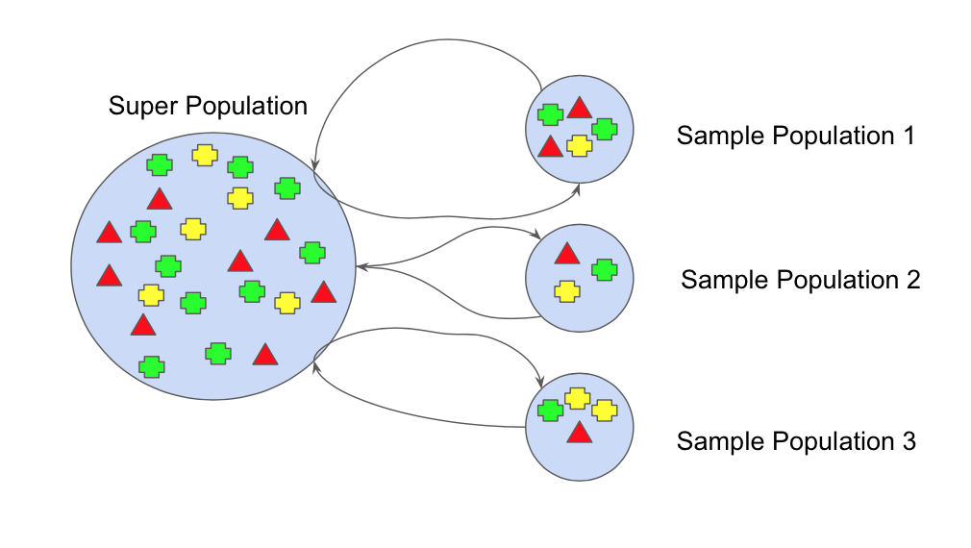

Bootstrap refers to random sampling with replacement. Bootstrap allows us to better understand the bias and the variance with the dataset. Bootstrap involves random sampling of small subset of data from the dataset. This subset can be replace. The selection of all the example in the dataset has equal probability. This method can help to better understand the mean and standand deviation from the dataset.

Let’s assume we have a sample of ‘n’ values (x) and we’d like to get an estimate of the mean of the sample.

mean(x) = 1/n \* sum(x)

# Trending AI Articles:

[1. Machines Demonstrate Self-Awareness](https://becominghuman.ai/machines-demonstrate-self-awareness-8bd08ceb1694)

[2. Visual Music & Machine Learning Workshop for Kids](https://becominghuman.ai/visual-music-machine-learning-workshop-for-kids-a90c957dab33)

[3. Part-of-Speech tagging tutorial with the Keras Deep Learning library](https://becominghuman.ai/part-of-speech-tagging-tutorial-with-the-keras-deep-learning-library-d7f93fa05537)

We know that our sample is small and that our mean has error in it. We can improve the estimate of our mean using the bootstrap procedure:

1. Create many (e.g. m) random sub-samples of our dataset with replacement (meaning we can select the same value multiple times).
2. Calculate the mean of each sub-sample.
3. Calculate the average of all of our collected means and use that as our estimated mean for the data.

For example, let’s say we used 3 resamples and got the mean values 2.5, 3.3 and 4.7. Taking the average of these we could take the estimated mean of the data to be 3.5.

Having understood Bootstrapping we will use this knowledge to understand **Bagging** and **Boosting**.

## BAGGING

Bootstrap Aggregation (or Bagging for short), is a simple and very powerful ensemble method. Bagging is the application of the Bootstrap procedure to a high-variance machine learning algorithm, typically decision trees.

1. Suppose there are N observations and M features. A sample from observation is selected randomly with replacement(Bootstrapping).
2. A subset of features are selected to create a model with sample of observations and subset of features.
3. Feature from the subset is selected which gives the best split on the training data.(Visit my blog on Decision Tree to know more of best split)
4. This is repeated to create many models and every model is trained in parallel
5. Prediction is given based on the aggregation of predictions from all the models.

When bagging with decision trees, we are less concerned about individual trees overfitting the training data. For this reason and for efficiency, the individual decision trees are grown deep (e.g. few training samples at each leaf-node of the tree) and the trees are not pruned. These trees will have both high variance and low bias. These are important characterize of sub-models when combining predictions using bagging. The only parameters when bagging decision trees is the number of samples and hence the number of trees to include. This can be chosen by increasing the number of trees on run after run until the accuracy begins to stop showing improvement

## BOOSTING

Boosting refers to a group of algorithms that utilize weighted averages to make weak learners into stronger learners. Unlike bagging that had each model run independently and then aggregate the outputs at the end without preference to any model. Boosting is all about “teamwork”. Each model that runs, dictates what features the next model will focus on.

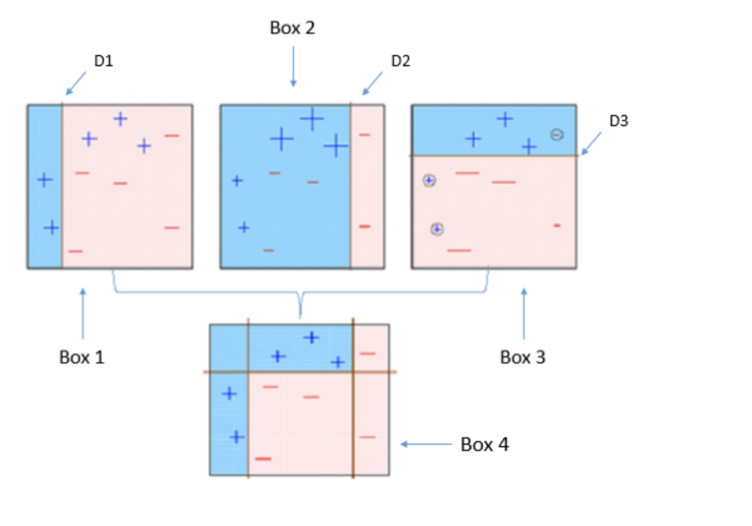

Box 1: You can see that we have assigned equal weights to each data point and applied a decision stump to classify them as + (plus) or — (minus). The decision stump (D1) has generated vertical line at left side to classify the data points. We see that, this vertical line has incorrectly predicted three + (plus) as — (minus). In such case, we’ll assign higher weights to these three + (plus) and apply another decision stump.

Box 2: Here, you can see that the size of three incorrectly predicted + (plus) is bigger as compared to rest of the data points. In this case, the second decision stump (D2) will try to predict them correctly. Now, a vertical line (D2) at right side of this box has classified three mis-classified + (plus) correctly. But again, it has caused mis-classification errors. This time with three -(minus). Again, we will assign higher weight to three — (minus) and apply another decision stump.

Box 3: Here, three — (minus) are given higher weights. A decision stump (D3) is applied to predict these mis-classified observation correctly. This time a horizontal line is generated to classify + (plus) and — (minus) based on higher weight of mis-classified observation.

Box 4: Here, we have combined D1, D2 and D3 to form a strong prediction having complex rule as compared to individual weak learner. You can see that this algorithm has classified these observation quite well as compared to any of individual weak learner.

# Which is the best, Bagging or Boosting?

There’s not an outright winner; it depends on the data, the simulation and the circumstances.  
Bagging and Boosting decrease the variance of your single estimate as they combine several estimates from different models. So the result may be a model with **higher stability**.

If the problem is that the single model gets a very low performance, Bagging will rarely get a **better bias**. However, Boosting could generate a combined model with lower errors as it optimises the advantages and reduces pitfalls of the single model.

By contrast, if the difficulty of the single model is **over-fitting**, then Bagging is the best option. Boosting for its part doesn’t help to avoid over-fitting; in fact, this technique is faced with this problem itself. For this reason, Bagging is effective more often than Boosting.

## Further Reading

[Mehods to optimize Machine Learning models](https://hub.packtpub.com/ensemble-methods-optimize-machine-learning-models/)will help you understand Ensemble model.

[Bagging and Random Forest Ensemble Algorithms for Machine Learning](https://machinelearningmastery.com/bagging-and-random-forest-ensemble-algorithms-for-machine-learning/) talks about Random Forest Algorithm.

[A Primer to Ensemble Learning](https://analyticsindiamag.com/primer-ensemble-learning-bagging-boosting/)

# References

1. Friedman, Jerome H. Greedy function approximation: A gradient boosting machine. Ann. Statist. 29 (2001), no. 5, 1189–1232.
2. Prokhorenkova, Liudmila, Gusev, Gleb et.al. (2018). [CatBoost: unbiased boosting with categorical features](https://arxiv.org/abs/1706.09516). In Advances in Neural Information Processing Systems
3. CatBoost Parameters. <https://catboost.ai/docs/concepts/python-reference_parameters-list.html>

**An Introduction to Naïve Bayes Classifier**

**Naïve Bayes Classifier?**

The Naïve Bayes Classifier belongs to the family of probability classifier, using Bayesian theorem. The reason why it is called ‘Naïve’ because it requires rigid independence assumption between input variables. Therefore, it is more proper to call Simple Bayes or Independence Bayes. This algorithm has been studied extensively since 1960s. Simple though it is, Naïve Bayes Classifier remains one of popular methods to solve text categorization problem, the problem of judging documents as belonging to one category or the other, such as email spam detection.

The goal of Naïve Bayes Classifier is to calculate conditional probability:



for each of K possible outcomes or classes Ck.

Let x=(x1,x2,…,xn). Using Bayesian theorem, we can get:



The joint probability can be written as:

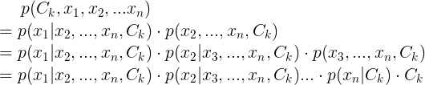

Assume that all features x are mutually independent, we can get:



Therefore, formula can be written as:

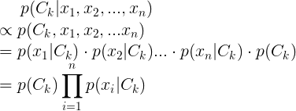

Therefore, this is the final formula for Naïve Bayes Classifier.

**2.** **How to calculate parameters and make a prediction in Naïve Bayes Classifier?**

Maximum Likelihood Estimation (MLE) is used to estimate parameters — prior probability and conditional probability.

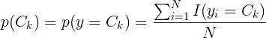

The prior probability equals the number of certain cases of y occur divided by the total number of records.

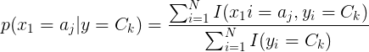

The conditional probability of p(x1=a1|y=C1) equals the number of cases when x1 equals to a1 **and** y equals to C1 divided by the number of cases when y equals to C1.

Naïve Bayes Classifier uses following formula to make a prediction:



For example, 15 records in the table below are used to train a Naïve Bayes model, and then a prediction is made to a new record X(B, S).

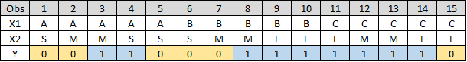

Use formula above to estimate prior and conditional probability, and we can get:

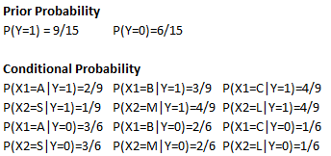

Finally, as of X(B, S), we can get:

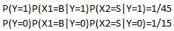

P(Y=0)P(X1=B|Y=0)P(X2=S|Y=0)> P(Y=1)P(X1=B|Y=1)P(X2=S|Y=1), so y=0.

**3. Laplace Smoothing**

In statistics, Laplace Smoothing is a technique to smooth categorical data. Laplace Smoothing is introduced to solve the problem of zero probability. By applying this method, prior probability and conditional probability can be written as:

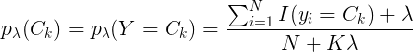

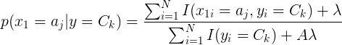

K denotes the number of different values in y and A denotes the number of different values in aj. Usually lambda in the formula equals to 1.

By applying Laplace Smoothing, the prior probability and conditional probability in previous example can be written as:

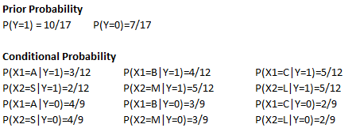

**4. Application in python**

Step 1: Create a dataset.

Step 2: Train Naïve Bayes Model by calculate prior and conditional probability.

Step 3: Make a prediction.

**Summary:**

Naïve Bayes Classifier can be trained easily and fast and can be used as benchmark model. When variable selection is carried out properly, Naïve Bayes can perform as well as or even better than other statistical models such as logistic regression and SVM. Naive Bayes requires a strong assumption of independent predictors, so when the model has a bad performance, the reason leading to that may be the dependence between predictors.

You can read more blogs by clicking on the following link:

Reference:

[1] Christopher M. Bishop, (2009), Pattern Recognition and Machine Leaning

[2] <https://en.wikipedia.org/wiki/Naive_Bayes_classifier>

[3] <https://en.wikipedia.org/wiki/Additive_smoothing>

# Authors

|  |  |
| --- | --- |
| Ernesto Mazza  Author  6th Grade | A young person wearing a white shirt |
| Lesa Wallace  Author  7th Grade |  |
| Lynette Yang  Author  10th Grade | A person with pink hair looking at the camera |
| Author name  Title  Organization |  |